Document Number: COP-WFP-WFD-06-2013-v1

Installation Work Package Life Cycle
#4 Control of IWP in the Field

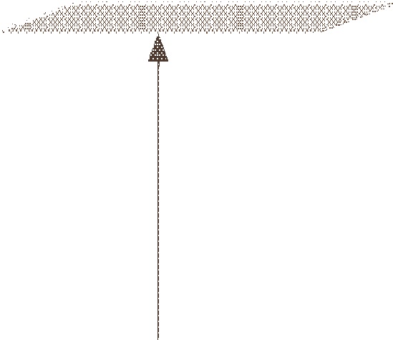Return IWP to Planning department
Planning department files complete IWPs

Confirm progress report

See #5 IWP Close Out (A)

Completed Items

See #3 IWP Issuance to the field (A)

Monitor the status until complete
Remove unfinished tasks for repackaging

Removed Items

See #1 Electronic IWP creation (A)

YES
YES
Repack

Planning department records progress from field

Is the IWP 100% complete NO within the scheduled time
frame?

Is it Feasible for IWP to NO remain in the field?

Is the IWP to be held or unfinished items to be
repackaged

Hold

Return IWP to Planning department

Monitor IWP until Hold is removed

See #3 IWP
Issuance to Field (A)

Author: Robin Mikaelsson Approver: COAA WFP Committee

Page 1 of 1 WFP-WFD-2013-146-A IWP Lifecycle 4.vsd

