Document Number: COP-WFP-WFD-05-2013-v1

Installation Work Package Life Cycle
#3 IWP Issuance to the Field

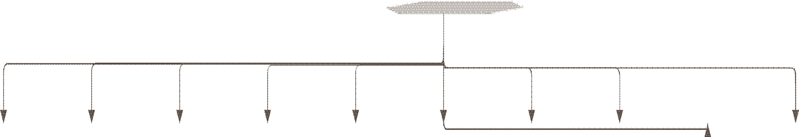See #2 Document Control Interface (A)

See #4 Control of IWP in the field (A)

Planner Receives IWP from Doc Control
Planner files both copies of IWP until constraints are satisfied

Safety and permitting

Quality Control

IFC Drawings Schedule Materials

Pre- Fabrication

Work Access and Laydown

Craft Availability

Construction Equipment and tools

Scaffoldng
Final Verification of Constraints

YES
Have all constraints been satisfied?

Release IWP to applicable superintendent
Send confirmation of start to support craft

NO Is it feasible to hold packages as
is?

YES

Monitor Constraints

At crew meeting, superintendant walks through IWPs

Field Executes the work in IWP
NO

Regularly report progress on predetermined interval
See #1 Electronic IWP Creation (A)

See #4 Control of IWP in the Field (A)

Author: Robin Mikaelsson Approver: COAA WFP Committee
Page 1 of 1 WFP-WFD-2013-145-A IWP Lifecycle 3.vsd

