Rev. No | Rev Description | Date | Author | Checked By: |  |  | Approved By:
 |  |  |  | Contracts admin. | Project Controls | WFP Manager | Contractor | Construction/ Planning Manager
A | Issued For Review | MM/DD/YYYY
B | IFC | MM/DD/YYYY
C | Contractor Finalization | MM/DD/YYYY

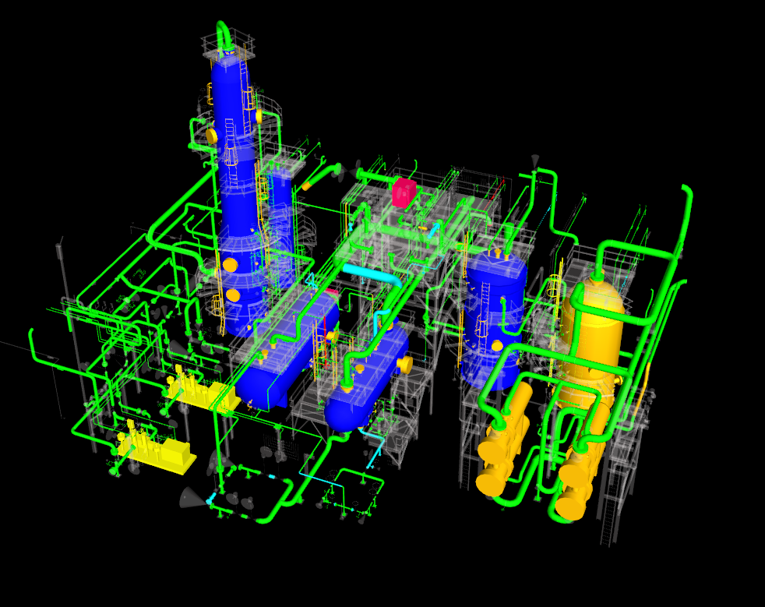

Table Of Contents
Section No. | Section Description | # of Sheets
1.0 | Scope of Work
2.0 | EWP Reference List
3.0 | Engineering Information
4.0 | Quality
5.0 | Vendor Support
6.0 | WorkFace Planning
7.0 | 3D Model Shots of EWP
8.0 | Contact List

1.0 SCOPE OF WORK
  - Summary Description of the Scope of Work
A summary description of the scope of this EWP is to be provided here. Reference additional EWPs.
  - Execution Strategy
Provide the strategic intent or Path of Construction for scopes to be executed in this EWP. Reference integration and interface requirements and Project Schedule.
  - Execution Milestones
Identify key milestone dates for scopes of work referenced based on the Level III Project Schedule.
  - Work Included
Include any scope items that are not contained in the defined EWPs, or where the referenced documents do not adequately convey the scope.
  - Work excluded
Identify work that is specifically not included that is not identified in the defined EWPs, or where the referenced documents do not adequately convey the limits of scope.

2.0 EWP REFERENCE LIST
2.1 EWP Reference List
Identify additional EWPs that must be referenced to understand scope and execution strategy.

3.0 ENGINEERING INFORMATION
3.1 Holds List
Identify Hold and forecast release for documents listed but not released
  - Additional Technical Information
Identify any technical information that is not included in other documentation
  - Technical document lists
Identify and include the lists of technical documents included in this EWP

4.0 QUALITY
4.1 Inspection and Test Plans
All work defined in this EWP will be executed to requirements of Owner-approved Inspection and Test Plans (ITP). ITPs will be developed in compliance to Owner document XXX-XXX-000 Contractor Quality Requirements Specification Standard.
4.2 Weld Procedures
No welding process will be applied to the execution of scopes defined in this EWP without an approved Welding Procedure. Welding Procedures will satisfy welding requirements identified in EWPs listed in Section 2.0 EWP List.

5.0 VENDOR SUPPORT
5.1 Equipment List Vendor Requiring Support
Provide a list of applicable equipment that will require vendor assistance.
5.2 Purchase Order Schedule
Provide confirmation that a Contract or Purchase Order is in place.
5.3 Vendor Contact Information
Prepare a list of Vendor contact information, notification requirements and anticipated required at site dates.

6.0 WORKFACE PLANNING
6.1 Field Installation Work Package List and Schedule
A detailed breakdown of the planned number IWPs associated with the EWP is to be provided by the Contractor along with the release plan.
The Contractor Shall follow the implementation practices as described but CII and COAA.
(Insert Links to Web information for COAA, CII, and the 272IR)
7.0 3D Model Shots Of EWP
7.0 Model Shots

Include here several 3D model shots of the EWP

8.0 Contact List
8.0 Contact List

Provide a comprehensive list of Contact Information for:

- Project Personnel
- Engineering Personnel
- Materials Management
- Vendors
- Document Owners

