CONSTRUCTION WORK PACKAGE
Project Name:
Project CWP WBS No:
CWP |  | Plant |  | Area |  | Discipline |  | Sequence No
C W P | - |  | - |  | - |  | -
Description:

Rev.  No | Rev Description | Date | Author | Checked By: |  |  | Approved By:
 |  |  |  | Contracts  admin. | Project  Controls | WFP  Manager | Contractor | Construction/  Planning Manager
A | Issued For Review | MM/DD/YYYY
B | IFC | MM/DD/YYYY
C | Contractor Finalization | MM/DD/YYYY

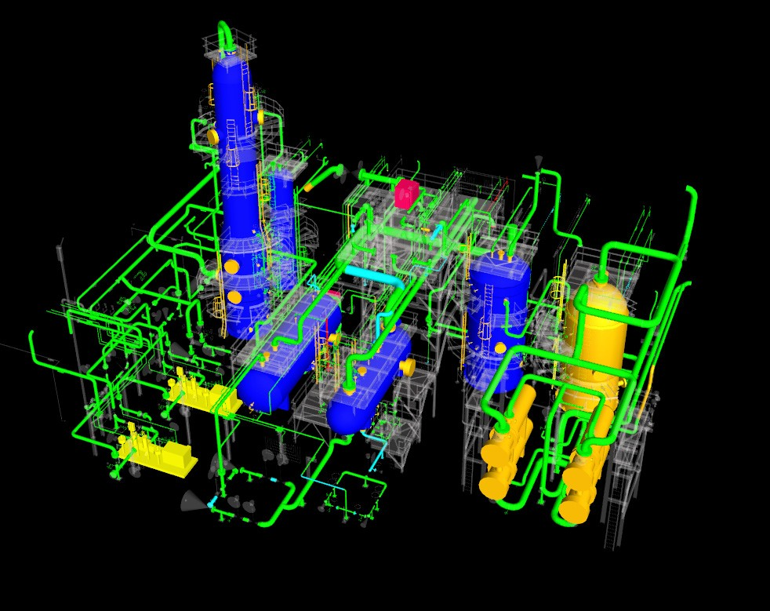

CONSTRUCTION WORK PACKAGE
Project Name: |  |  |  |  | Company Logo
Project CWP WBS No:
CWP |  | Plant |  | Area |  | Discipline |  | Sequence No
C W P | - |  | - |  | - |  | -
Description:

Table Of Contents
Section No. | Section Description | # of Sheets
1.0 | Scope of Work
2.0 | CWP Reference List
3.0 | Engineering Information
4.0 | Craft / Manpower
5.0 | Direct Field Equipment and Materials
6.0 | Safety
7.0 | Quality
8.0 | Regulatory Approvals and Permits
9.0 | Sub-contracts (Construction Contractor)
10.0 | Vendor Support
11.0 | Rigging Studies
12.0 | Scaffolding
13.0 | Special Equipment, tools and consumables
14.0 | Waste Management
15.0 | Risk Register
16.0 | WorkFace Planning
17.0 | Project Controls
18.0 | Turnover Documents
19.0 | 3D Model Shots of CWP
20.0 | Submittals
21.0 | Contact List

CONSTRUCTION WORK PACKAGE
Project Name: |  |  |  |  | Company Logo
Project CWP WBS No:
CWP |  | Plant |  | Area |  | Discipline |  | Sequence No
C W P | - |  | - |  | - |  | -
Description:

1.0 SCOPE OF WORK
  - Summary Description of the Scope of Work
A summary description of the scope of this CWP is to be provided here. Reference additional CWPs, Fabrication Work Plans and/or Modularization Work Plans that will be combined to form a construction or fabrication contract.

  - Execution Strategy
Provide the strategic intent or Path of Construction for scopes to be executed in this CWP. Reference integration and interface requirements and Project Schedule.
  - Execution Milestones
Identify key milestone dates for scopes of work referenced based on the Level III Project Schedule.
  - Work Included
Include any scope items that are not contained in the defined EWPs, or where the referenced documents do not adequately convey the scope.
  - Work excluded
Identify work that is specifically not included that is not identified in the defined EWPs, or where the referenced documents do not adequately convey the limits of scope.
2.0 CWP REFERENCE LIST
  - CWP Reference List and Interface lists

Identify additional CWPs that must be referenced to understand scope and execution strategy. Identify Tie-in requirements document
  - Owner Supplied Sub-Contractors

Provide specific list of CWPs executed buy owner supplied sub-contractors pertinent to this CWP.

CONSTRUCTION WORK PACKAGE
Project Name: |  |  |  |  | Company Logo
Project CWP WBS No:
CWP |  | Plant |  | Area |  | Discipline |  | Sequence No
C W P | - |  | - |  | - |  | -
Description:

3.0 ENGINEERING INFORMATION
  - Engineering Work Package List

A listing of all EWPs associated with this CWP including EWP number, description and revision
  - Holds List
Identify Hold and forecast release for documents listed but not released
  - Additional Technical Information
Identify any technical information that is not included in other documentation

  - Technical document lists
Identify and include the lists of technical documents included in this CWP
4.0 MANPOWER
  - Manpower Requirement

Provide an estimate of manpower requirements
  - Density calculations
Complete workplace density calculations
  - Special Skills
Identify all specialty skill requirements to complete tasks and their impact on schedule (if any)

CONSTRUCTION WORK PACKAGE
Project Name: |  |  |  |  | Company Logo
Project CWP WBS No:
CWP |  | Plant |  | Area |  | Discipline |  | Sequence No
C W P | - |  | - |  | - |  | -
Description:

5.0 MATERIALS
  - Bill of Materials Matrix (owner, engineer, vendor, contractor, fabricator supplied)
List responsibilities for materials not identified in EWPs. Ensure Cross-reference lists between tag numbers; requisition numbers, PO numbers, and IFC drawing numbers are included in EWPs.
  - Owner supplied equipment and materials
Must include all owners provided, or free-issued to Contractor, materials and tagged items.
  - Required at Site Dates (change to key and long lead)
Confirmation that material deliveries conform to Require at Site dates (RAS). Include RAS vs. ETA

  - Total Quantities
Provide Total material quantities as applicable (i.e. Ea, Tonne, Y cu, ft, dia-inch, etc.)
6.0 SAFETY
  - Safety
Provide high level Job Hazard Analysis for the identified work scopes, rank and set priorities for hazardous jobs contained in the execution of the CWP. These jobs should be the first priority for analysis and identification of items such as:

    - Safe work plans

    - Special Training requirements

    - Special PPE requirements

    - Special Permits (confined space, road closures, man baskets, lock-outs, etc)

    - WHIMIS/MSDS requirements
Note: Detailed JHAs or FLHAs will take place at the IWP level. (To be provided by the Contractor)

CONSTRUCTION WORK PACKAGE
Project Name: |  |  |  |  | Company Logo
Project CWP WBS No:
CWP |  | Plant |  | Area |  | Discipline |  | Sequence No
C W P | - |  | - |  | - |  | -
Description:

7.0 QUALITY
  - Inspection and Test Plans
All work defined in this CWP will be executed to requirements of Owner-approved Inspection and Test Plans (ITP). ITPs will be developed in compliance to Owner document XXX-XXX-000 Contractor Quality Requirements Specification Standard.

  - Weld Procedures
No welding process will be applied to the execution of scopes defined in this CWP without an approved Welding Procedure. Welding Procedures will satisfy welding requirements identified in EWPs listed in Section 2.0 EWP List.

  - Survey Requirements
This section should state the strategic intent for survey requirements and survey control plan for the scopes defined
8.0 REGULATORY APPROVALS AND PERMITS
  - Regulatory Approval Requirements
Regulatory Approval Requirements and compliance status must be communicated to contractors. Review compliance requirements and include applicable special permits required for execution of the CWP. (Such as Building Permits, Potable Water, Disposal, etc.)
  - Permit Schedule

A list of permit requirements for the defined scopes is to be provided.

CONSTRUCTION WORK PACKAGE
Project Name: |  |  |  |  | Company Logo
Project CWP WBS No:
CWP |  | Plant |  | Area |  | Discipline |  | Sequence No
C W P | - |  | - |  | - |  | -
Description:

9.0 SUB-CONTRACTS (Construction Contractor)
  - Contractor activities
Provide an explanation of the services to be sub-contracted as well as the target start and completion dates for said services and the contract formation process.
  - Services Provided
List the services that will be provided to the contractor by a sub-contractor, and by Owner, if they are to be different than agreed.
10.0 VENDOR SUPPORT
  - Equipment List Vendor Requiring Support

Provide a list of applicable equipment that will require vendor assistance.
  - Purchase Order Schedule
Provide confirmation that a Contract or Purchase Order is in place.
  - Vendor Contact Information
Prepare a list of Vendor contact information, notification requirements and anticipated required at site dates.

11.0 Critical Lifts / Crane Schedule
  - Lift Studies
Include applicable anticipated critical lifts for the work scope in this CWP. (To be incorporated into the detailed IWPs)

  - Lift Schedule
Provide a lift schedule that links requirements to the Level 3 Project Schedule for this CWP.
12.0 SCAFFOLDING
12.1 Scaffolding Plan
Provide the estimated scaffolding types, location, duration and quantity requirements (including materials and labor) for the scope of work associated with the CWP.
13.0 SPECIAL EQUIPMENT, TOOLS AND CONSUMABLES
  - Special Construction Equipment
Provide a listing of special construction equipment needed and the availability timelines (if it is Owner supplied)

  - Special Tools and Consumables
Identify all special tools and consumable requirements necessary to perform the work (e.g. refractory dry- out, laser alignment, etc.)
8

CONSTRUCTION WORK PACKAGE
Project Name: |  |  |  |  | Company Logo
Project CWP WBS No:
CWP |  | Plant |  | Area |  | Discipline |  | Sequence No
C W P | - |  | - |  | - |  | -
Description:

[Type the company name] | CWP Template

CONSTRUCTION WORK PACKAGE
Project Name: |  |  |  |  | Company Logo
Project CWP WBS No:
CWP |  | Plant |  | Area |  | Discipline |  | Sequence No
C W P | - |  | - |  | - |  | -
Description:

14.0 WASTE MANAGEMENT
14.1 Waste Management Plan
Typically the Waste Management Strategy/Plan is defined in general terms in the Construction Execution Plan with respect to responsibilities.
The Contractor is to provide a listing here as to the types and estimated quantities of waste associated with the CWP along with the discarding plan. (This to be in alignment with the overall Site Waste Management Plan)
15.0 RISK REGISTER
15.1 Risk and Mitigation
Provide a listing of items from the risk register that apply to the CWP complete with mitigation measures and an associated status report.

CONSTRUCTION WORK PACKAGE
Project Name: |  |  |  |  | Company Logo
Project CWP WBS No:
CWP |  | Plant |  | Area |  | Discipline |  | Sequence No
C W P | - |  | - |  | - |  | -
Description:

16.0 WORKFACE PLANNING

16.1 Installation Work Package List and Schedule
A detailed breakdown of the planned number IWPs associated with the CWP is to be provided by the Contractor along with the release plan.
The Contractor Shall follow the implementation practices as described but CII and COAA. (Insert Links to Web information for COAA, CII, and the 272IR)

CONSTRUCTION WORK PACKAGE
Project Name: |  |  |  |  | Company Logo
Project CWP WBS No:
CWP |  | Plant |  | Area |  | Discipline |  | Sequence No
C W P | - |  | - |  | - |  | -
Description:

17.0 PROJECT CONTROLS
  - Integrated Schedule
A detailed Level 3 construction schedule showing integration; with other construction disciplines and contractors is to be provided by Owner’s Project Controls group along with an overall narrative of the proposed Suncor Execution Strategy.

  - Progress and Performance Measurement
Provide a confirmation and listing of:

    - progress measurement and performance requirements
    - the support mechanisms are set up and;
    - the material quantities and labour are rolled up to the required WBS level. Add WBS chart to outline WBS numbers within this CWP
18.0 TURNOVER DOCUMENTS
18.0 Turnover Document Matrix

Provide a list or matrix of the required documents for Turnover that pertains to this CWP.
18.1 Turn Over Responsibility
Reference the Project Turnover Responsibility Matrix
18.2 Templates for Turnover Binders
Reference the location of the Templates required to develop the Turnover Binders.

CONSTRUCTION WORK PACKAGE
Project Name: |  |  |  |  | Company Logo
Project CWP WBS No:
CWP |  | Plant |  | Area |  | Discipline |  | Sequence No
C W P | - |  | - |  | - |  | -
Description:

19.0 3D Model Shots Of CWP
19.0 Model Shots

Include here several 3D model shots of the CWP
20.0 Submittals
  - Submittals

    - CONTRACTOR to submit to the OWNER an approved Methodology Statement (or equivalent) for this CWP two weeks prior to commencing work.

    - CONTRACTOR to submit to the OWNER a schedule for this CWP based on IWPs two weeks prior to commencing work.

    - CONTRACTOR to submit to the OWNER a resource staffing plan for this CWP two weeks prior to commencing work.

    - CONTRACTOR to submit to the OWNER a detailed equipment plan (complete with pricing) for this CWP two weeks prior to commencing work.

    - CONTRACTOR to submit to the OWNER an estimate of man hours (complete with pricing) for this CWP two weeks prior to commencing work.

    - CONTRACTOR to submit to the OWNER a status listing of all CONTRACTOR supplied items (complete with pricing) required for this CWP two weeks prior to commencing work.

    - CONTRACTOR to submit to the OWNER for approval the proposed ITP for this CWP two weeks prior to commencing work.

    - CONTRACTOR to submit to the OWNER for approval a job hazard analysis for this CWP two weeks prior to commencing work.

    - CONTRACTOR to submit to the OWNER for approval a rigging/lifting study for this CWP two weeks prior to commencing work.

- CONTRACTOR to submit to the OWNER the work permit(s) for this CWP two weeks prior to commencing work.

CONSTRUCTION WORK PACKAGE
Project Name: |  |  |  |  | Company Logo
Project CWP WBS No:
CWP |  | Plant |  | Area |  | Discipline |  | Sequence No
C W P | - |  | - |  | - |  | -
Description:

20.0 Contact List
  - Contact List

Provide a comprehensive list of Contact Information for:

    - Construction Management Personnel
    - Project Personnel
    - Engineering Personnel
    - Materials Management
    - Vendors
    - Document Owners
    - Area Hospitals and Doctors
    - Emergency Response Teams
    - Etc.,

