Physical Demands Analysis

Modular Industrial 3rd Year Apprentice Electrician

Prepared for:
Construction Owners Association of Alberta

Job Title: | Modular Industrial 3rd Year Apprentice Electrician | Assessment Location: |  | Data Collection Date:

Completed By: |  | Submitted on:

Disclaimer: | The Physical Demands noted in this report may vary depending on company and location. Please contact the company directly to confirm this physical demands analysis is an accurate representation of the specific job title for the specific location.  Depending on the company and location, safety standards for lifting require any lifting greater than 50 lbs. to be done with two people; and any lifting greater than 80 lbs. to be done with the use of machinery.

Work Schedule: | Shift Duration: 4 days/week, 10 hours/day; may vary  Break Schedule: Total of 1 hour break per day  Shift Rotation: Not applicable  On call is required: No  Overtime required: No; but may be available

Education / Experience: | Education required: Required to complete 2 years of the 4-year apprenticeship program; upon completion of the 3rd year of hours, the 3rd year apprentice will be eligible for completion of the 3rd year schooling. In class portion is 8 weeks for the first 3 years; and 12 weeks in the fourth year.  Hours required for position: 1500 hours per year of apprenticeship  Tickets that may be required (not limited to): Fall protection, H2S Alive, Elevated Work Platform (EWP), First Aid, WHIMIS and Construction Safety Training Systems (CSTS).

Labour Provider:

Job Overview: | An Industrial 3rd Year Apprentice Electrician assists with the installation of electrical circuits and wires into buildings and/or structures. The Industrial 3rd Year Apprentice Electrician assists with the mentoring of 1st and 2nd Year apprentices.
 | % of shift | Job Task | Task Description
 | 10 | Safety / Job Prep and Planning Phase | - Attend safety meetings as required and perform daily stretching routine. Complete appropriate paperwork for task, including pre-task safety card.  - Direction provided by foreman; although would assist the Journeyman with reading blue prints, drawings. Should be generally knowledgeable of specs.  - Communication with other tradesmen required.  - Gather materials and tools required for the job. May use cart to push/pull items to/from worksite.  - Inspect any equipment prior to using it. Flag off area as required.
 | 5 | Spotting for moving equipment | - A spotter is required for moving the EWP, or Genie, that may be required to reach heights while installing cable trays, pulling cable, or performing any other job function at heights.
 | 85 | Providing electrical cable and supports to structure | - Prior to installing the electrical cable, the 3rd Year Apprentice Electrician assists with ensuring all electrical supports are installed into the structure. For example, cable trays, will need to be bolted together and onto the building structure prior to cable being pulled onto them. The 3rd Year Apprentice Electrician may need to remove fireproofing using electrical tools.  - The cable tray or unistrut may require cutting; this would be completed using a chop saw. The 3rd Year Apprentice Electrician would also use a grinder and metal file to clean the edge for the Welder.  - The Electrician is responsible for testing wire prior to using it and/or if they suspect the wire has been compromised. This is completed using a megger and/or multi meter.  - A large part of the job demands include bonding all current carrying electrical components to the ground grid. This is completed using small hand tools.  - One of the more heavy job demands is pulling cable from large spools (typically on the ground, outside of the structure), through the structure and onto/through the cable trays. This is typically done with multiple people as a team. It requires significant pushing and pulling.  - As an Industrial 3rd Year Apprentice Electrician, taping EHT to the large pipes is required. This involves repetitive reaching, wrapping of tape and/or wire around the pipe.  - Hazard / safety stickers regarding electricity are placed along the industrial structure every 10 feet to ensure awareness by all trades and/or operators.  - The Industrial 3rd Year Apprentice Electrician may be responsible for installing ground wire by digging trenches, rolling wire and bending it into tight spaces within the ground.

Equipment/  Tools/ Materials: | Equipment, tools and materials used may include, but are not limited to:  - Reciprocating saw  - Drill  - Portable ban saw  - Chop saw  - Hand tools in tool bag may include:  - Screw drivers  - Ratchets  - Knives  - Saws  - Level  - Crimps  - Pliers  - Measuring tape  - Skill saw  - EWP  - Zoom boom / cranes – operated by equipment operators  - Unistrut  - Cable tray  - Cable / ground wire  - EHT  - Tape  - Thin wire

Exposures / Environment: | Exposures and environment may include, but are not limited to:  - Inclement weather (rain, wind, varying temperatures, snow, ice, etc.)  - Uneven, slippery, rough walking surface  - Loud noises  - Sparks (if around welder – Arc flashes)  - Moving vehicles / heavy equipment around site  - Heights greater than 6 feet  - Toxins (fire proofing materials, paint, gases, fumes)  - Vibration  - Tools falling  - Trip hazards  - Head and/or knee bangers

Personal Protective  Equipment Required at all times: | - Hard hat  - Steel toed boots  - Gloves  - Foam safety eyewear (fectoggle)  - Safety vest or high visibility stripes  - Long sleeves and pants
Personal Protective  Equipment used as Required: | PPE’s used may include, but are not limited to:  - Calorie rated protective suit  - Harness / fall arrest  - Hearing protection

NOC STRENGTH LEVEL KEY
Strength Level | Definition
Limited (Lim) | Up to 5 kg (11 pounds)
Light (L) | 5 kg to 10 kg (11 – 22 pounds)
Medium (M) | 10 kg to 20 kg (22 – 44 pounds)
Heavy (H) | Greater than 20 kg (44 pounds plus)

FREQUENCY KEY
Frequency | % of Workday | Hours – Based on 8 hour Workday
Not Required (N/R) | 0% | 0
Rarely (R) | 1 – 5% | <25 min/day
Occasionally (O) | 6 – 33% | 25 min to 2 hours 40 min/day
Frequently (F) | 34 – 66% | 2 hours 41 min to 5 hours 17 min/day
Constantly (C) | 67 – 100% | 5 hours 18 min to 8 hours/day

*Frequency Key based on WCB Alberta Recommendations
*Strength Level Key based on the National Occupational Classification

Job Demand | Frequency / NOC Strength Level |  |  |  |  | Details/ Measurements
 | N/R | R | O | F | C

Material Handling:
Floor to Waist Level Lifting |  | H | M |  |  | Hand tools – up to 5 lbs.  Reciprocating saw – 25 lbs.  Drill – 5 lbs.  Portable ban saw – 17 lbs.  Unistrut (double) – 75 lbs.  2’ wide aluminum cable tray – 68 lbs.
Knee to Waist Level Lifting |  | H | M |  |  | As above
Waist to Waist Level Lifting |  | H | M | L |  | As above
Waist to Chest Level Lifting |  |  |  | L | Lim | Hand tools – up to 5lbs.  Reciprocating saw – 25 lbs.  Drill – 5 lbs.  Portable ban saw – 17 lbs.
Waist to Shoulder Level Lifting |  | H | L |  |  | Hand tools – Up to 5lbs.  Reciprocating saw – 25 lbs.  Drill – 5 lbs.  Portable ban saw – 17 lbs.  2’ wide aluminum cable tray – 68 lbs.
Waist to Overhead Level Lifting |  |  | Lim |  |  | Hand tools – up to 5lbs. when installing overhead  Aluminum unistrut – 5 to 9 lbs.
Front Carry |  | H | M | L | Lim | Hand tools – up to 5 lbs.  Reciprocating saw – 25 lbs.  Drill – 5 lbs.  Portable ban saw – 17 lbs.  Unistrut – 75 lbs.
Right / Left-handed Carry (Dominant Hand) |  | M |  |  | Lim | Hand tools – up to 5 lbs.  Reciprocating saw – 25 lbs.  Drill – 5 lbs.  Portable ban saw – 17 lbs.
Shoulder Carry |  | H |  |  |  | 2’ wide aluminum cable tray – 68 lbs.
Static  Pushing/Pulling (Force) |  |  |  | L |  | While using hand tools
Dynamic  Pushing/Pulling (Force) |  | H |  |  |  | Pulling cable – up to 50 lbs.  While using chop saw  Material and tools cart – 25 to 30 lbs.

Job Demand | Frequency |  |  |  |  | Details/Measurements
 | N/R | R | O | F | C

Upper Extremity Work:
Hand Gripping |  |  |  |  | X | Using hand tools  Installing cable tray, junction box, etc.  Bonding  Taping pipe  Pulling cable  Grounding wire  Bending heat tracing wire
Pinch Gripping |  |  | X |  |  | Installing junction box / panels using screw drivers and other small hand tools  Pen/pencil tasks
Upper Extremity Coordination |  |  |  |  | X | Using hand tools  Installing cable tray, junction box, etc.  Bonding  Taping pipe  Pulling cable  Grounding wire  Spotting (hand signals)  Bending heat tracing wire
Reaching Forward |  |  |  | X |  | As above
Overhead Shoulder Level Reaching |  |  | X |  |  | Using hand tools  Installing cable tray, junction box, etc.  Bonding  Taping pipe  Pulling cable
Below Shoulder Level Reaching |  |  | X |  |  | Using hand tools  Installing cable tray, junction box, etc.  Bonding  Taping pipe  Pulling cable  Grounding wire  Spotting (hand signals)
Throwing | X |  |  |  |  | Not Required

Job Demand | Frequency |  |  |  |  |  | Details/Measurements
 | N/R |  | R | O | F | C
Positional Work:
Trunk Flexion (Bending) |  |  |  | X | X | X | Constant – grounding wire  Occasional to Frequent – pulling cable, taping pipe, bonding, installing cable tray, retrieving materials and low levels
Trunk Rotation (Twisting) |  |  |  | X |  |  | Grounding wire, pulling cable, taping pipe, bonding, installing cable tray, retrieving/moving materials from side to side
Kneeling |  |  |  | X | X |  | Installing cable tray, junction box, etc.  Bonding  Taping pipe  Retrieving materials
Crawling |  |  | X |  |  |  | As above
Crouching |  |  |  | X | X |  | As above
Squatting |  |  |  | X |  |  | As above
Neck Flexion |  |  |  | X | X | X | Constant – grounding wire, working on cable tray that is below eye level  Occasional to Frequent – pulling cable, taping pipe, bonding, installing cable tray, retrieving materials and low levels, operating EWP
Neck Extension |  |  |  | X | X |  | Spotting  Operating EWP  Working on/installing cable tray that is above eye level  Taping pipe
Neck Rotation |  |  |  |  | X | X | As needed for functional movement patterns

Job Demand | Frequency |  |  |  |  | Details/Measurements
 | N/R | R | O | F | C
Static Work:
Sitting |  | X | X |  |  | To access awkward spaces / low level spaces
Standing |  |  |  | X |  | Operating EWP  Safety meetings  Planning phase  Installing cable tray, junction box, etc.  Bonding  Taping pipe  Pulling cable  Grounding wire  Spotting
Balancing |  | X | X |  |  | Scaffolding stairs, ladders  Operating EWP

Job Demand | Frequency |  |  |  |  | Details/Measurements
 | N/R | R | O | F | C
Ambulation:
Walking: Level Surfaces |  | X |  |  |  | Inside an office or on-site trailer
Walking: Uneven Surfaces |  |  |  | X |  | Gravel, construction site with hazards, scaffolding plywood surface, grating
Walking: Slopes |  | X |  |  |  | May be required at some sites
Jumping | X |  |  |  |  | Not Required
Running | X |  |  |  |  | Not Required

Job Demand | Frequency |  |  |  |  | Details/Measurements
 | N/R | R | O | F | C
Climbing:
Stairs |  | X |  |  |  | Scaffolding stairs to access work platform, in office or to access on-site trailer
Ladder |  | X |  |  |  | Scaffolding ladders to access work platform
Other | X

PHOTOS OF TASKS AND WORK ENVIRONMENT

Figure 1: Large spools of cable.  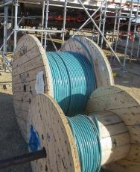 | Figure 2: 2’ wide aluminum cable trays prior to being installed.  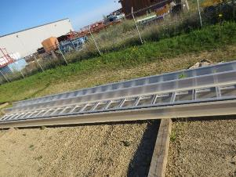
Figure 3: Chop saw used to cut metal pieces as necessary.  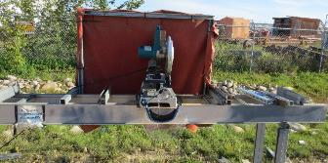 | Figure 4: Junction box with stand.  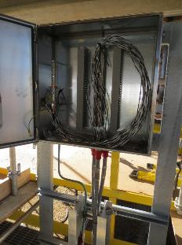
Figure 5: An example of bonding electrical components.  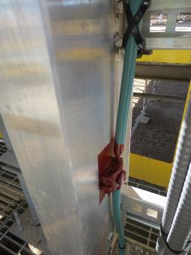 | Figure 6: An example of taping pipe; using fiberglass tape to secure EHT to pipe.  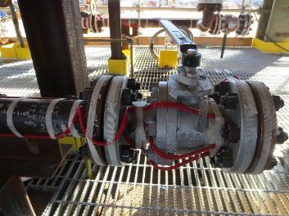
Figure 7: Cable tray that has been installed onto the structure.  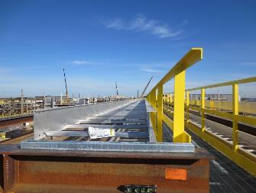 | Figure 8: Temporary power box.  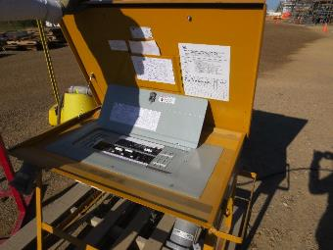
Figure 9: Cable trays may be installed underneath the bottom beam of the structure requiring crouching, kneeling, neck extension.  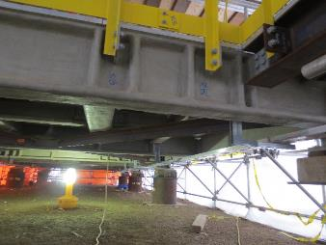 | Figure 10: The scaffolding surface may need to be cut to allow the cable trays to be installed into the structure.  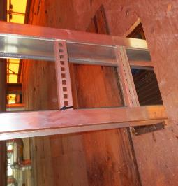
Figure 11: Cart used to carry tools and materials from tool crib / office to job site or module.  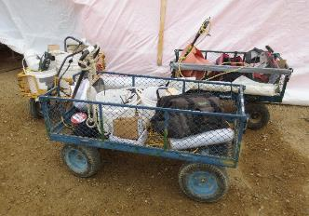 | Figure 12: Hooking the megger up to test connections and ensure wiring has been completed appropriately.  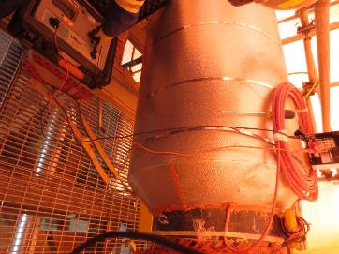
Figure 13: The electrician may sit to access low level work. This figure is an example of wire tracing pipes. This requires bending the trace wire and securing using hand tools.  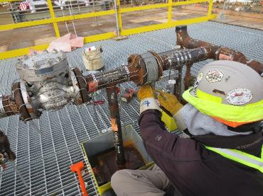 | Figure 14: The electrician may be required to use the chop saw to cut the unistrut, or double unistrut.  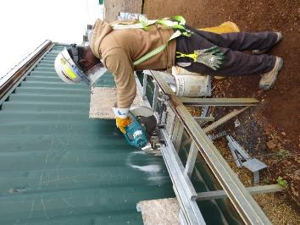
__________________________
Tanis Ellard, BScKin
Kinesiologist

SITE SPECIFIC JOB DEMAND ADDITIONS:
Job Demand | Frequency |  |  |  |  | Details/Measurements
 | N/R | R | O | F | C
Site Specific Job Demand:

Validation Agreement

Job Title: | Modular Industrial 3rd Year Apprentice Electrician
Data Collection Date: | September 12, 2016

We the undersigned have reviewed the Physical Demands Analysis for this position and agree that the physical demands documented in this report are representative of the true demands of the tasks associated with the job title as assessed on the date listed above.

Completed by: |  | Tanis Ellard, BScKin
Approved by: |  | Management Representative
Approved by: |  | Worker Representative

