Physical Demands Analysis

Modular Industrial 1st Year Apprentice Ironworker

Prepared for:
Construction Owners Association of Alberta

Job Title: | Modular Industrial 1st Year Apprentice Ironworker | Assessment Location: |  | Data Collection Date:

Completed By: |  | Submitted on:

Disclaimer: | The Physical Demands noted in this report may vary depending on company and location. Please contact the company directly to confirm this physical demands analysis is an accurate representation of the specific job title for the specific location.  Depending on the company and location, safety standards for lifting require any lifting greater than 50 lbs. to be done with two people; and any lifting greater than 80 lbs. to be done with the use of machinery.

Work Schedule: | Shift Duration: 4 days/week, 10 hours/day; may vary  Break Schedule: Total of 1 hour break per day  Shift Rotation: Not applicable  On call is required: No  Overtime required: No; but may be available

Education / Experience: | Education required: Minimum of Grade 10 education to apply for apprenticeship. Upon completion of the hours required, there is 6 weeks of in-class work. The International Brotherhood of Ironworkers union offers a pre-apprenticeship program that is a 2 week course.  Hours required for position: 1500 hours per year of apprenticeship  Tickets that may be required (not limited to): Fall protection, H2S Alive, wildlife awareness, ground disturbance and Elevated Work Platform (EWP) machinery use, Confined Space, First Aid, WHIMIS, Construction Safety Training Systems (CSTS) and Basic Safety Orientation (BSO).

Labour Provider:

Job Overview: | An Industrial 1st Year Apprentice Ironworker assists with erecting and building main structural members of a building, tower or bridge using steel. The 1st Year Apprentice Ironworker learns behind the Journeyman and is mentored throughout his apprenticeship.
 | % of shift | Job Task | Task Description
 | 10 | Safety / Job Prep and Planning Phase | - Attend safety meetings as required and perform daily stretching routine. Complete appropriate paperwork for task, including pre-task safety card.  - Direction provided by foreman and Journeyman; although would be mentored with reading blue prints, drawings and would be encouraged to be knowledgeable of the specs  - Communication with other tradesmen; specifically working in close proximity to Crane Operators.  - Assist with gathering materials and tools required for the job.  - Inspection of any equipment prior to using it. Flag off area as required.
 | 10 | Spotting for moving equipment | - A spotter is required for moving the EWP, crane, or any additional equipment that is moving throughout the site.
 | 80 | Preparing for and assisting with building and erecting a steel structure | - A 1st year apprentice ironworker would assist with moving any dunnage to create blocking piles for under the steel structure.  - A 1st year apprentice ironworker may be responsible for assisting with creating pieces of buildings as large as the entire side of a building (called a bent); to as small as the grating, beams (large and small) and ladders.  - Preassemble as much of the structural steel as possible prior to erecting. This requires the use of hand tools, power tools, torches, grinders. The 1st year apprentice ironworker may be required to move beams and braces with the use of a grasshopper (a push/pull device with a wheel) if they do not have access to a zoom boom.  - Depending on the building being assembled, the floor would typically be created first. The walls would each be rigged up and temporarily held up by two cranes (one for each wall on opposite sides of the structure). The 1st year apprentice ironworker would then assist with securing each side of the wall to the floor structure using tone guns, hand tools, come-alongs and chain falls, for example.  - Once the four sides of the structure, ceiling and floor are secured to each other, the ironworker then begins to assist with assembling the support beams, ladders, railings and grating (or as applicable to the blueprints of the structure).  - Typically the 1st year apprentice ironworker does not leave the EWP to walk along or climb any of the beams.

Equipment/  Tools/ Materials: | Equipment, tools and materials used may include, but are not limited to:  - Tool belt with the following in it:  - Hammer  - 2 bolt bags  - Frog holding 2 spud wrenches and sleever bar  - 2 bull pins  - Dewey dag  - Clip wrench  - Measuring tape  - EWP (Genie)  - Crane(s); operated by Crane Operator  - Come along  - Chain fall  - Tone gun  - Shackle  - Metal sling  - Sorting hook  - Snipe wrench  - Grinder  - Torch  - Canvas bag to hold some of the tools  - Grasshopper  - Bolt buckets  - Zoom boom

Exposures / Environment: | Exposures and environment may include, but are not limited to:  - Inclement weather (rain, wind, varying temperatures, snow, ice, etc.)  - Uneven, slippery, rough walking surface  - Loud noises  - Sparks (from grinder)  - Moving vehicles / heavy equipment around site  - Heights greater than 6 feet  - Toxins (fire proofing materials, paint, gases, fumes)  - Vibration  - Tools falling  - Trip hazards  - Head and/or knee bangers

Personal Protective  Equipment Required at all times: |  | - Hard hat  - Steel toed boots  - Gloves  - Foam safety eyewear (fectoggle)  - Safety vest or high visibility stripes  - Long sleeves and pants
Personal Protective  Equipment used as Required: |  | PPE’s used may include, but are not limited to:  - Harness / fall arrest  - Hearing protection  - Face shield
 | NOC STRENGTH LEVEL KEY
 | Strength Level |  | Definition
 | Limited (Lim) |  | Up to 5 kg (11 pounds)
 | Light (L) |  | 5 kg to 10 kg (11 – 22 pounds)
 | Medium (M) |  | 10 kg to 20 kg (22 – 44 pounds)
 | Heavy (H) |  | Greater than 20 kg (44 pounds plus)

FREQUENCY KEY
Frequency | % of Workday | Hours – Based on 8 hour Workday
Not Required (N/R) | 0% | 0
Rarely (R) | 1 – 5% | <25 min/day
Occasionally (O) | 6 – 33% | 25 min to 2 hours 40 min/day
Frequently (F) | 34 – 66% | 2 hours 41 min to 5 hours 17 min/day
Constantly (C) | 67 – 100% | 5 hours 18 min to 8 hours/day

*Frequency Key based on WCB Alberta Recommendations
*Strength Level Key based on the National Occupational Classification

Job Demand | Frequency / NOC Strength Level |  |  |  |  | Details/ Measurements
 | N/R | R | O | F | C

Material Handling:
Floor to Waist Level Lifting |  | H | H |  |  | Tone gun – 20 lbs  ¾ inch, 10ft. metal sling – 20 lbs.  Snipe wrench – 5 lbs.  Tool belt with tools (no bolt bags) – 30 lbs.  Tool belt with tools and 2 bolt bags – 60 lbs.  20ft. chain, 1 ½ ton capacity chain fall – 45 lbs. (length of chain and capacity can vary, making it weight less or more)  ¾ ton capacity come along – 20 lbs.  3 ton capacity come along – 55 lbs.  Shackle – can vary between 17 lbs. to 47 lbs.
Knee to Waist Level Lifting |  | H | H |  |  | As above
Waist to Waist Level Lifting |  | H | H | L |  | As above
Waist to Chest Level Lifting |  | H | L |  | Lim | Tone gun – 20 lbs  ¾ inch, 10ft. metal sling – 20 lbs.  Snipe wrench – 5 lbs.  20ft. chain, 1 ½ ton capacity chain fall – 45 lbs. (length of chain and capacity can vary, making it weigh less or more)  ¾ ton capacity come along – 20 lbs.  3 ton capacity come along – 55 lbs.  Shackle – can vary between 17 lbs to 47 lbs  Hand tools from tool belt to chest height – 1lb to 5 lbs.
Waist to Shoulder Level Lifting |  | H | L |  | Lim | As above
Waist to Overhead Level Lifting |  | H | L |  |  | As above
Front Carry |  | H |  | M | M-H (tool belt) | Tone gun – 20 lbs  ¾ inch, 10ft. metal sling – 20 lbs.  Snipe wrench – 5 lbs.  20ft. chain, 1 ½ ton capacity chain fall – 45 lbs. (length of chain and capacity can vary, making it weight less or more)  ¾ ton capacity come along – 20 lbs.  3 ton capacity come along – 55 lbs.  Shackle – can vary between 17 lbs. to 47 lbs.  Attached to waist on constant basis (medium to heavy strength level):  Tool belt with tools (no bolt bags) – 30 lbs.  Tool belt with tools and 2 bolt bags – 60 lbs.
Right / Left-handed Carry (Dominant Hand) |  |  | L | Lim | Lim | Hand tools from tool belt – 1lb to 5 lbs.  Tone gun – 20 lbs  ¾ inch, 10ft. metal sling – 20 lbs.  Snipe wrench – 5 lbs.  Shackle – 17 lbs.
Shoulder Carry | X |  |  |  |  | Not required
Static  Pushing/Pulling (Force) |  |  | M |  |  | Tone gun – 20 lbs. in weight; added static pushing force while using
Dynamic  Pushing/Pulling (Force) |  | H |  |  |  | Outrigger pads – floor level and circular – 70 lbs.  Vertical push/pull to bring tools up to work platform – 30 – 50 lbs. depending on amount of tools in canvas bag  Grasshopper – without weight or beam on it – 50 lbs. of force required

Job Demand | Frequency |  |  |  |  | Details/Measurements
 | N/R | R | O | F | C

Upper Extremity Work:
Hand Gripping |  |  |  |  | X | Using hand tools, slings, securing shackles, grinder, torch, come along, chain falls, etc.  Manual handling tasks  Sorting materials  Assembling structural steel
Pinch Gripping |  | X |  |  |  | Pen/pencil if required during measurement and calculation
Upper Extremity Coordination |  |  |  |  | X | Using hand tools, slings, securing shackles, grinder, torch, come along, chain falls, etc.  Manual handling tasks  Sorting materials  Assembling structural steel  Retrieving materials  Spotting (hand signals) as necessary
Reaching Forward |  |  | X |  |  | As above
Overhead Shoulder Level Reaching |  | X |  |  |  | As above
Below Shoulder Level Reaching |  |  |  | X |  | Using hand tools, slings, securing shackles, grinder, torch, come along, chain falls, etc.  Manual handling tasks  Sorting materials  Assembling structural steel  Retrieving materials  Spotting (hand signals) as necessary
Throwing | X |  |  |  |  | Not Required

Job Demand | Frequency |  |  |  |  |  | Details/Measurements
 | N/R |  | R | O | F | C
Positional Work:
Trunk Flexion (Bending) |  |  |  | X | X |  | Lifting materials and tools from low levels  Assembling structural steel  Sorting / retrieving materials  While grinding at waist or lower height
Trunk Rotation (Twisting) |  |  |  | X |  |  | Assembling structural steel, securing beams  Retrieving materials
Kneeling |  |  |  | X |  |  | Assembling structural steel, securing beams  Retrieving materials
Crawling |  |  | X |  |  |  | Accessing awkward positions to install ladder, railing, etc. and/or assemble structural steel
Crouching |  |  | X | X |  |  | Retrieving materials from low levels  Accessing awkward positions to install ladder, railing, etc. and/or assemble structural steel
Squatting |  |  |  | X |  |  | Assembling structural steel  Retrieving materials from floor
Neck Flexion |  |  |  | X |  |  | Assembling structural steel  Retrieving materials from floor
Neck Extension |  |  |  | X |  |  | Spotting  Assembling structural steel  Retrieving materials from high levels  While climbing up beam to access heights
Neck Rotation |  |  |  | X | X |  | As needed for functional movement patterns

Job Demand | Frequency |  |  |  |  | Details/Measurements
 | N/R | R | O | F | C
Static Work:
Sitting | X |  |  |  |  | Not Required
Standing |  |  |  | X | X | Safety meetings  Planning phase  Assembling structural steel, securing beams  Spotting
Balancing |  | X | X |  |  | Scaffolding, ladders, stairs

Job Demand | Frequency |  |  |  |  | Details/Measurements
 | N/R | R | O | F | C
Ambulation:
Walking: Level Surfaces |  | X |  |  |  | Inside an office or on-site trailer
Walking: Uneven Surfaces |  |  |  | X |  | Gravel, construction site with hazards, scaffolding plywood surface
Walking: Slopes | X |  |  |  |  | Not Required
Jumping | X |  |  |  |  | Not Required
Running | X |  |  |  |  | Not Required

Job Demand | Frequency |  |  |  |  | Details/Measurements
 | N/R | R | O | F | C
Climbing:
Stairs |  | X |  |  |  | Scaffolding stairs to access structure  In office or to access on-site trailer
Ladder |  | X |  |  |  | Scaffolding ladders to access scaffolding deck
Other | X

PHOTOS OF TASKS AND WORK ENVIRONMENT

Figure 1: Grasshopper used to manipulate and moved large beams around if the zoom boom is not available for use.  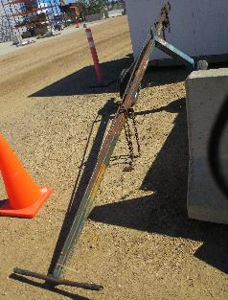 | Figure 2: The Industrial 1st Year Apprentice Ironworker’s typical tool belt.  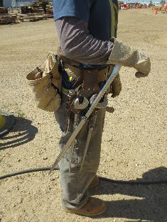
Figure 3: Sorting hook attached to cable used to rig the bent and allow the crane to pick up the structural steel.  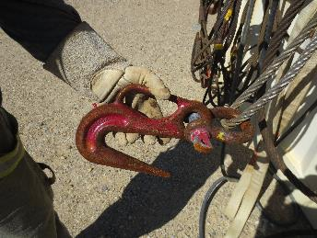 | Figure 4: View from underneath the surface of the grating or floor of the module. Note the large steel structure at the top of the photo and smaller support beams.  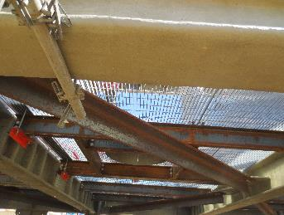
Figure 5: Large structural beams used to create structural steel. Size of beams vary and number of holes also vary. Each hole will be secured to the adjacent beam with a bolt.  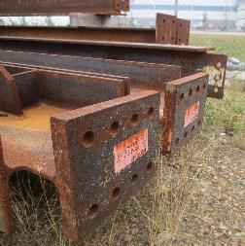 | Figure 6: The ironworker assembling a bolt on the beam.  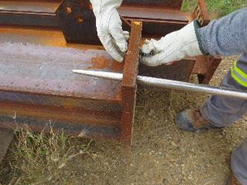

__________________________
Tanis Ellard, BScKin
Kinesiologist

SITE SPECIFIC JOB DEMAND ADDITIONS:
Job Demand | Frequency |  |  |  |  | Details/Measurements
 | N/R | R | O | F | C
Site Specific Job Demand:

Validation Agreement

Job Title: | Modular Industrial 1st Year Apprentice Ironworker
Data Collection Date: | September 1, 2016

We the undersigned have reviewed the Physical Demands Analysis for this position and agree that the physical demands documented in this report are representative of the true demands of the tasks associated with the job title as assessed on the date listed above.

Completed by: |  | Tanis Ellard, BScKin
Approved by: |  | Management Representative
Approved by: |  | Worker Representative

