Physical Demands Analysis

HVAC Technician

Prepared for:
Construction Owners Association of Alberta

Job Title: | HVAC Technician | Assessment Location: |  | Data Collection Date:

Completed By: |  | Submitted on:

Disclaimer: | The Physical Demands noted in this report may vary depending on company and location. Please contact the company directly to confirm this physical demands analysis is an accurate representation of the specific job title for the specific location.

Work Schedule: | Shift Duration: 12 hours/day; may vary  Break Schedule: Total of 1 hour break per day  Shift Rotation: 14 days on, 14 days off  On call is required: Yes; during the evening  Overtime required: No; but is often available

Education / Experience: | Education required: Journeyman Refrigeration and Air Conditioning Mechanic or Gas Fitter Certificate. To obtain this, they must complete a 4-year apprenticeship program. The in-class portion is 8 weeks for the first 3 years; and 12 weeks in the fourth year.  Hours required for position: ~1500 hours  Tickets that may be required (not limited to): Fall protection, Wildlife awareness, Elevated Work Platform (EWP) machinery use, Confined Space, First Aid, WHMIS, Construction Safety Training Systems (CSTS) and Basic Safety Orientation (BSO).

Labour Provider: | N/A

Job Overview: | The HVAC Technician is responsible for installing and maintaining Heating, Ventilation, Air Conditioning, and Refrigeration systems. The Technician may spend extended periods of time working outside on the roof. Tasks are generated and logged through Electronically Generated Services (EGS). The HVAC Technician is trained in Field Level Hazard Assessments (FLHA), and may work alongside laborers or other maintenance staff. Their days are unpredictable because mechanical issues and troubleshooting may take priority over other tasks.
 | % of shift | Job Task | Task Description
 | 10% | Safety/meetings | - Toolbox talk – Safety topics are discussed during the toolbox talk. The Technician will receive additional information such as:  - Tasks for the day  - Important events from previous shifts  - A FLHA is completed and signed before starting any work where hazards are present.  - The FLHA is updated when there are changes to the tasks.
 | 90% | On site work | - Selecting Electronic Generated Services (EGS) – EGS are accessed on the computer.  - EGS are selected and printed.  - Some EGS may take priority over others.  - Some EGS may require several days to complete due to the ordering of parts.  - Completing EGS  - EGS may need to be completed indoors and/or outdoors.  - Indoors – staff, guest, and common areas.  - Outdoors – building exterior such as on the roof or the side of the building.  - The Technician will need to collect necessary tools and parts to complete the EGS.  - The Technician may need to climb stairs, ladders, or drive to access the work area.  - The Technician will repair the issue, or install new equipment indicated by the EGS.  - They may need to repair or install condensers, heaters, air conditioning units, and/or refrigeration units.  - Other maintenance staff members may need to assist.  - High voltage areas (>24V) will require the assistance of an Electrician.  - Preventative maintenances (PM) are performed when possible.  - When performing a PM, the Technician may work alongside other maintenance staff.  - High voltage areas (>24V) will require the assistance of an Electrician.  - A checklist is followed when performing a maintenance.  - A PM may consist of the following:  - Ensuring power is cut off.  - Gaining access to condensers, heaters, ventilation units, air conditioning units, and/or refrigeration units.  - Checking the condition of condensers, heaters, ventilation units, air conditioning units, and/or refrigeration units.  - Cleaning debris and dust using compressed air, a rag, and/or a vacuum.  - Removing built up ice using a scraper.  - Testing the operation of the condensers, heaters, ventilation units, air conditioning units, and/or refrigeration units.  - Completing paperwork – paperwork for daily checks, EGS, PMs, orders, and hours.

Equipment/  Tools: | - Small hand tools, such as wrenches and screwdrivers (~1 lbs)  - Power drill (~4-5 lbs)  - Tool bag (28 lbs when full)  - Step ladder (~7 lbs)  - 10 foot ladder (~30 lbs)

Exposures / Environment: | - High voltage equipment  - Hot temperatures  - Cold temperatures  - Working from heights  - Pinch points  - Rain  - Snow  - Ice  - Wind  - Overhead hazards

Personal Protective  Equipment Required: | - Steel toed boots  - Foam safety eyewear (fectoggle)  - Long sleeves and pants
Personal Protective  Equipment as Required: | - Hard hat  - Gloves  - Harness  - Safety vest or high visibility stripes

NOC STRENGTH LEVEL KEY
Strength Level | Definition
Limited (Lim) | Up to 5 kg (11 pounds)
Light (L) | 5 kg to 10 kg (11 – 22 pounds)
Medium (M) | 10 kg to 20 kg (22 – 44 pounds)
Heavy (H) | Greater than 20 kg (44 pounds plus)
*Strength Level Key based on the National Occupational Classification

FREQUENCY KEY
Frequency | % of Workday | Hours – Based on 8 hour Workday
Not Required (N/R) | 0% | 0
Rarely (R) | 1 – 5% | <25 min/day
Occasionally (O) | 6 – 33% | 25 min to 2 hours 40 min/day
Frequently (F) | 34 – 66% | 2 hours 41 min to 5 hours 17 min/day
Constantly (C) | 67 – 100% | 5 hours 18 min to 8 hours/day
*Frequency Key based on WCB Alberta Recommendations

Job Demand | Frequency / NOC Strength Level |  |  |  |  | Details/ Measurements
 | N/R | R | O | F | C

Material Handling:
Floor to Waist Level Lifting |  | H | M | Lim |  | - Heavy lifting may occur with (but not limited to):  - Nitrogen cylinders (>44 lbs)  - Bottles of refrigerant (~45 lbs)  - A laborer or another maintenance staff member can assist with heavy lifting.  - Medium level lifting may occur with (but not limited to):  - Tool bag (28 lbs when full)  - 10 foot ladder (30 lbs)  - Limited level lifting may occur with (but not limited to):  - Small hand tools (~1 lbs)  - Power drill (4-5 lbs)  - Air filters (~1 lbs)
Knee to Waist Level Lifting |  | H | M | Lim |  | - As above
Waist to Waist Level Lifting |  | H | M | Lim |  | - As above
Waist to Chest Level Lifting |  |  |  | Lim |  | - Limited level lifting may occur with (but not limited to):  - Small hand tools (~1 lbs)  - Power drill (4-5 lbs)  - Air filters (~1 lbs)
Waist to Shoulder Level Lifting |  |  | Lim |  |  | - As above
Waist to Overhead Level Lifting |  |  | Lim |  |  | - Limited level lifting may occur with (but not limited to):  - Small hand tools (~1 lbs)  - Power drill (4-5 lbs)
Front Carry |  | H | M |  |  | - Heavy carrying may occur with (but not limited to):  - Nitrogen cylinders (>44 lbs)  - Bottles of refrigerant (~45 lbs)  - A laborer or another maintenance staff member can assist with heavy carrying.  - Medium level carrying may occur with (but not limited to):  - Tool bag (28 lbs when full)  - 10 foot ladder (30 lbs)  - Limited level carrying may occur with air filters.
Right / Left-handed Carry (Dominant Hand) |  |  | M | Lim |  | - Medium level carrying may occur with (but not limited to) the tool bag (28 lbs when full).  - Limited level carrying may occur with (but not limited to):  - Small hand tools (~1 lbs)  - Power drill (4-5 lbs)
Shoulder Carry |  |  | M |  |  | - Medium level carrying may occur when using a shoulder strap to carry the tool bag.
Static  Pushing/Pulling (Force) |  |  | L |  |  | - Holding parts in place during installation.
Dynamic  Pushing/Pulling (Force) |  |  | H |  |  | - Pushing and pulling appliances and equipment.  - Pushing and pulling nitrogen tanks (>44 lbs)  - Using hand tools for installations, repairs, or maintenances.

Job Demand | Frequency |  |  |  |  | Details/Measurements
 | N/R | R | O | F | C

Upper Extremity Work:
Hand Gripping |  |  |  | X |  | - When lifting and carrying equipment such as the tool bag.  - When using tools to install or repair equipment.  - When driving.
Pinch Gripping |  |  |  | X |  | - Gripping small parts when repairing or installing equipment.  - When using a pen to complete paperwork.
Upper Extremity Coordination |  |  |  | X |  | - When lifting and carrying equipment such as the tool bag.  - When using tools to install or repair equipment.  - When driving.
Reaching Forward |  |  |  | X |  | - As above
Overhead Shoulder Level Reaching |  |  | X |  |  | - When using tools to install or repair equipment.
Below Shoulder Level Reaching |  |  |  | X |  | - When lifting and carrying equipment such as the tool bag.  - When using tools to install or repair equipment.
Throwing | X

Job Demand | Frequency |  |  |  |  |  | Details/Measurements
 | N/R |  | R | O | F | C
Positional Work:
Trunk Flexion (Bending) |  |  |  |  | X |  | - When lifting equipment such as the tool bag.  - When working on low-level equipment such as heating vents and air conditioning units.  - Depending on the EGS or PM, the Technician may need to spend time in many different positions.
Trunk Rotation (Twisting) |  |  |  | X |  |  | - When working behind equipment and in tight spaces.
Kneeling |  |  |  | X |  |  | - When working on low-level equipment such as heating vents and air conditioning units.
Crawling |  |  | X |  |  |  | - When performing EGS underneath the building or at low levels.
Crouching |  |  |  | X |  |  | - When working on low-level equipment such as heating vents and air conditioning units.
Squatting |  |  |  |  | X |  | - When lifting equipment such as the tool bag.
Neck Flexion |  |  |  |  | X |  | - When working on low-level equipment such as heating vents and air conditioning units.
Neck Extension |  |  |  | X |  |  | - When working on overhead ventilation units.
Neck Rotation |  |  |  | X |  |  | - When working behind equipment and in tight spaces.

Job Demand | Frequency |  |  |  |  | Details/Measurements
 | N/R | R | O | F | C
Static Work:
Sitting |  |  | X |  |  | - When completing paperwork and/or driving.
Static Standing |  |  |  | X |  | - When completing various EGS or PMs.
Balancing |  |  | X |  |  | - When using a ladder.

Job Demand | Frequency |  |  |  |  | Details/Measurements
 | N/R | R | O | F | C
Ambulation:
Walking: Level Surfaces |  |  |  |  | X | - Walking indoors or outdoors on the roof.
Walking: Uneven Surfaces |  |  | X |  |  | - Walking outside.  - There may be snow, ice, mud, and gravel present.
Walking: Slopes |  |  | X |  |  | - As above.
Jumping | X
Running | X

Job Demand | Frequency |  |  |  |  | Details/Measurements
 | N/R | R | O | F | C
Climbing:
Stairs |  |  |  | X |  | - Stairs indoors and outdoors.
Ladder |  |  | X |  |  | - Ladders indoors and outdoors.
Other | X

PHOTOS OF TASKS AND WORK ENVIRONMENT
Figure 1: The HVAC Technician may carry their equipment using a tool bag. The Technician will carry the tool bag only when needed.  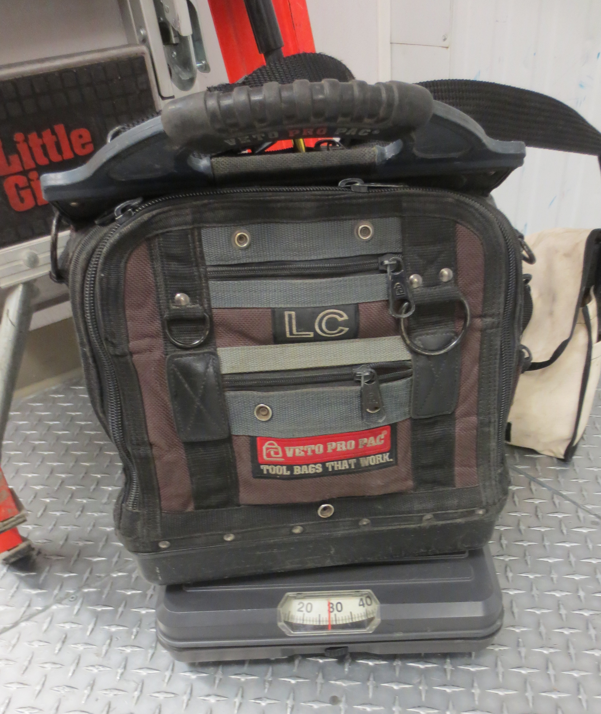 | Figure 2: The HVAC Technician may need to service exterior condensers. Condensers can be located on the side of the building, or on the roof.  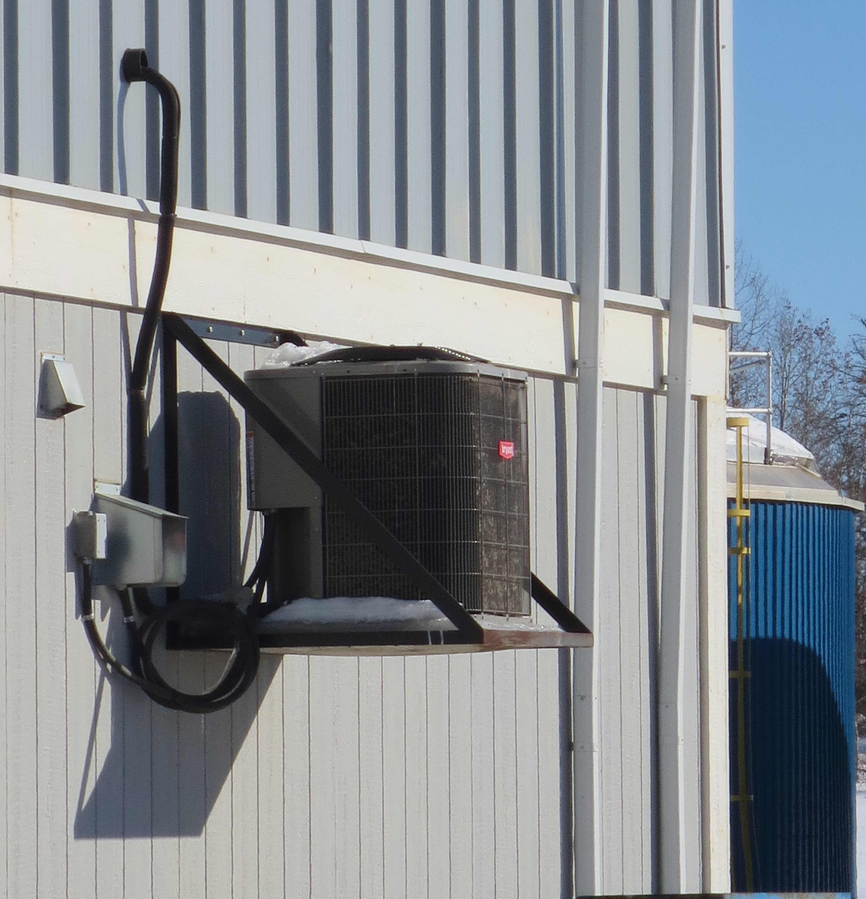
Figure 3: The HVAC Technician may need to service cooling units within walk-in freezers. The Technician may repair or replace cooling fans.  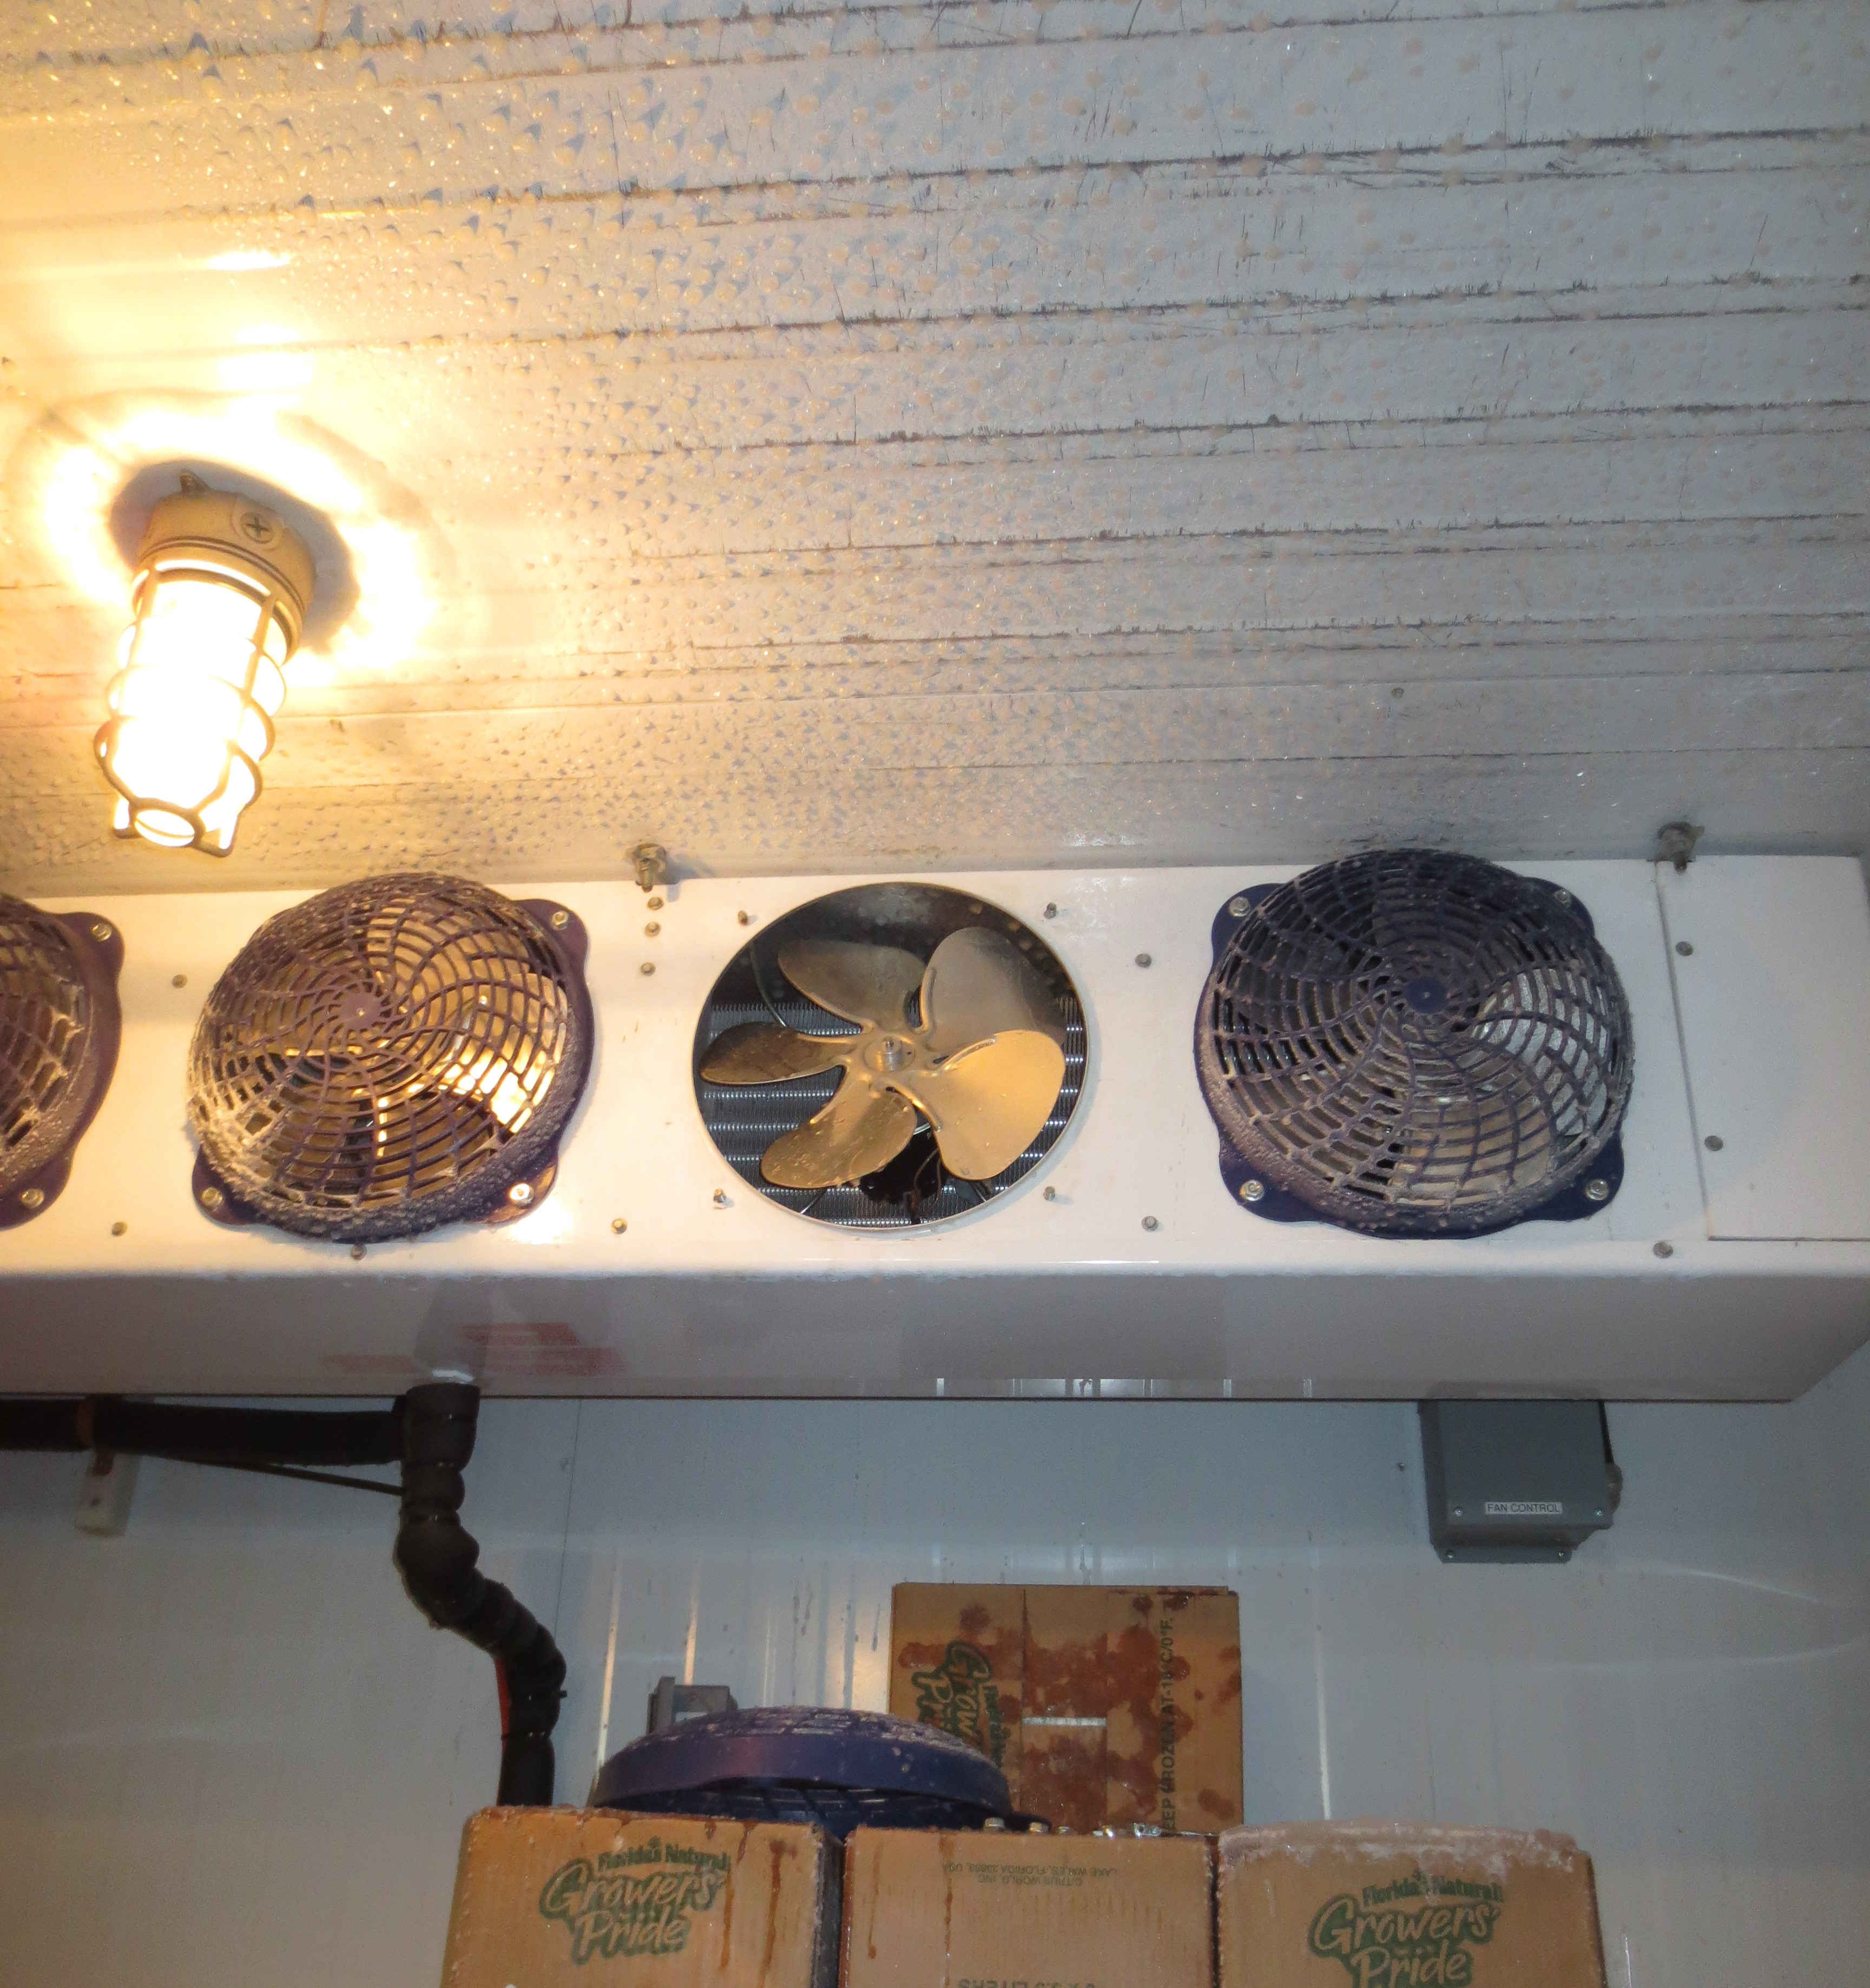 | Figure 3: Packaged Terminal Air Conditioning (PTAC) units may need to be serviced by the HVAC Technician.  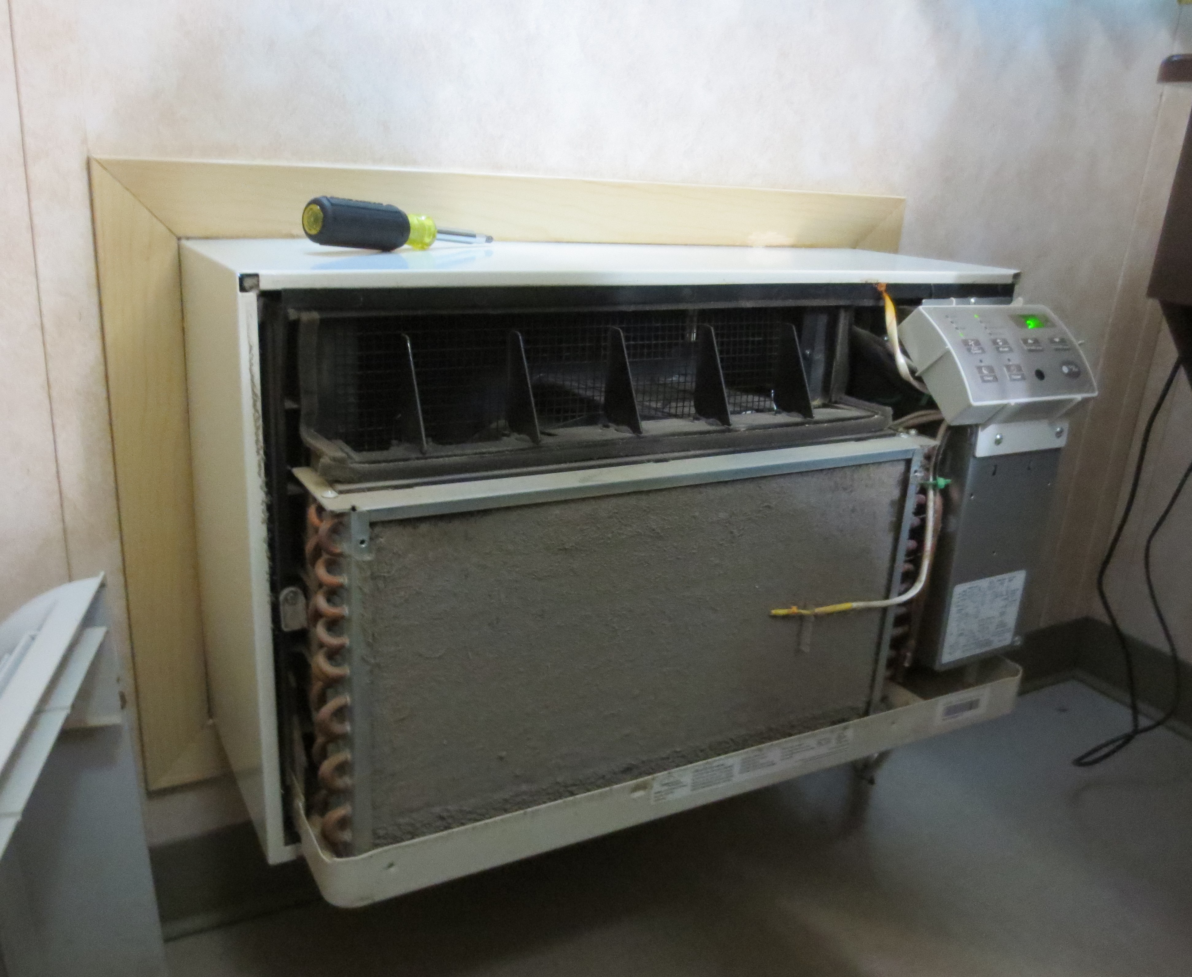
Richard Huynh, BScKin
Kinesiologist

SITE SPECIFIC JOB DEMAND ADDITIONS:

Job Demand | Frequency |  |  |  |  | Details/Measurements
 | N/R | R | O | F | C
Site Specific Job Demand:

Validation Agreement

Job Title: | HVAC Technician
Data Collection Date: | March 1, 2018

We the undersigned have reviewed the Physical Demands Analysis for this position and agree that the physical demands documented in this report are representative of the true demands of the tasks associated with the job title as assessed on the date listed above.

Completed by: |  | Insert Lifemark Clinician Name and Credentials
Approved by: |  | Management Representative
Approved by: |  | Worker Representative
Approved by: |  | Labour Provider Representative

