Physical Demands Analysis

HVAC (Hydrovac) Operator

Prepared for:
Construction Owners Association of Alberta

Job Title: | HVAC Operator | Assessment Location: |  | Data Collection Date:

Completed By: |  | Submitted on:

Disclaimer: | The Physical Demands noted in this report may vary depending on company and location. Please contact the company directly to confirm this physical demands analysis is an accurate representation of the specific job title for the specific location.

Work Schedule: | Shift Duration: 10 hours/day; may vary  Break Schedule: Total of 1 hour break per day  Shift Rotation: Not applicable  On call is required: Yes  Overtime required: No; but may be available

Education / Experience: | Education required: Class 3 Driver’s License  Hours required for position: N/A  Tickets that may be required (not limited to): Fall protection, H2S Alive, Wildlife awareness, Ground Disturbance, Confined Space, First Aid, WHIMIS, Construction Safety Training Systems (CSTS) and Basic Safety Orientation (BSO).

Labour Provider: | N/A

Job Overview: | An HVAC Operator is responsible for driving and operating an HVAC truck. Operators use pressurized water from the truck to dig trenches to locate pipes and utility lines for clients. Operators are trained in Field Level Hazard Assessments (FLHA), and are required to complete an FLHA each day. Additionally, they are responsible for inspecting, filling up, and dumping the HVAC truck.
 | % of shift | Job Task | Task Description
 | 10% | Safety/Truck Preparation | - The Operator will perform a walk around and visual inspection of the HVAC truck at the start of the shift.  - The Operator will fill the truck with clean water and fuel.  - An FLRA is completed and sign before starting any additional work.  - The FLHA is updated when there are changes to the tasks.
 | 80% | On site work | - The Operator will drive to various worksites. Locations are determined the day before, and may change throughout the day.  - Depending on the distance between the locations and the amount of work to be completed, the amount of driving per day may vary.  - When on site, the Operator will locate the dig site.  - Dig sites are marked with paint and flags before the Operator arrives on site.  - Signs are placed around the area to notify pedestrians and traffic of the work being completed.  - When digging, the Operator will use a controller to operate the hydraulic boom and digging wand.  - A suction tube (13 lbs) is mounted to the hydraulic boom, and is positioned at the dig site to remove debris and water.  - The digging wand (3 lbs) is connected to a clean water line and is used to create holes and trenches.  - The Operator will periodically switch with a HVAC Swamper. This is done to reduce repetition and fatigue.  - To a dig a deep trench, extensions may be added to the suction tube and digging wand.  - The dig is completed once the trench is dug to client specifications and pipes/utility lines are exposed.  - If the water tank is empty during or between digs, the Operator will need to drive offsite to fill up the tank.  - The Operator will call clients to confirm and determine the next worksites.
 | 10% | Dumping | - The Operator will dump the contents of the HVAC truck at a waste management site. This occurs when the truck is full of debris or at the end of the shift.

Equipment/  Tools: | - Hydraulic boom and controller  - Suction tube and extensions (13 lbs)  - Digging wand and extensions (3 lbs)  - Signage and pylons (1-5 lbs)  - Small hand tools such as mallets, wrenches, pliers (1-2 lbs)

Exposures / Environment: | - Flying debris  - Open holes  - Pipes and utility lines  - Vibrations  - Working alone  - Wildlife  - Hot temperatures  - Cold temperatures  - Rain  - Snow  - Ice  - Wind  - Loud noises  - Heights  - Dust and debris  - Overhead hazards  - Falling from heights

Personal Protective  Equipment Required: | - Hard hat  - Steel toed boots  - Gloves  - Safety vest or high visibility stripes  - Long sleeves and pants  - Hearing protection  - Face shield  - Rain pants
Personal Protective Equipment as Required: | - Foam safety eyewear (fectoggle)  - F/R coveralls  - Fall Protection

NOC STRENGTH LEVEL KEY
Strength Level | Definition
Limited (Lim) | Up to 5 kg (11 pounds)
Light (L) | 5 kg to 10 kg (11 – 22 pounds)
Medium (M) | 10 kg to 20 kg (22 – 44 pounds)
Heavy (H) | Greater than 20 kg (44 pounds plus)
*Strength Level Key based on the National Occupational Classification

FREQUENCY KEY
Frequency | % of Workday | Hours – Based on 8 hour Workday
Not Required (N/R) | 0% | 0
Rarely (R) | 1 – 5% | <25 min/day
Occasionally (O) | 6 – 33% | 25 min to 2 hours 40 min/day
Frequently (F) | 34 – 66% | 2 hours 41 min to 5 hours 17 min/day
Constantly (C) | 67 – 100% | 5 hours 18 min to 8 hours/day

*Frequency Key based on WCB Alberta Recommendations

Job Demand | Frequency / NOC Strength Level |  |  |  |  | Details/ Measurements
 | N/R | R | O | F | C

Material Handling:
Floor to Waist Level Lifting |  |  | L |  |  | - Lifting occurs when using tools, and signage.  - The Operator may also lift pieces of plywood or other coverings on the trench.
Knee to Waist Level Lifting |  |  | L |  |  | - As above.
Waist to Waist Level Lifting |  |  | L |  |  | - As above.
Waist to Chest Level Lifting |  |  |  | L |  | - Lifting occurs when retrieving, using, and storing tools such as the digging wand or suction tube.
Waist to Shoulder Level Lifting |  |  |  | L |  | - As above.
Waist to Overhead Level Lifting |  |  | L |  |  | - As above.
Front Carry |  |  | L |  |  | - Occurs when carrying signs, pylons, and tools around the worksite.
Right / Left-handed Carry (Dominant Hand) |  |  | L |  |  | - As above.
Shoulder Carry |  | L |  |  |  | - Remote hose/Dig tubes
Static  Pushing/Pulling (Force) |  |  |  | L |  | - Pushing and pulling is required when operating the digging wand.  - The amount of time spent operating the digging wand may vary depending on the amount of work and whether the Operator is working alone.
Dynamic  Pushing/Pulling (Force) |  |  |  | L |  | - As above.

Job Demand | Frequency |  |  |  |  | Details/Measurements
 | N/R | R | O | F | C

Upper Extremity Work:
Hand Gripping |  |  |  |  | X | - Occurs when gripping the steering wheel, digging wand, and other hand tools.
Pinch Gripping |  |  | X |  |  | - Occurs when gripping pens and small hand tools.
Upper Extremity Coordination |  |  |  |  | X | - Occurs when driving, digging, and other onsite tasks.
Reaching Forward |  |  |  |  | X | - As above.
Overhead Shoulder Level Reaching |  |  | X |  |  | - Occurs when reaching for tools stored in the truck, operating a digging wand, and reaching for switches and levers.  - The Operator may need to reach overhead when entering the truck.
Below Shoulder Level Reaching |  |  |  |  | X | - Occurs when reaching for tools stored in the truck, operating a digging wand, reaching for switches and levers, and lifting tools and supplies.
Throwing | X

Job Demand | Frequency |  |  |  |  |  | Details/Measurements
 | N/R |  | R | O | F | C
Positional Work:
Trunk Flexion (Bending) |  |  |  |  | X |  | - Occurs when operating the digging wand and lifting.  - The amount of trunk flexion may vary from Operator to Operator.  - An Operator may prefer to use extensions as opposed to bending over when digging deep trenches.
Trunk Rotation (Twisting) |  |  |  | X |  |  | - May occur when operating the digging wand and checking mirrors while driving.
Kneeling |  |  |  | X |  |  | - Occurs when operating the digging wand and digging a deep trench.  - The amount of kneeling may vary from operator to operator.  - An Operator may prefer to use extensions as opposed to kneeling when digging deep trenches.
Crawling |  | X
Crouching |  |  |  | X |  |  | - Occurs when operating the digging wand and digging a deep trench.  - The amount of crouching may vary from operator to operator.  - An Operator may prefer to use extensions as opposed to crouching when digging deep trenches.
Squatting |  |  |  | X |  |  | - Occurs when lifting and operating the digging wand digging a deep trench.
Neck Flexion |  |  |  |  |  | X | - Occurs when looking down into a trench to observe for pipes and utility lines.  - The amount of neck flexion may vary depending on the amount of work and if the Operator is working alone.
Neck Extension |  |  |  | X |  |  | - Occurs when looking up at the hydraulic boom.
Neck Rotation |  |  |  | X |  |  | - Occurs when scanning the worksite and checking mirrors while driving.

Job Demand | Frequency |  |  |  |  | Details/Measurements
 | N/R | R | O | F | C
Static Work:
Sitting |  |  | X |  |  | - Occurs when driving.
Static Standing |  |  |  | X |  | - Occurs when operating the digging wand.  - The amount of static standing may vary depending on the amount of work, whether the Operator is working alone, and the depth of the trench.  - The Operator may crouch or kneel for deeper trenches.
Balancing |  |  | X |  |  | - Occurs when the Operator climbs on top of the truck.  - The Operator will need to climb on the truck when they have issues with the boom.  - Occurs when the Operator is working on uneven surfaces.

Job Demand | Frequency |  |  |  |  | Details/Measurements
 | N/R | R | O | F | C
Ambulation:
Walking: Level Surfaces |  |  | X |  |  | - Occurs on level ground and paved roads/sidewalks.
Walking: Uneven Surfaces |  |  | X |  |  | - Occurs on the side of the road.
Walking: Slopes |  |  | X |  |  | - As above.
Jumping |  | X |  |  |  | - Occurs when jumping off the back step of the truck.
Running | X

Job Demand | Frequency |  |  |  |  | Details/Measurements
 | N/R | R | O | F | C
Climbing:
Stairs |  |  | X |  |  | - Occurs when climbing in and out of truck.
Ladder |  | X |  |  |  | - Occurs when climbing to the top of the truck.
Other | X

PHOTOS OF TASKS AND WORK ENVIRONMENT

Figure 1: The Operator will drive the HVAC truck to designated work sites. The truck is equipped with a hydraulic boom and multiple compressors.  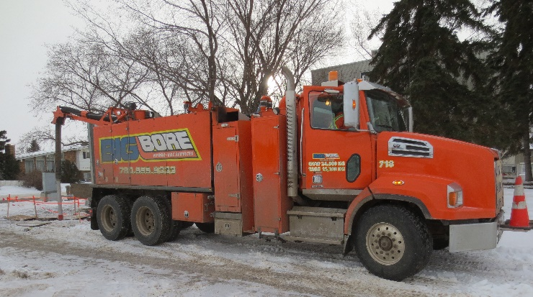 | Figure 2: A suction tube is attached to the end of the boom to remove debris while the Operator is digging.  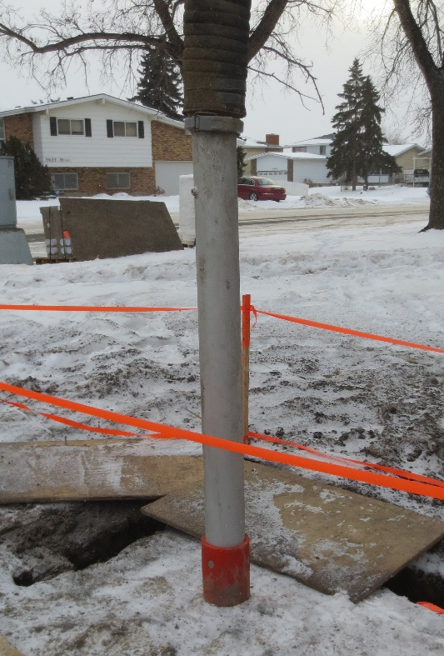

Figure 3: Signs are placed around the work area to inform traffic and pedestrians.  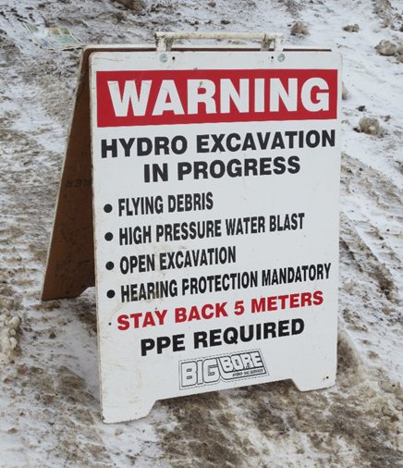 | Figure 4: The Operator digs a trench using a digging wand. Depending on the job, the amount time spending digging may vary.  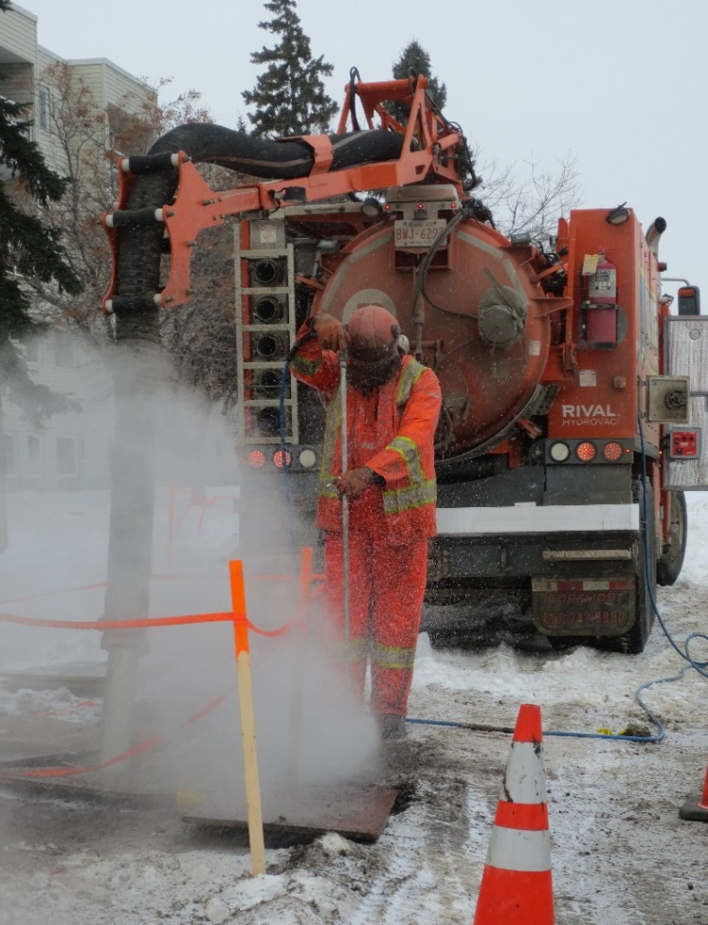

Figure 5: An Operator is crouching to dig a deep trench. The Operator can use an extension on the digging wand instead of crouching.  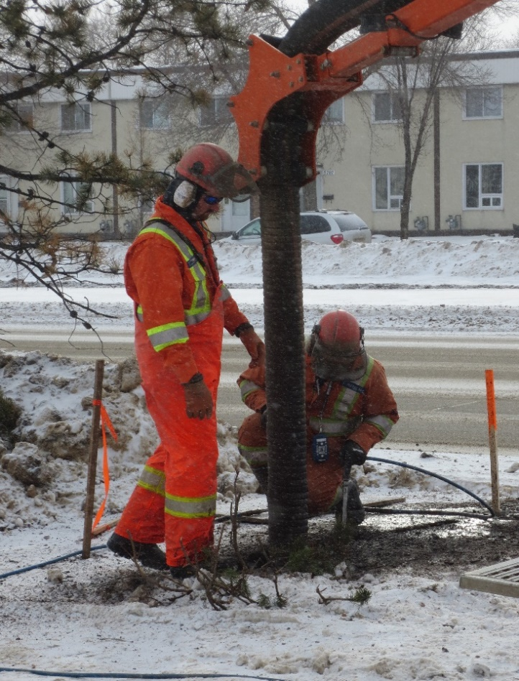 | Figure 6: After dumping the contents of the tank, the Operator uses pressurized water to clean the inside of the tank.  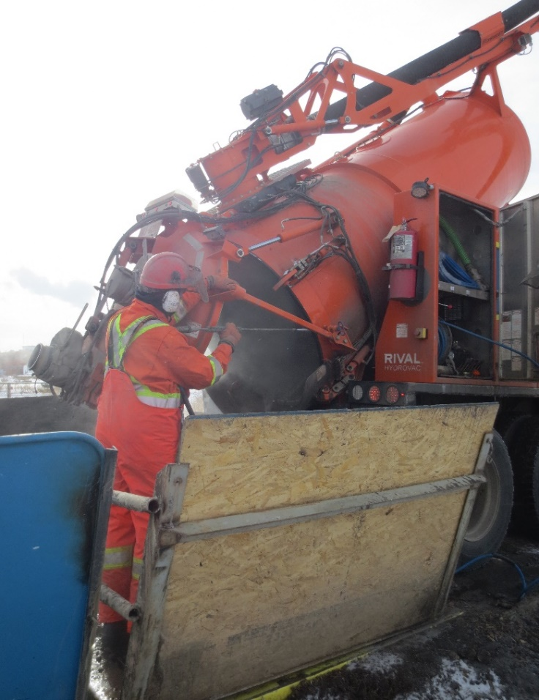

__________________________
Richard Huynh, BScKin
Kinesiologist

SITE SPECIFIC JOB DEMAND ADDITIONS:

Job Demand | Frequency |  |  |  |  | Details/Measurements
 | N/R | R | O | F | C
Site Specific Job Demand:

Validation Agreement

Job Title:
Data Collection Date:

We the undersigned have reviewed the Physical Demands Analysis for this position and agree that the physical demands documented in this report are representative of the true demands of the tasks associated with the job title as assessed on the date listed above.

Completed by: |  | Insert Lifemark Clinician Name and Credentials
Approved by: |  | Management Representative
Approved by: |  | Worker Representative
Approved by: |  | Labour Provider Representative

