Physical Demands Analysis

Gas Fitter

Prepared for:
Construction Owners Association of Alberta

Job Title: | Gas Fitter | Assessment Location: |  | Data Collection Date:

Completed By: |  | Submitted on:

Disclaimer: | The Physical Demands noted in this report may vary depending on company and location. Please contact the company directly to confirm this physical demands analysis is an accurate representation of the specific job title for the specific location.

Work Schedule: | Shift Duration: 12 hours/day; may vary  Break Schedule: Total of 1 hour break per day  Shift Rotation: 14 days on, 14 days off  On call is required: Yes; during the evening  Overtime required: No; but is often available

Education / Experience: | Education required: Journeyman Gas Fitter Certificate. To obtain this, they must complete a 4-year apprenticeship program. The in-class portion is 8 weeks for the first 3 years; and 12 weeks in the fourth year.  Hours required for position: ~1500 hours  Tickets that may be required (not limited to): Fall protection, H2S Alive, Wildlife awareness, Ground Disturbance, Elevated Work Platform (EWP) machinery use, Confined Space, First Aid, WHMIS, Construction Safety Training Systems (CSTS) and Basic Safety Orientation (BSO).

Labour Provider: | N/A

Job Overview: | The Gas Fitter works with pipes, valves, pumps, and fixtures containing and transporting gases such as propane. They are responsible for installing new gas fixtures as well as maintaining and repairing current ones. Tasks are generated and logged through Electronically Generated Services (EGS). The Gas Fitter is trained in Field Level Hazard Assessments (FLHA), and may work alongside laborers or other maintenance staff. Their days are unpredictable because mechanical issues and troubleshooting may take priority over other tasks.
 | % of shift | Job Task | Task Description
 | 10% | Safety/meetings | - Toolbox talk – Safety topics are discussed during the toolbox talk. The Gas Fitter will receive additional information such as:  - Tasks for the day  - Important events from previous shifts  - A FLHA is completed and signed before starting any work where hazards are present.  - The FLHA is updated when there are changes to the tasks.
 | 90% | On site work | - Daily checks – The Gas Fitter will follow a checklist and perform inspections on meters, pumps, and valves.  - Some walking outside may be required.  - Values are recorded and filed electronically.  - Selecting Electronic Generated Services (EGS) – EGS are accessed on the computer.  - EGS are selected and printed.  - Some EGS may take priority over others.  - Some EGS may require several days to complete due to the ordering of parts.  - Completing EGS  - EGS may need to be completed indoors and/or outdoors.  - Indoors – staff, guest, and common areas.  - Outdoors – building exterior such as on the roof or the side of the building.  - The Gas Fitter will need to collect necessary tools and parts to complete the EGS.  - The Gas Fitter may need to climb stairs, ladders, or drive to access the work area.  - The Gas Fitter will troubleshoot and repair the issue, or install new fixtures indicated by the EGS.  - They may need to repair or install propane lines, steam pipes, fuel lines, vaporizers, and/or hot water tanks.  - Other maintenance staff members may need to assist.  - High voltage areas (>24V) will require the assistance of an Electrician.  - Preventative maintenances (PM) are performed when possible.  - When performing a PM, the Gas Fitter may work alongside other maintenance staff.  - High voltage areas (>24V) will require the assistance of an Electrician.  - A checklist is followed when performing the maintenance.  - A PM may consist of the following:  - Ensuring power is cut off.  - Gaining access to pipes, valves, and pumps.  - Checking the condition of pipes, valves, and pumps.  - Cleaning debris and dust using compressed air, a rag, and/or a vacuum.  - Testing the operation of the pipes, valves, or pumps.  - Completing paperwork – paperwork for daily checks, EGS, PMs, orders, and hours.

Equipment/  Tools: | - Small hand tools, such as wrenches and screwdrivers (~1 lbs)  - Power drill (~4-5 lbs)  - Tool bag (25 lbs when full)  - Step ladder (~7 lbs)  - 10 foot ladder (~30 lbs)  - Rags

Exposures / Environment: | - Compressed air  - Gases under pressure, such as steam and propane  - H2S gas  - High voltage equipment  - Hot temperatures  - Cold temperatures  - Working from heights  - Pinch points  - Rain  - Snow  - Ice  - Wind  - Overhead hazards

Personal Protective  Equipment Required: | - Steel toed boots  - Foam safety eyewear (fectoggle)  - Long sleeves and pants
Personal Protective  Equipment as Required: | - Hard hat  - Gloves  - Safety vest or high visibility stripes  - H2S monitor

NOC STRENGTH LEVEL KEY
Strength Level | Definition
Limited (Lim) | Up to 5 kg (11 pounds)
Light (L) | 5 kg to 10 kg (11 – 22 pounds)
Medium (M) | 10 kg to 20 kg (22 – 44 pounds)
Heavy (H) | Greater than 20 kg (44 pounds plus)
*Strength Level Key based on the National Occupational Classification

FREQUENCY KEY
Frequency | % of Workday | Hours – Based on 8 hour Workday
Not Required (N/R) | 0% | 0
Rarely (R) | 1 – 5% | <25 min/day
Occasionally (O) | 6 – 33% | 25 min to 2 hours 40 min/day
Frequently (F) | 34 – 66% | 2 hours 41 min to 5 hours 17 min/day
Constantly (C) | 67 – 100% | 5 hours 18 min to 8 hours/day

*Frequency Key based on WCB Alberta Recommendations

Job Demand | Frequency / NOC Strength Level |  |  |  |  | Details/ Measurements
 | N/R | R | O | F | C

Material Handling:
Floor to Waist Level Lifting |  | H | M | Lim |  | - Heavy lifting may occur with machinery and appliances such as washing machines and dryers (>44 lbs)  - A laborer or another maintenance staff member can assist with heavy lifting.  - Medium level lifting may occur with (but not limited to):  - Tool bag (25 lbs when full)  - 10 foot ladder (30 lbs)  - Limited level lifting may occur with (but not limited to):  - Small hand tools (~1 lbs)  - Power drill (4-5 lbs)  - Rags (< 1 lbs)
Knee to Waist Level Lifting |  | H | M | Lim |  | - As above
Waist to Waist Level Lifting |  | H | M | Lim |  | - As above
Waist to Chest Level Lifting |  |  |  | Lim |  | - Limited level lifting may occur with (but not limited to):  - Small hand tools (~1 lbs)  - Power drill (4-5 lbs)  - Rags (< 1 lbs)
Waist to Shoulder Level Lifting |  |  | Lim |  |  | - As above
Waist to Overhead Level Lifting |  |  | Lim |  |  | - As above
Front Carry |  | H | M |  |  | - Heavy level carrying may occur with machinery and appliances such as washing machines and dryers (>44 lbs)  - A laborer or another maintenance staff member will assist with heavy carrying.  - Medium level carrying may occur with (but not limited to):  - Tool bag (25 lbs when full)  - 10 foot ladder (30 lbs)
Right / Left-handed Carry (Dominant Hand) |  |  | M | Lim |  | - Medium level carrying may occur with (but not limited to) the tool bag (25 lbs when full).  - Limited level carrying may occur with (but not limited to):  - Small hand tools (~1 lbs)  - Power drill (4-5 lbs)  - Rags (< 1 lbs)
Shoulder Carry |  |  | M |  |  | - Medium level carrying may occur when using a shoulder strap to carry the tool bag.
Static  Pushing/Pulling (Force) |  |  | L |  |  | - Holding fixtures and parts in place during installation.
Dynamic  Pushing/Pulling (Force) |  |  | H |  |  | - Pushing and pulling appliances and machines to access pumps, valves, and gas fittings.

Job Demand | Frequency |  |  |  |  | Details/Measurements
 | N/R | R | O | F | C

Upper Extremity Work:
Hand Gripping |  |  |  | X |  | - When lifting and carrying.  - When using tools to install or repair fixtures.  - When driving.
Pinch Gripping |  |  |  | X |  | - Gripping small parts when repairing or installing fixtures.  - When using a pen to complete paperwork.
Upper Extremity Coordination |  |  |  | X |  | - When lifting and carrying.  - When using tools to install or repair fixtures.  - When driving.
Reaching Forward |  |  |  | X |  | - As above
Overhead Shoulder Level Reaching |  |  | X |  |  | - When using tools to install or repair fixtures.
Below Shoulder Level Reaching |  |  |  | X |  | - When lifting and carrying.  - When using tools to install or repair fixtures.
Throwing | X

Job Demand | Frequency |  |  |  |  |  | Details/Measurements
 | N/R |  | R | O | F | C
Positional Work:
Trunk Flexion (Bending) |  |  |  |  | X |  | - When lifting.  - When working on low-level gas lines and pipes.  - Depending on the EGS or PM, the Gas Fitter may need to spend time in many different positions.
Trunk Rotation (Twisting) |  |  |  | X |  |  | - When working on gas lines behind equipment and in tight spaces.
Kneeling |  |  |  | X |  |  | - When working on low-level gas lines and pipes.
Crawling |  |  | X |  |  |  | - When completing EGS underneath the building or at low levels.
Crouching |  |  |  | X |  |  | - When working on low-level gas lines and pipes.
Squatting |  |  |  |  | X |  | - When lifting.
Neck Flexion |  |  |  |  | X |  | - When working on low-level gas lines.
Neck Extension |  |  |  | X |  |  | - When working on overhead gas lines and pipes.
Neck Rotation |  |  |  | X |  |  | - When working on gas lines behind equipment and in tight spaces.

Job Demand | Frequency |  |  |  |  | Details/Measurements
 | N/R | R | O | F | C
Static Work:
Sitting |  |  | X |  |  | - When completing paperwork and/or driving.
Static Standing |  |  |  | X |  | - When completing various EGS or PMs.
Balancing |  |  | X |  |  | - When using a ladder.

Job Demand | Frequency |  |  |  |  | Details/Measurements
 | N/R | R | O | F | C
Ambulation:
Walking: Level Surfaces |  |  |  |  | X | - Walking indoors.
Walking: Uneven Surfaces |  |  | X |  |  | - Walking outside.  - There may be snow, ice, mud, and gravel present.
Walking: Slopes |  |  | X |  |  | - As above.
Jumping | X
Running | X

Job Demand | Frequency |  |  |  |  | Details/Measurements
 | N/R | R | O | F | C
Climbing:
Stairs |  |  |  | X |  | - Stairs indoors and outdoors.
Ladder |  |  | X |  |  | - Ladders indoors and outdoors.
Other | X

PHOTOS OF TASKS AND WORK ENVIRONMENT

Figure 1: Gas and water lines may need to be serviced. They are accessed through the mechanical room.  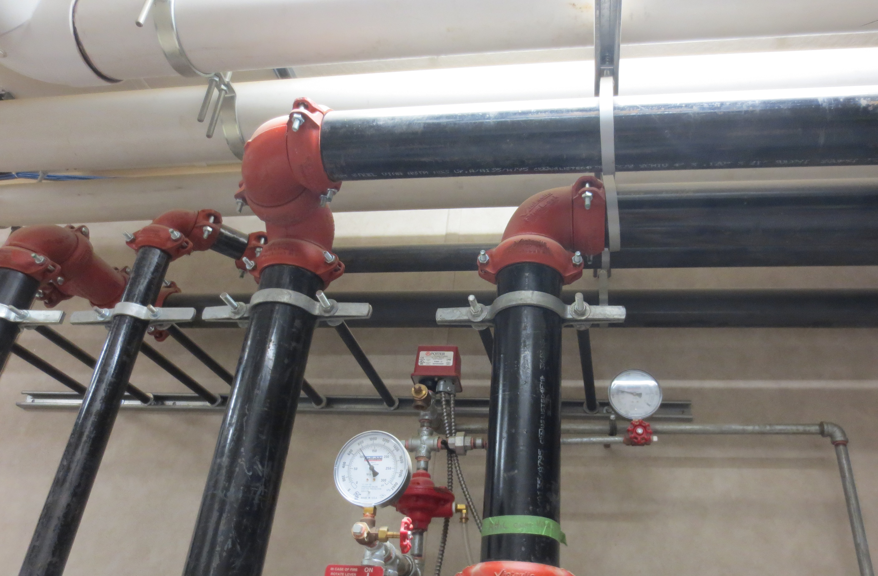 | Figure 2: A Gas Fitter may repair kitchen appliances such as the steamer. The Gas Fitter will need to crouch or kneel to access low-level pipes and valves.  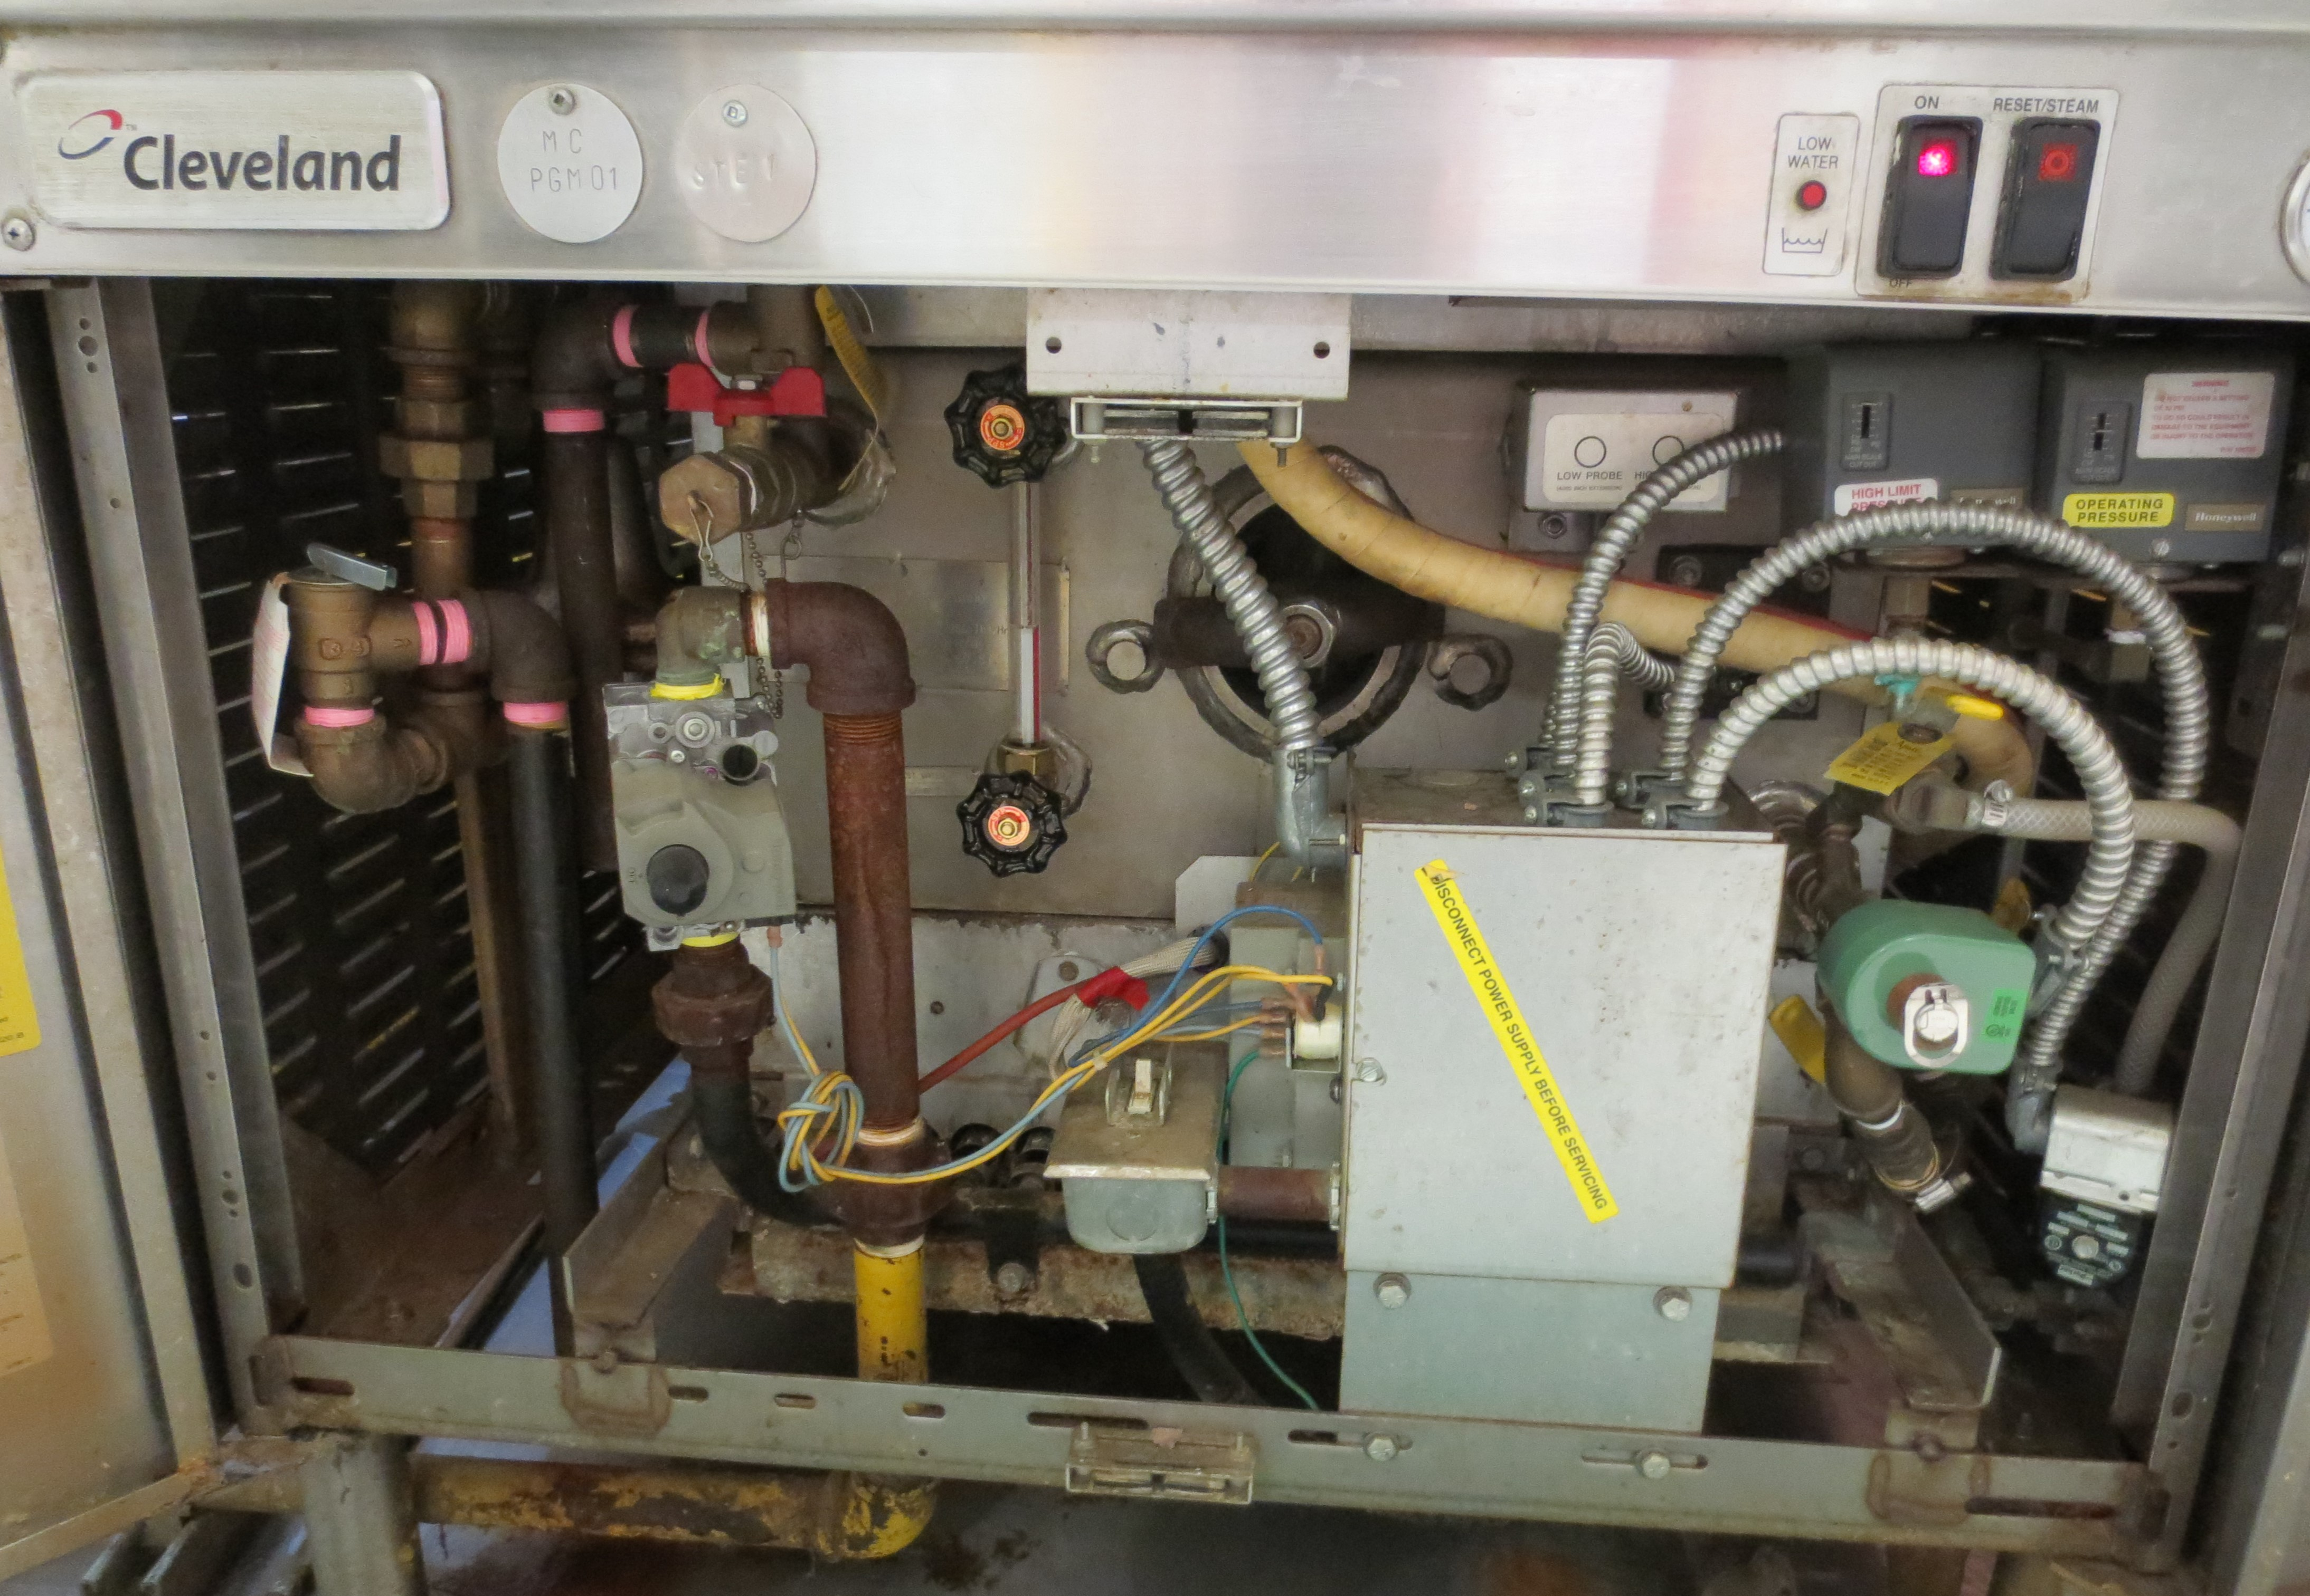
Figure 3: A Gas Fitter may repair kitchen appliances such as the steamer. The Gas Fitter will need to twist to access pipes and valves in tight spaces.  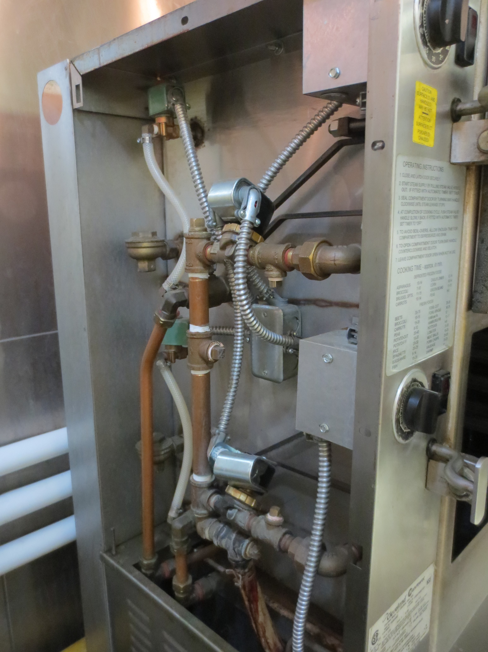 | Figure 3: Some service requests will require the Gas Fitter to drive. A company truck will be used to travel to different work areas.  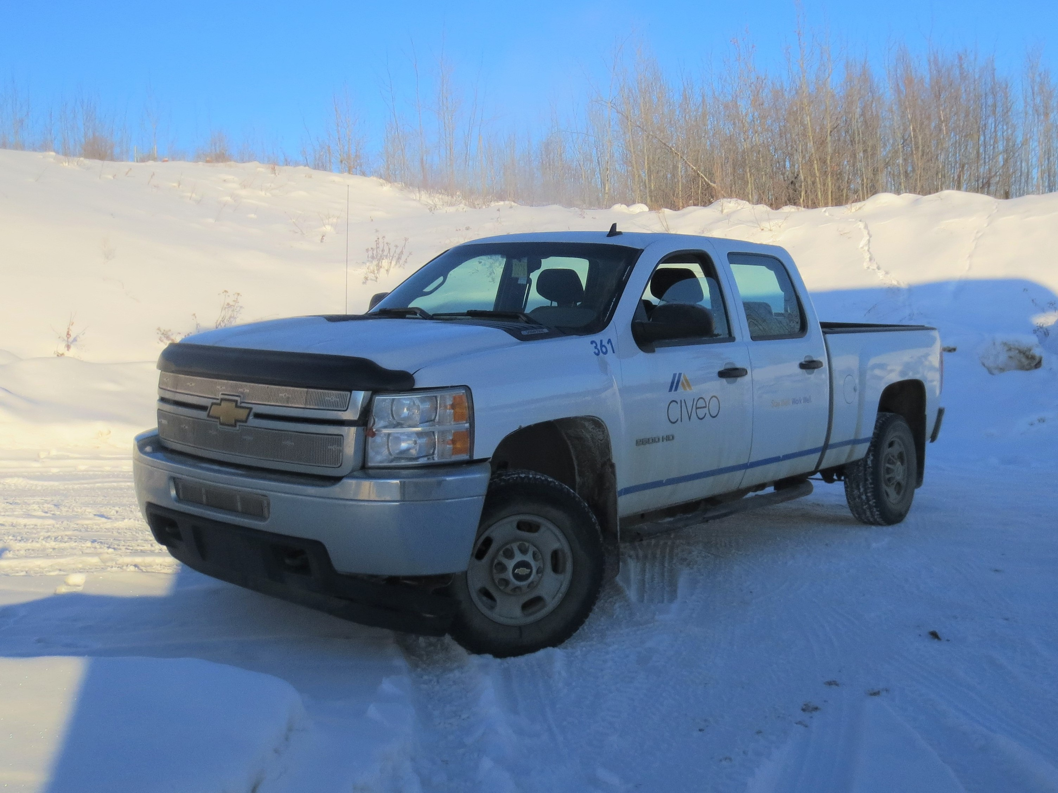
Richard Huynh, BScKin
Kinesiologist

SITE SPECIFIC JOB DEMAND ADDITIONS:

Job Demand | Frequency |  |  |  |  | Details/Measurements
 | N/R | R | O | F | C
Site Specific Job Demand:

Validation Agreement

Job Title: | Gas Fitter
Data Collection Date: | February 28, 2018

We the undersigned have reviewed the Physical Demands Analysis for this position and agree that the physical demands documented in this report are representative of the true demands of the tasks associated with the job title as assessed on the date listed above.

Completed by: |  | Richard Huynh, Kinesiologist
Approved by: |  | Management Representative
Approved by: |  | Worker Representative
Approved by: |  | Labour Provider Representative

