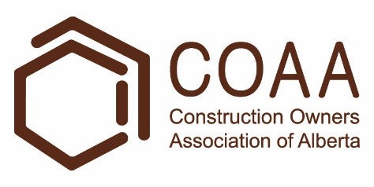 | Physical Demands Analysis  Glazier  Prepared for:  Construction Owners Association of Alberta

Job Title: | Glazier | Assessment Location: |  | Data Collection Date:

Completed By: |  | Submitted on:

Disclaimer: | The Physical Demands noted in this report may vary depending on company and location. Please contact the company directly to confirm this physical demands analysis is an accurate representation of the specific job title for the specific location.

Work Schedule: | Shift Duration: 5 days/week, 8 hours/day; may vary  Break Schedule: Total of 45 minute break per day; may vary  Shift Rotation: Not applicable  On call is required: No  Overtime required: No; but may be available

Education / Experience: | Education required: Glazier Apprenticeship or Journeyman certificate, or equivalent training. To obtain their Journeyman certificate, they must complete a 4 year apprenticeship program. The in-class portion is 8 weeks for the first 3 years, and 12 weeks in the fourth year.  Hours required for position: ~1500 hours  Tickets that may be required (not limited to): Fall protection, Elevated Work Platform (EWP) machinery use, Fall Rescue Training, Forklift Training, Telehandler Training, Swing Stage Training, First Aid, WHIMIS, Construction Safety Training Systems (CSTS) and Basic Safety Orientation (BSO).

Labour Provider: | N/A

Job Overview: | The Glazier is responsible for constructing and installing curtain walls and windows. The Glazier can work on building exteriors or interiors, and they can work on new buildings or renovations. Their tasks include (but not limited to) framing, glazing, and installing flashing. The glazier will complete tasks such as framing and glazing for the majority of the project. Installing flashing will be completed at the end of the project.  *A Glazier’s day and the physical demands will vary depending on the specific project and the current stage of the project.
 | % of shift | Job Task | Task Description
 | 0-10% | Safety and meetings | - Toolbox talk – Safety topics are discussed during the toolbox talk. The Glazier will receive additional information such as tasks for the day and important events from previous shifts  - A Field Level Hazard Assessment (FLHA) is completed and signed before starting any work where hazards are present.  - The FLHA is updated when there are changes to the tasks.
 | 0-30% | Work site set up | - Unloading supplies and materials such as glass panels.  - The Glazier will use machines such as forklifts or telehandlers to assist loading and unloading.  - The Glazier will typically use drywall carts to move glass and metal panels.  - Depending on the situation, the Glazier may need to manually lift panels using a suction cup.  - Scaffolding or swing stages may need to be set up.  - This will depend on the stage and scale of the project.
 | 0-80% | Framing | - Installing fixing plates and anchors.  - Fixing plates are fastened to the floor using bolts.  - Anchors are used to provide additional support for aluminum mullions.  - Assembling and installing frames.  - Studs or mullions are measured, cut, and assembled to form a frame for panels of glass or metal.  - Depending on the project, the studs may be reinforced with steel.  - The Glazier will use various tools such as mallets and power drills to set aluminum frames into fixing plates.
 | 0-80% | Glazing | - Inserting infills into frames.  - The Glazier will set panels of glass or metal into the frames.  - Depending on the project, they may work on a swing stage.  - The Glazier may lift panels by hand or machine.  - When lifting by hand they will use suction cups.  - When using machines, such as a crane, they will use a power cup.  - The Glazier will hold the panel in place while pressure plates installed.  - The pressure plates will secure the panels onto the frame.  - The Glazier may install unitized curtain walls.  - Unitized curtain walls are pre-fabricated and are installed using anchors mounted onto the floor.  - Curtain wall assemblies are typically installed with the aid of a crane or lift.
 | 0-80% | Flashing | - Silicone is used to seal joints and edges.  - The glazier will install capping plates, membranes, and flashing to complete the installation.

Equipment/  Tools: | - Hand tools such as pry bars and mallets (~1-3 lbs).  - Caulking gun (~3 lbs)  - Suction cup (~2-3 lbs)  - Handheld power tools such as hammer drills and power shears (~3-5 lbs)  - Swing stage counter weights (55 lbs)  - Power cup (70 lbs)

Exposures / Environment: | - Hot Temperatures  - Cold Temperatures  - Varying weather conditions (such as strong winds and rain)  - Sharp edges  - Pinch points  - Working from heights  - Overhead hazards

Personal Protective  Equipment Required: | - Hard hat  - Steel toed boots  - Foam safety eyewear (fectoggle)  - Safety vest or high visibility stripes
Personal Protective  Equipment as Required: | - Fall protection  - Gloves

NOC STRENGTH LEVEL KEY
Strength Level | Definition
Limited (Lim) | Up to 5 kg (11 pounds)
Light (L) | 5 kg to 10 kg (11 – 22 pounds)
Medium (M) | 10 kg to 20 kg (22 – 44 pounds)
Heavy (H) | Greater than 20 kg (44 pounds plus)
*Strength Level Key based on the National Occupational Classification

FREQUENCY KEY
Frequency | % of Workday | Hours – Based on 8 hour Workday
Not Required (N/R) | 0% | 0
Rarely (R) | 1 – 5% | <25 min/day
Occasionally (O) | 6 – 33% | 25 min to 2 hours 40 min/day
Frequently (F) | 34 – 66% | 2 hours 41 min to 5 hours 17 min/day
Constantly (C) | 67 – 100% | 5 hours 18 min to 8 hours/day

*Frequency Key based on WCB Alberta Recommendations

Job Demand | Frequency / NOC Strength Level |  |  |  |  | Details/ Measurements
 | N/R | R | O | F | C

Material Handling:
Floor to Waist Level Lifting |  |  | H |  |  | *All manual handling will depend on the stage of the project.  - Occurs when lifting equipment and materials.  - The amount of heavy lifting will vary depending on the stage of the project and task at hand.  - Heavy level lifting may include (but not limited to):  - Glass or metal panels  - Panels can weigh over 200 lbs.  - The Glazier will get assistance when lifting heavy panels.  - Power cup (70 lbs)  - Medium level lifting may include (but not limited to):  - Box of silicone (~35 lbs)  - Full box of gasket (~25 lbs)  - 50”x50” Aluminum panel (~40 lbs)  - Limited level lifting may include (but not limited to) hand tools and short lengths of material.
Knee to Waist Level Lifting |  |  | H |  |  | - As above.
Waist to Waist Level Lifting |  |  | H |  |  | - As above.
Waist to Chest Level Lifting |  |  | H |  |  | - Occurs when lifting equipment and material.  - Heavy level lifting may include (but not limited to) power cups and panels (70 lbs).  - Medium level lifting may include (but not limited to) bundles of materials such as pressure plates (25-44 lbs).  - Limited level lifting may include (but not limited to) hand tools and short lengths of material.
Waist to Shoulder Level Lifting |  |  | M |  |  | - Occurs when lifting equipment and material.  - Medium level lifting may include (but not limited to) bundles of materials such as pressure plates (25-44 lbs).  - Limited level lifting may include (but not limited to) hand tools and short lengths of material.
Waist to Overhead Level Lifting |  |  | M |  |  | - As above.
Front Carry |  |  | H |  |  | - Occurs when carrying equipment and material.  - The amount of heavy carrying will vary depending on the stage of the project and task at hand.  - Heavy level carrying may include (but not limited to):  - Glass or metal panels  - Panels can weigh over 200 lbs.  - The Glazier will get assistance when carrying heavy panels.  - Power cup (70 lbs)  - Medium level carrying may include (but not limited to):  - Box of silicone (~35 lbs)  - Full box of gasket (~25 lbs)  - 50”x50” Aluminum panel (~40 lbs)  - Limited level carrying may include (but not limited to) hand tools and short lengths of material.
Right / Left-handed Carry (Dominant Hand) |  |  | H |  |  | - Occurs when carrying equipment and material.  - Heavy level carrying may occur when using suction cups to carry panels (>44 lbs).  - Medium level carrying may include (but not limited to) their tool bag (~35 lbs).  - Limited level carrying may include (but not limited to) hand tools and short lengths of material.
Shoulder Carry |  |  | M |  |  | - Medium level lifting may include (but not limited to) bundles of materials such as pressure plates (25-44 lbs).
Static  Pushing/Pulling (Force) |  |  | H |  |  | - Occurs when securing panels against an aluminum frame.  - The glazier will hold the panel in place while pressure plates are installed.
Dynamic  Pushing/Pulling (Force) |  |  | H |  |  | - Occurs when using tools, such as pushing/pulling on a pry bar.  - Occurs when moving equipment and materials, such as pushing drywall carts.

Job Demand | Frequency |  |  |  |  | Details/Measurements
 | N/R | R | O | F | C

Upper Extremity Work:
Hand Gripping |  |  |  | X |  | - Occurs when gripping tools and materials, such as suction cups and pressure plates.
Pinch Gripping |  |  | X |  |  | - Occurs when gripping fasteners and writing utensils.
Upper Extremity Coordination |  |  |  | X |  | - Occurs when manipulating equipment and material.
Reaching Forward |  |  |  | X |  | - Occurs when using tools and reaching for materials.
Overhead Shoulder Level Reaching |  |  | X |  |  | - As above.
Below Shoulder Level Reaching |  |  |  | X |  | - As above.
Throwing | X

Job Demand | Frequency |  |  |  |  |  | Details/Measurements
 | N/R |  | R | O | F | C
Positional Work:
Trunk Flexion (Bending) |  |  |  | X |  |  | - Occurs when lifting and during job specific tasks such as installing membranes and plates at low levels.
Trunk Rotation (Twisting) |  |  |  | X |  |  | - Occurs when moving equipment and materials around the work site.
Kneeling |  |  |  | X |  |  | - Occurs during job specific tasks such as installing membranes and plates at low levels.
Crawling |  |  |  | X |  |  | - As above.
Crouching |  |  |  | X |  |  | - As above.
Squatting |  |  |  | X |  |  | - Occurs when lifting.
Neck Flexion |  |  |  |  | X |  | - Occurs when installing fixing plates, membranes, monitoring surroundings, and inspecting work.
Neck Extension |  |  |  |  | X |  | - Occurs when monitoring surroundings, and inspecting work.
Neck Rotation |  |  |  |  | X |  | - As above.

Job Demand | Frequency |  |  |  |  | Details/Measurements
 | N/R | R | O | F | C
Static Work:
Sitting | X
Static Standing |  |  |  | X |  | - Occurs when framing and glazing.
Balancing |  |  | X |  |  | - Working on swing stages or elevated platforms.

Job Demand | Frequency |  |  |  |  | Details/Measurements
 | N/R | R | O | F | C
Ambulation:
Walking: Level Surfaces |  |  |  | X |  | - Walking on site floors.
Walking: Uneven Surfaces |  |  | X |  |  | - Walking outside when working on building exteriors.
Walking: Slopes |  |  | X |  |  | - Walking on slopes is site dependant.
Jumping | X
Running | X

Job Demand | Frequency |  |  |  |  | Details/Measurements
 | N/R | R | O | F | C
Climbing:
Stairs |  |  | X |  |  | - Walking up to various building levels.  - The amount of stairs is site dependant.
Ladder |  |  | X |  |  | - Climbing up scaffolds or ladders.  - The amount of ladders is site dependant.
Other | X

PHOTOS OF TASKS AND WORK ENVIRONMENT

Figure 1: The Glazier will need to move large panels of glass and metal to their worksite when constructing a curtain wall.  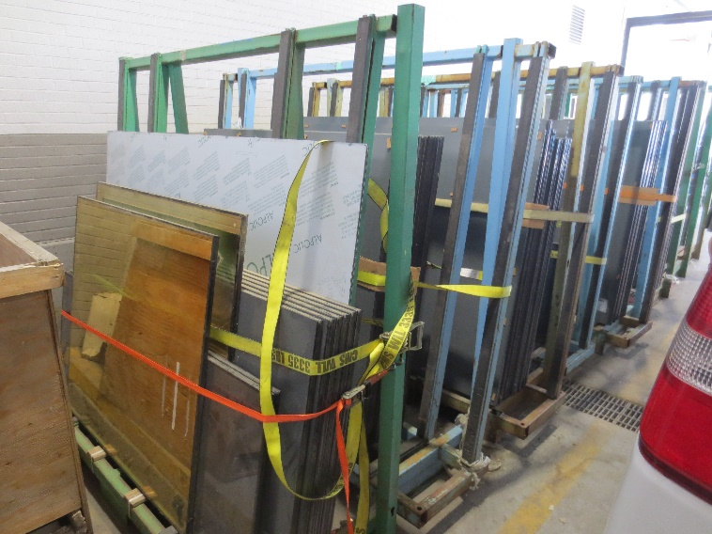 | Figure 2: The Glazier will use suction cups when handling panels.  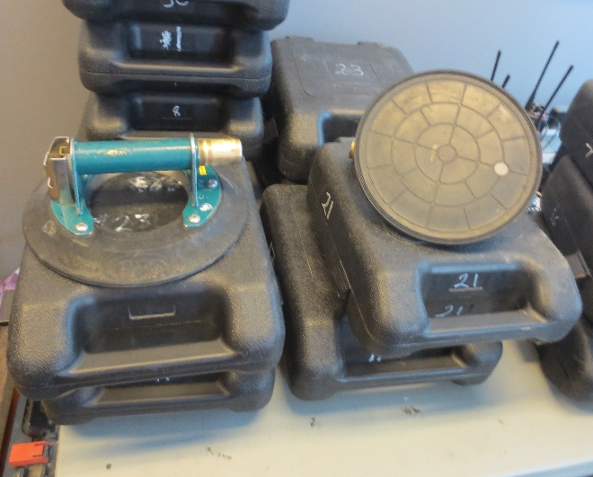
Figure 3: The Glazier will use a power cup (with the assistance of a crane) when handling large and heavy panels.  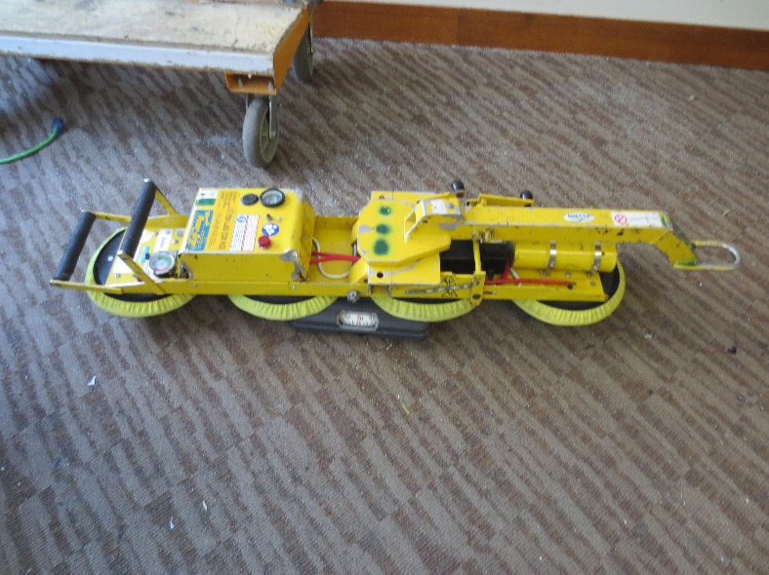 | Figure 4: A Glazier is installing flashing while on scaffolding. They may use a swing stage, scaffolding, or elevated work platform.  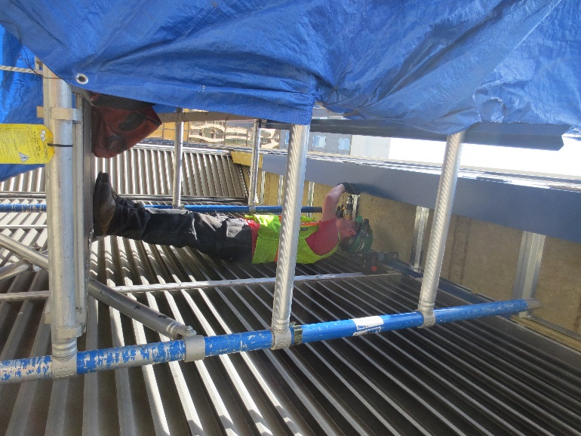

Figure 5: Pressure plates are used to hold panels in place. They are secured using screws and glue.  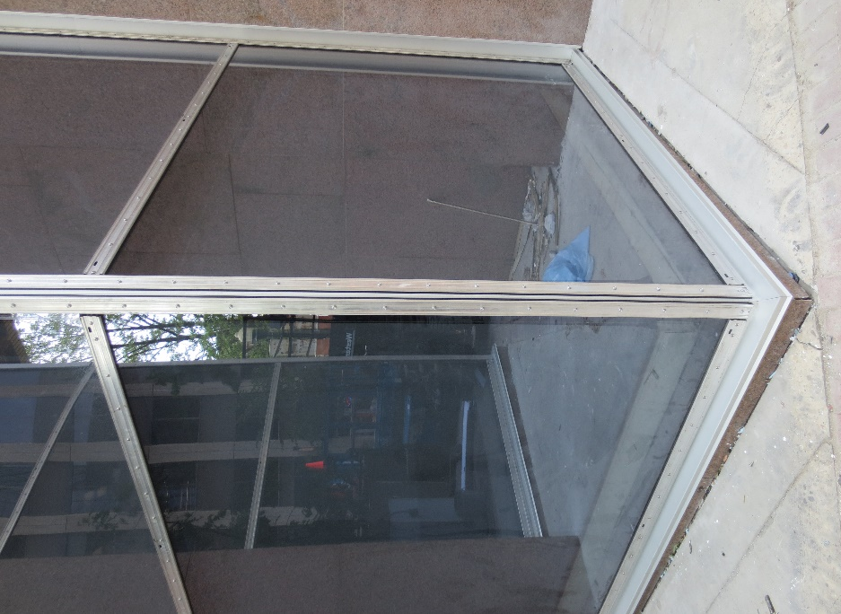 | Figure 6: A completed curtain wall has capping plates and flashing installed. The capping plates and flashing cover pressure plates and membranes.  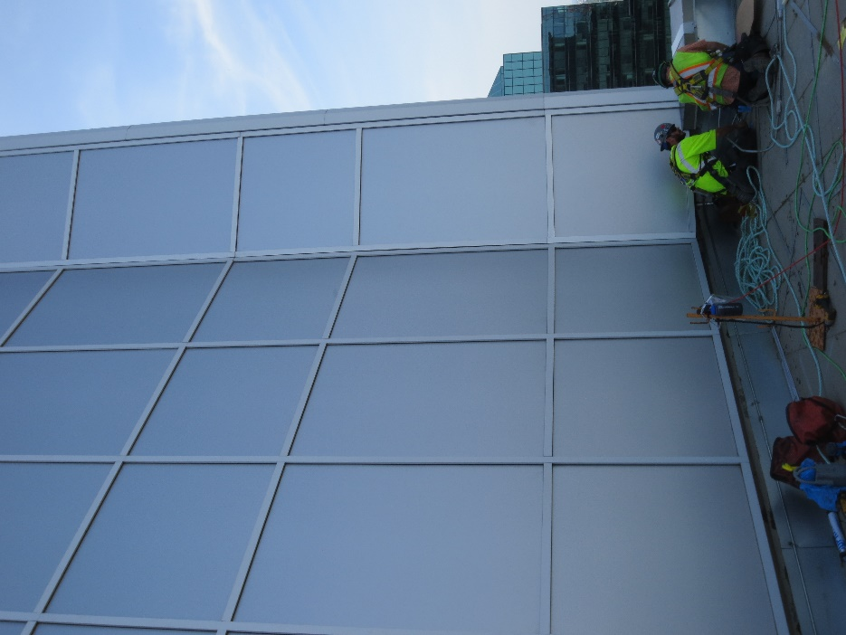

_________________________
Richard Huynh, BScKin
Kinesiologist

SITE SPECIFIC JOB DEMAND ADDITIONS:

Job Demand | Frequency |  |  |  |  | Details/Measurements
 | N/R | R | O | F | C
Site Specific Job Demand:

Validation Agreement

Job Title: | Glazier
Data Collection Date: | June 7, 2018

We the undersigned have reviewed the Physical Demands Analysis for this position and agree that the physical demands documented in this report are representative of the true demands of the tasks associated with the job title as assessed on the date listed above.

Completed by: | Richard Huynh, Kinesiologist | Lifemark Clinician Name and Credentials
Approved by: |  | Management Representative
Approved by: |  | Worker Representative
Approved by: |  | Labour Provider Representative

