Physical Demands Analysis

Fire Sprinkler Installer

Prepared for:
Construction Owners Association of Alberta

Job Title: | Fire Sprinkler Installer | Assessment Location: |  | Data Collection Date:

Completed By: |  | Submitted on:

Disclaimer: | The Physical Demands noted in this report may vary depending on company and location. Please contact the company directly to confirm this physical demands analysis is an accurate representation of the specific job title for the specific location.

Work Schedule: | Shift Duration: 8 hours/day; may vary  Break Schedule: Total of 1 hour break per day  Shift Rotation: Not applicable  On call is required: No  Overtime required: No; but may be available

Education / Experience: | Education required: Journeyman Sprinkler Fitter or Gas Fitter Certificate. To obtain this, they must complete a 4-year apprenticeship program. The in-class portion is 8 weeks for the first 3 years, and 12 weeks in the fourth year.  Hours required for position: ~1500 hours  Tickets that may be required (not limited to): Fall protection, Elevated Work Platform (EWP) machinery use, First Aid, WHMIS, Construction Safety Training Systems (CSTS) and Basic Safety Orientation (BSO).

Labour Provider: | N/A

Job Overview: | The Fire Sprinkler Installer is responsible for installing and maintaining fire sprinkler systems on commercial and industrial sites. The Installers generally complete the majority of their installation while the ceiling and walls are unfinished. They will measure, cut, and fit pipes according to blueprints. They will work at heights, on either a ladder or elevated work platform.
 | % of shift | Job Task | Task Description
 | 10% | Safety/meetings | - Toolbox talk – Safety topics are discussed during the toolbox talk. The Installer will receive additional information such as:  - Tasks for the day  - Important events from previous shifts  - A FLHA is completed and signed before starting any work where hazards are present.  - The FLHA is updated when there are changes to the tasks.
 | 90% | On site work | - Work site setup  - The Installer will gather required materials and equipment to their worksite.  - Materials may be moved with the assistance of machines, or by hand.  - Two or more people will handle heavy equipment and materials.  - Reading building blueprints  - Blueprints will dictate the position of the sprinkler system.  - Blueprints will help the Installer estimate the materials needed.  - The installer will verify that the blueprint provided meets building regulations for fire sprinkler systems.  - Collecting and preparing materials  - Pipes and hangers are measured and cut to length.  - The pipe may need to be grooved or threaded.  - The installer will collect appropriate materials such as valves, couplings, sprinkler heads, and/or hangers.  - Installing fire sprinkler systems  - The Installer will use a ladder or elevated work platform.  - Hangers are first installed onto the ceiling.  - The Installer may have the help of another employee to lift pieces of pipe onto hangers.  - Overhead pipes are joined using couplings.  - Steel pipes are joined using couplings.  - Plastic pipes are joined using plastic cement.  - Sprinkler heads are installed at specific intervals to meet building regulations.  - Installing fire sprinkler system shutoff valves  - Shutoff valves are installed in dedicated rooms.  - Installing emergency fire sprinkler pumps  - Depending on the worksite, the Installer will need to install a pre-fabricated pump.  - A pump is not necessary if the system connects to the municipality’s water supply.  - Inspections and checks  - The installer will confirm that sprinkler heads are spaced appropriately and within regulation.  - The installer will pressure test the system using compressed air.  - Covering sprinkler heads  - Sprinkler heads are fed through ceiling tiles.  - Cover plates are placed over sprinkler heads.

Equipment/  Tools: | - Hand tools, such as pipe wrenches (~3 lbs)  - Pipe cutter (~18 lbs)  - Power drill (~4-5 lbs)  - 8 foot ladder (~30 lbs)  - Pipe stand (~45 lbs)  - Roll groover/threading machine (~120 lbs, weight will depend on make and model)

Exposures / Environment: | - Hot temperatures  - Cold temperatures  - Working from heights  - Pinch points  - Overhead hazards  - Pressurized gases or liquids  - Chemicals, such as pipe cement

Personal Protective  Equipment Required: | - Steel toed boots  - Foam safety eyewear (fectoggle)  - Long sleeves and pants  - Hard hat  - Safety vest or high visibility stripes
Personal Protective  Equipment as Required: | - Gloves  - Harness

NOC STRENGTH LEVEL KEY
Strength Level | Definition
Limited (Lim) | Up to 5 kg (11 pounds)
Light (L) | 5 kg to 10 kg (11 – 22 pounds)
Medium (M) | 10 kg to 20 kg (22 – 44 pounds)
Heavy (H) | Greater than 20 kg (44 pounds plus)
*Strength Level Key based on the National Occupational Classification

FREQUENCY KEY
Frequency | % of Workday | Hours – Based on 8 hour Workday
Not Required (N/R) | 0% | 0
Rarely (R) | 1 – 5% | <25 min/day
Occasionally (O) | 6 – 33% | 25 min to 2 hours 40 min/day
Frequently (F) | 34 – 66% | 2 hours 41 min to 5 hours 17 min/day
Constantly (C) | 67 – 100% | 5 hours 18 min to 8 hours/day
*Frequency Key based on WCB Alberta Recommendations

Job Demand | Frequency / NOC Strength Level |  |  |  |  | Details/ Measurements
 | N/R | R | O | F | C

Material Handling:
Floor to Waist Level Lifting |  |  | H | M |  | - The amount of lifting required will depend on the stage of the project.  - Heavy lifting of material is completed by two or more people.  - Heavy lifting may occur with (but not limited to):  - Full length steel pipe (~112 lbs, weight will vary depending on thickness)  - Roll groover/threading machine (~120 lbs)  - Medium level lifting may occur with (but not limited to) 5-9 ft steel pipe.  - Limited level lifting may occur with (but not limited to):  - Small hand tools (~3 lbs)  - Power drill (4-5 lbs)  - Pipe hangers, couplings, sprinkler heads (1-6 lbs)
Knee to Waist Level Lifting |  |  | H | M |  | - As above
Waist to Waist Level Lifting |  |  | H | M |  | - As above
Waist to Chest Level Lifting |  |  | H |  |  | - Heavy lifting may occur with (but not limited to):  - Full length steel pipe (~112 lbs, weight will vary depending on thickness)  - Medium level lifting may occur with (but not limited to):  - 5-9 ft steel pipe (weight will vary depending on thickness)  - 8 foot ladder (30 lbs)  - Limited level lifting may occur with (but not limited to):  - Small hand tools (~3 lbs)  - Power drill (4-5 lbs)  - Pipe hangers, couplings, sprinkler heads (1-6 lbs)
Waist to Shoulder Level Lifting |  |  | H |  |  | - Heavy lifting may occur with (but not limited to):  - Full length steel pipe (~112 lbs, weight will vary depending on thickness)  - Medium level lifting may occur with (but not limited to) 5-9 ft steel pipe.  - Limited level lifting may occur with (but not limited to):  - Small hand tools (~3 lbs)  - Power drill (4-5 lbs)  - Pipe hangers, couplings, sprinkler heads (1-6 lbs)
Waist to Overhead Level Lifting |  |  | L |  |  | - Light level lifting may occur with (but not limited to) 2-5 ft steel pipe.  - Limited level lifting may occur with (but not limited to):  - Small hand tools (~3 lbs)  - Power drill (4-5 lbs)  - Pipe hangers, couplings, sprinkler heads (1-6 lbs)
Front Carry |  |  | H |  |  | - Heavy level carrying is completed by two or more people.  - Heavy carrying may occur with (but not limited to):  - Full length steel pipe (~112 lbs, weight will vary depending on thickness)  - Roll groover/threading machine (~120 lbs)  - Medium level lifting may occur with (but not limited to) 5-9 ft steel pipe.  - Limited level lifting may occur with (but not limited to):  - Small hand tools (~3 lbs)  - Power drill (4-5 lbs)  - Pipe hangers, couplings, sprinkler heads (1-6 lbs)
Right / Left-handed Carry (Dominant Hand) |  |  | M |  |  | - Medium level lifting may occur with (but not limited to) their tool bag and bags of couplings.  - Limited level carrying may occur with (but not limited to):  - Small hand tools (~3 lbs)  - Power drill (4-5 lbs)  - Pipe hangers, couplings, sprinkler heads (1-6 lbs)
Shoulder Carry |  |  | H |  |  | - Heavy lifting may occur with (but not limited to):  - Full length steel pipe (~112 lbs, weight will vary depending on thickness)  - Medium level lifting may occur with (but not limited to) 5-9 ft steel pipe.
Static  Pushing/Pulling (Force) |  |  | M |  |  | - Holding parts in place during installation, grooving, or threading.
Dynamic  Pushing/Pulling (Force) |  |  | M |  |  | - Using tools and pushing pipes into place.

Job Demand | Frequency |  |  |  |  | Details/Measurements
 | N/R | R | O | F | C

Upper Extremity Work:
Hand Gripping |  |  |  |  | X | - Handling equipment and materials such as wrenches and pipes.
Pinch Gripping |  | X |  |  |  | - Using pens and markers.
Upper Extremity Coordination |  |  |  |  | X | - Handling equipment and materials such as wrenches and pipes.
Reaching Forward |  |  |  | X |  | - When lifting and using equipment such as the roll groover.
Overhead Shoulder Level Reaching |  |  |  | X |  | - When installing pipe hangers, pipes, and couplings.
Below Shoulder Level Reaching |  |  |  | X |  | - When lifting equipment and materials.
Throwing |  | X |  |  |  | - When throwing waste into bins.

Job Demand | Frequency |  |  |  |  |  | Details/Measurements
 | N/R |  | R | O | F | C
Positional Work:
Trunk Flexion (Bending) |  |  |  |  | X |  | - When lifting equipment and materials from floor or knee level.
Trunk Rotation (Twisting) |  |  |  | X |  |  | - When handling equipment and materials within the work site.
Kneeling |  | X
Crawling |  | X
Crouching |  |  |  | X |  |  | - When collecting equipment and materials.
Squatting |  |  |  |  | X |  | - When lifting equipment and materials.
Neck Flexion |  |  |  |  | X |  | - When lifting equipment and materials.  - When using equipment such as the roll groover or pipe stand.
Neck Extension |  |  |  |  | X |  | - When scanning overhead to install pipes.  - When working on overhead pipes.
Neck Rotation |  |  |  | X |  |  | - When scanning the work site.

Job Demand | Frequency |  |  |  |  | Details/Measurements
 | N/R | R | O | F | C
Static Work:
Sitting | X
Static Standing |  |  |  | X |  | - When using a roll groover or pipe stand.
Balancing |  |  |  | X |  | - When using a ladder.

Job Demand | Frequency |  |  |  |  | Details/Measurements
 | N/R | R | O | F | C
Ambulation:
Walking: Level Surfaces |  |  |  |  | X | - Walking indoors.
Walking: Uneven Surfaces |  | X |  |  |  | - Walking outside.
Walking: Slopes |  | X |  |  |  | - As above.
Jumping | X
Running | X

Job Demand | Frequency |  |  |  |  | Details/Measurements
 | N/R | R | O | F | C
Climbing:
Stairs |  |  | X |  |  | - Climbing stairs to access work sites on different levels.
Ladder |  |  |  | X |  | - Climbing ladders to install overhead pipes.
Other | X

PHOTOS OF TASKS AND WORK ENVIRONMENT

Figure 1: The Installer will measure and cut pipes to size according to blueprints and measurements taken on site.  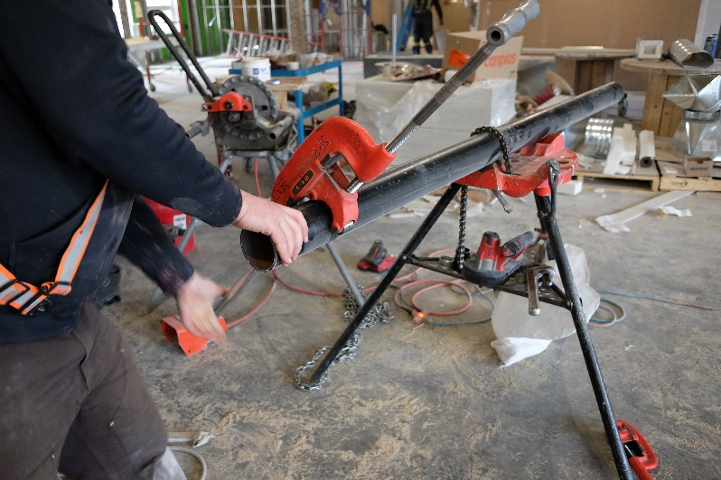 | Figure 2: The Installer uses a roll groover/threading machine on the end of steel pipes. The pipes will be connected together using couplings.  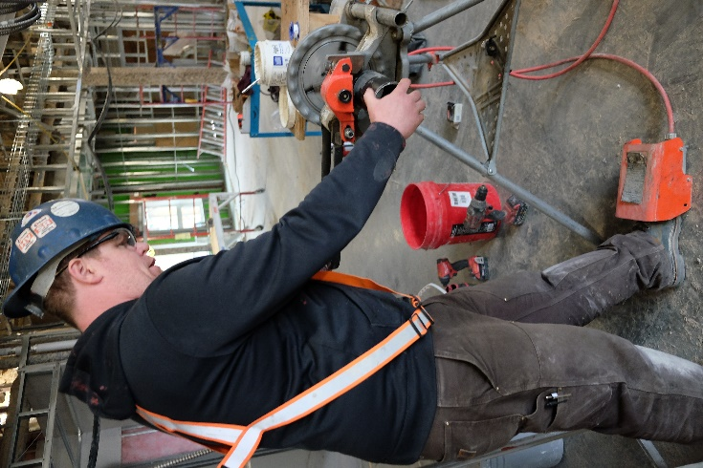

Figure 3: The Installer will have to lift one end of the pipe onto hangers installed on the ceiling. Long lengths of pipe are lifted by two employees.  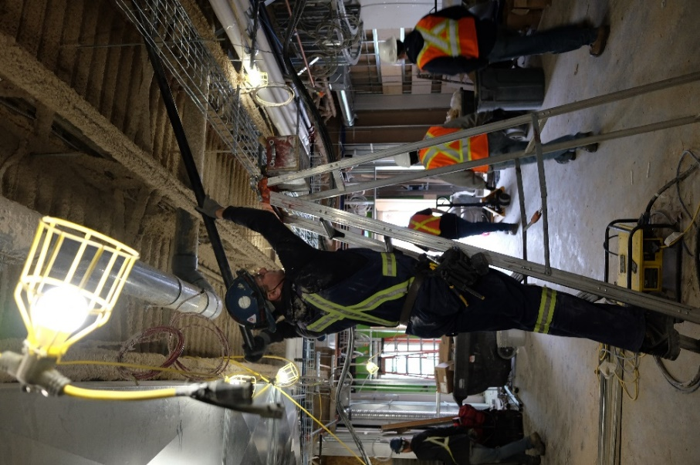 | Figure 4: The Installer will climb a ladder to lift the pipe onto the hangers.  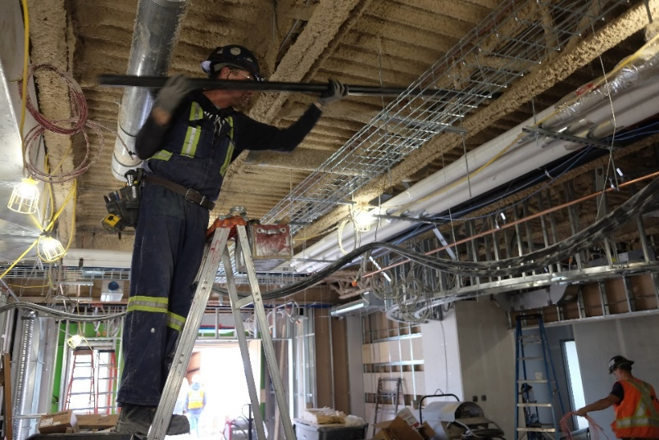

Figure 4: The Installer uses a power drill to cut holes in the steel pipe. The Installer will either connect another pipe, or fit a sprinkler head.  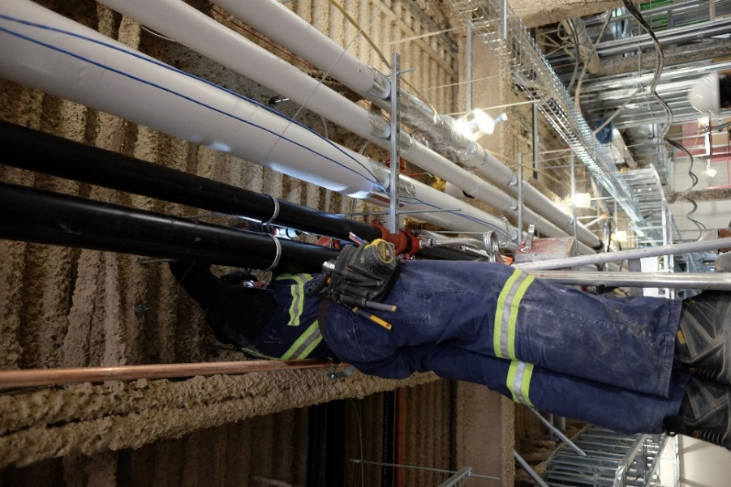 | Figure 6: Steel pipes are connected using couplings. Other components, such as valves, may be connected to the pipes.  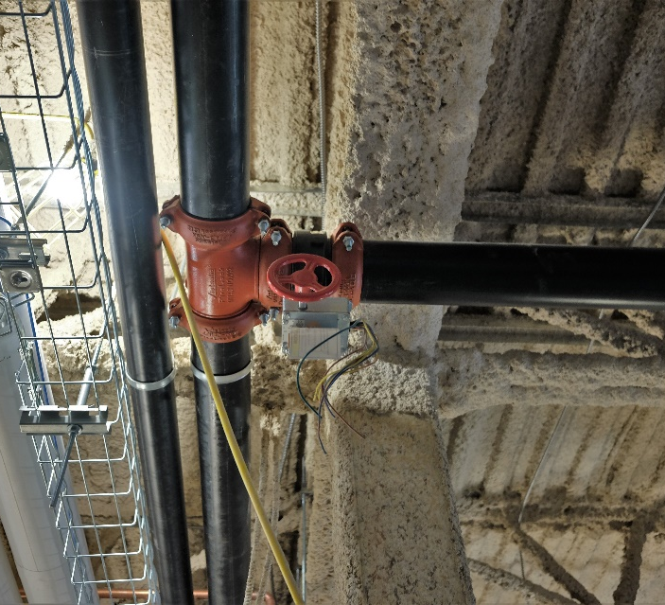

_________________________
Richard Huynh, BScKin
Kinesiologist

SITE SPECIFIC JOB DEMAND ADDITIONS:

Job Demand | Frequency |  |  |  |  | Details/Measurements
 | N/R | R | O | F | C
Site Specific Job Demand:

Validation Agreement

Job Title: | Fire Sprinkler Installer
Data Collection Date: | May 10, 2018

We the undersigned have reviewed the Physical Demands Analysis for this position and agree that the physical demands documented in this report are representative of the true demands of the tasks associated with the job title as assessed on the date listed above.

Completed by: |  | Insert Lifemark Clinician Name and Credentials
Approved by: |  | Management Representative
Approved by: |  | Worker Representative
Approved by: |  | Labour Provider Representative

