Physical Demands Analysis

Chef

Prepared for:
Construction Owners Association of Alberta

Job Title: | Chef | Assessment Location: |  | Data Collection Date:

Completed By: |  | Submitted on:

Disclaimer: | The Physical Demands noted in this report may vary depending on company and location. Please contact the company directly to confirm this physical demands analysis is an accurate representation of the specific job title for the specific location.

Work Schedule: | Shift Duration: 12 hours/day; may vary  Break Schedule: Total of 1 hour break per day  Shift Rotation: 14 days on, 7 days off  On call is required: Yes; but very rare  Overtime required: No; but may be available

Education / Experience: | Education required: Journeyman Cooking Certificate. To obtain this, they must complete a 4-year apprenticeship program. The in-class portion is 8 weeks for the first 3 years, and 12 weeks in the fourth year.  Hours required for position: ~1500 hours  Tickets that may be required (not limited to): First Aid, WHMIS, Construction Safety Training Systems (CSTS) and Basic Safety Orientation (BSO).

Labour Provider: | N/A

Job Overview: | The Chef is primarily responsible for the administrative duties for the kitchen, such as ordering supplies, creating the schedule, developing the menu, and delivering toolbox meetings. They also expedite food during dinner services and ensure service runs smoothly. If the first cook is unavailable, the Chef will take over their duties of cooking and preparing meals.
 | % of shift | Job Task | Task Description
 | 10% | Safety/meetings | - Daily toolbox talks  - The Chef will choose the safety topic for the toolbox talk.  - The Chef will also communicate the tasks for the day and any important information from previous shifts to kitchen staff.  - Weekly safety meeting  - The chef will organize the safety meeting.  - The safety meeting will address several safety topics
 | 40-60% | Administrative work | - Developing the menu for the buffet and restaurant.  - Food items are planned for several weeks in advance and communicated to the cooks.  - The number of guests will dictate the amount of food that needs to be prepared.  - The chef will plan different food items for each day to provide the guests with a variety of food options.  - Managing kitchen inventory.  - Ordering supplies and food according to inventory on hand and the planned menu.  - Corresponding with food distributors.  - Completing and updating documentation.  - This includes (but not limited to) temperature logs, orders, cross-over shift notes, and inspections.  - Creating and managing the schedule for kitchen staff.
 | 30-50% | On site work | - Kitchen rounds.  - Checking temperatures of refrigerators, freezers, hot boxes, and other appliances.  - Completed twice daily.  - Checking food inventory.  - Cooking for dinner service – only occurs if the First Cook is unavailable.  - Checking the menu to determine which food item(s) to prepare.  - Gathering equipment and ingredients from the pantry, refrigerator, and/or freezer.  - Using a pushcart or rolling rack.  - Preparing food on the counter  - Opening packets, mixing ingredients, seasoning food.  - Cooking food using the oven, steamer, or kettle.  - The Chef will need to consider the different cooking times of certain foods.  - Storing food in hot boxes for dinner service.  - Expediting during dinner service.  - Checking temperatures before food is sent out.  - Ensuring that dinner service runs smoothly and assisting at cooking stations if necessary.

Equipment/  Tools: | - Cooking utensils, such as whisks and ladles (~1 lbs)  - Baking sheets (~1 lbs)  - Buffet trays (~1 lbs)  - Cooking thermometer  - Mixing bowls, various sizes  - Push cart  - Rolling racks

Exposures / Environment: | - Wet floors  - Cold temperatures  - Hot temperatures  - Pinch points

Personal Protective Equipment Required: | - Gloves  - Non-slip footwear
Personal Protective Equipment as Required: | - Oven mitts

NOC STRENGTH LEVEL KEY
Strength Level | Definition
Limited (Lim) | Up to 5 kg (11 pounds)
Light (L) | 5 kg to 10 kg (11 – 22 pounds)
Medium (M) | 10 kg to 20 kg (22 – 44 pounds)
Heavy (H) | Greater than 20 kg (44 pounds plus)
*Strength Level Key based on the National Occupational Classification

FREQUENCY KEY
Frequency | % of Workday | Hours – Based on 8 hour Workday
Not Required (N/R) | 0% | 0
Rarely (R) | 1 – 5% | <25 min/day
Occasionally (O) | 6 – 33% | 25 min to 2 hours 40 min/day
Frequently (F) | 34 – 66% | 2 hours 41 min to 5 hours 17 min/day
Constantly (C) | 67 – 100% | 5 hours 18 min to 8 hours/day
*Frequency Key based on WCB Alberta Recommendations

Job Demand | Frequency / NOC Strength Level |  |  |  |  | Details/ Measurements
 | N/R | R | O | F | C

Material Handling:
Floor to Waist Level Lifting |  | M |  |  |  | - Limited to medium level lifting may occur with (but not limited to):  - Empty baking sheets (~1.5 lbs each)  - Baking sheets can be used for large cuts of meat, vegetables, or other food items.  - Up to 35 lbs when full  - Empty buffet trays (~1.5 lbs each)  - Buffet trays can be used for rice, vegetables, or other food items.  - 15-20 lbs when full  - Containers of sauces, spices, and oils (8 lbs)  - Boxes of ingredients such as soup mix, potatoes, and meat (10-40 lbs)
Knee to Waist Level Lifting |  |  | M |  |  | - As above
Waist to Waist Level Lifting |  |  | M |  |  | - As above
Waist to Chest Level Lifting |  |  | M |  |  | - As above
Waist to Shoulder Level Lifting |  |  | M |  |  | - As above
Waist to Overhead Level Lifting |  |  | L |  |  | - Limited to medium level lifting may occur with (but not limited to):  - Empty baking sheets (~1.5 lbs each)  - Empty buffet trays (~1.5 lbs each)  - Containers of sauces, spices, and oils (8 lbs)
Front Carry |  |  | M |  |  | - Limited to medium level lifting may occur with (but not limited to):  - Empty baking sheets (~1.5 lbs each)  - Baking sheets can be used for large cuts of meat, vegetables, or other food items.  - Up to 35 lbs when full  - Empty buffet trays (~1.5 lbs each)  - Buffet trays can be used for rice, vegetables, or other food items.  - 15-20 lbs when full  - Containers of sauces, spices, and oils (8 lbs)  - Boxes of ingredients such as soup mix, potatoes, and meat (10-40 lbs)
Right / Left-handed Carry (Dominant Hand) |  |  | Lim |  |  | - Limited to light level carrying may occur with (but not limited to):  - Utensils (1-2 lbs)  - Kitchen thermometer (~2 lbs)  - Containers of sauces, spices, and oils (8 lbs)  - Cookware such as pans and deep fryer baskets (2-3 lbs)
Shoulder Carry | X
Static  Pushing/Pulling (Force) | X
Dynamic  Pushing/Pulling (Force) |  |  | L |  |  | - Pushing rolling racks (up to 15 lbs)  - Pushing cart of supplies (up to 15 lbs)  - Opening and closing walk in freezer and refrigerator doors.

Job Demand | Frequency |  |  |  |  | Details/Measurements
 | N/R | R | O | F | C

Upper Extremity Work:
Hand Gripping |  |  | X |  |  | - Gripping utensils, baking sheets, door handles, cart handles.
Pinch Gripping |  |  | X |  |  | - When using a pen to complete paperwork.
Upper Extremity Coordination |  |  | X |  |  | - When lifting equipment and supplies such as baking sheets and buffet trays.  - When using utensils and kitchen thermometer.  - When using cookware such as a deep fryer basket or pan.
Reaching Forward |  |  | X |  |  | - As above
Overhead Shoulder Level Reaching |  |  | X |  |  | - Reaching for supplies stored on overhead shelves.
Below Shoulder Level Reaching |  |  | X |  |  | - When lifting equipment and supplies such as baking sheets and buffet trays.  - Reaching for supplies stored on shelves at low levels.
Throwing | X

Job Demand | Frequency |  |  |  |  |  | Details/Measurements
 | N/R |  | R | O | F | C
Positional Work:
Trunk Flexion (Bending) |  |  |  | X |  |  | - When lifting equipment and supplies such as baking sheets and buffet trays.
Trunk Rotation (Twisting) |  |  |  | X |  |  | - When moving baking sheets and buffet trays.  - When walking through tight spaces in the walk-in fridge and freezer.
Kneeling |  | X
Crawling |  | X
Crouching |  |  | X |  |  |  | - When checking on food at the bottom of the oven or rolling rack.
Squatting |  |  |  | X |  |  | - When lifting equipment and supplies such as baking sheets and buffet trays.
Neck Flexion |  |  |  |  | X |  | - When lifting equipment and supplies such as baking sheets and buffet trays.  - When mixing ingredients at counter height.
Neck Extension |  |  |  | X |  |  | - When reaching for equipment and ingredients at higher levels.
Neck Rotation |  |  |  | X |  |  | - When collecting equipment and ingredients in tight spaces.

Job Demand | Frequency |  |  |  |  | Details/Measurements
 | N/R | R | O | F | C
Static Work:
Sitting |  |  |  |  | X | - When completing administrative duties and attending meetings.
Static Standing |  |  | X |  |  | - When expediting during dinner service.
Balancing | X

Job Demand | Frequency |  |  |  |  | Details/Measurements
 | N/R | R | O | F | C
Ambulation:
Walking: Level Surfaces |  |  |  |  | X | - Walking indoors.
Walking: Uneven Surfaces | X
Walking: Slopes | X
Jumping | X
Running | X

Job Demand | Frequency |  |  |  |  | Details/Measurements
 | N/R | R | O | F | C
Climbing:
Stairs | X
Ladder | X
Other | X

PHOTOS OF TASK AND WORK ENVIRONMENT

Figure 1: A programmable oven can be used to cook buffet menu items. The oven can accommodate baking sheets or buffet trays.  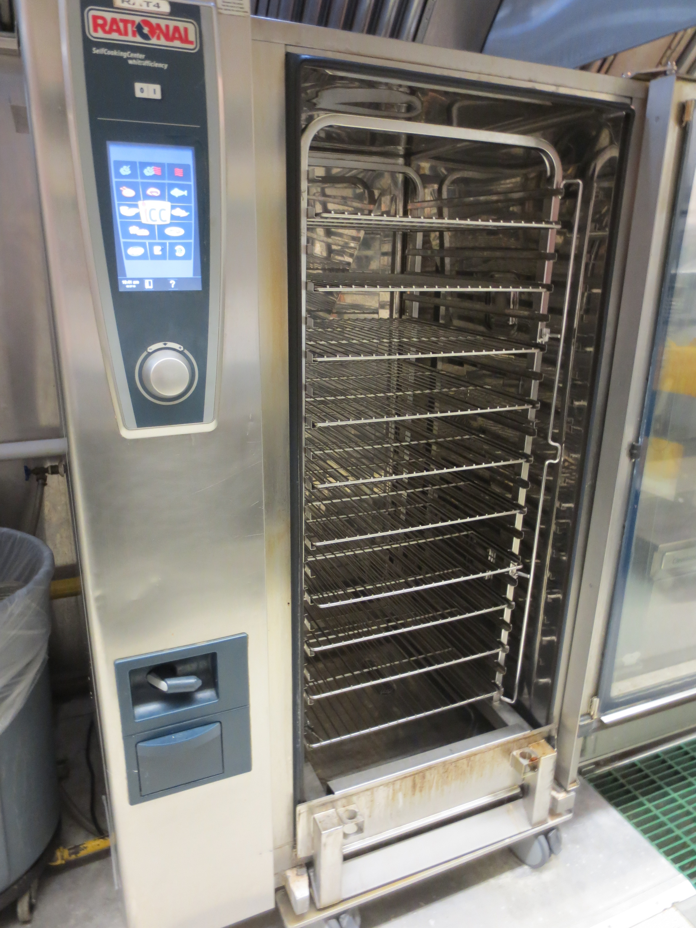 | Figure 2: An industrial kettle is used to heat up bags of sauce or as a source of hot water.  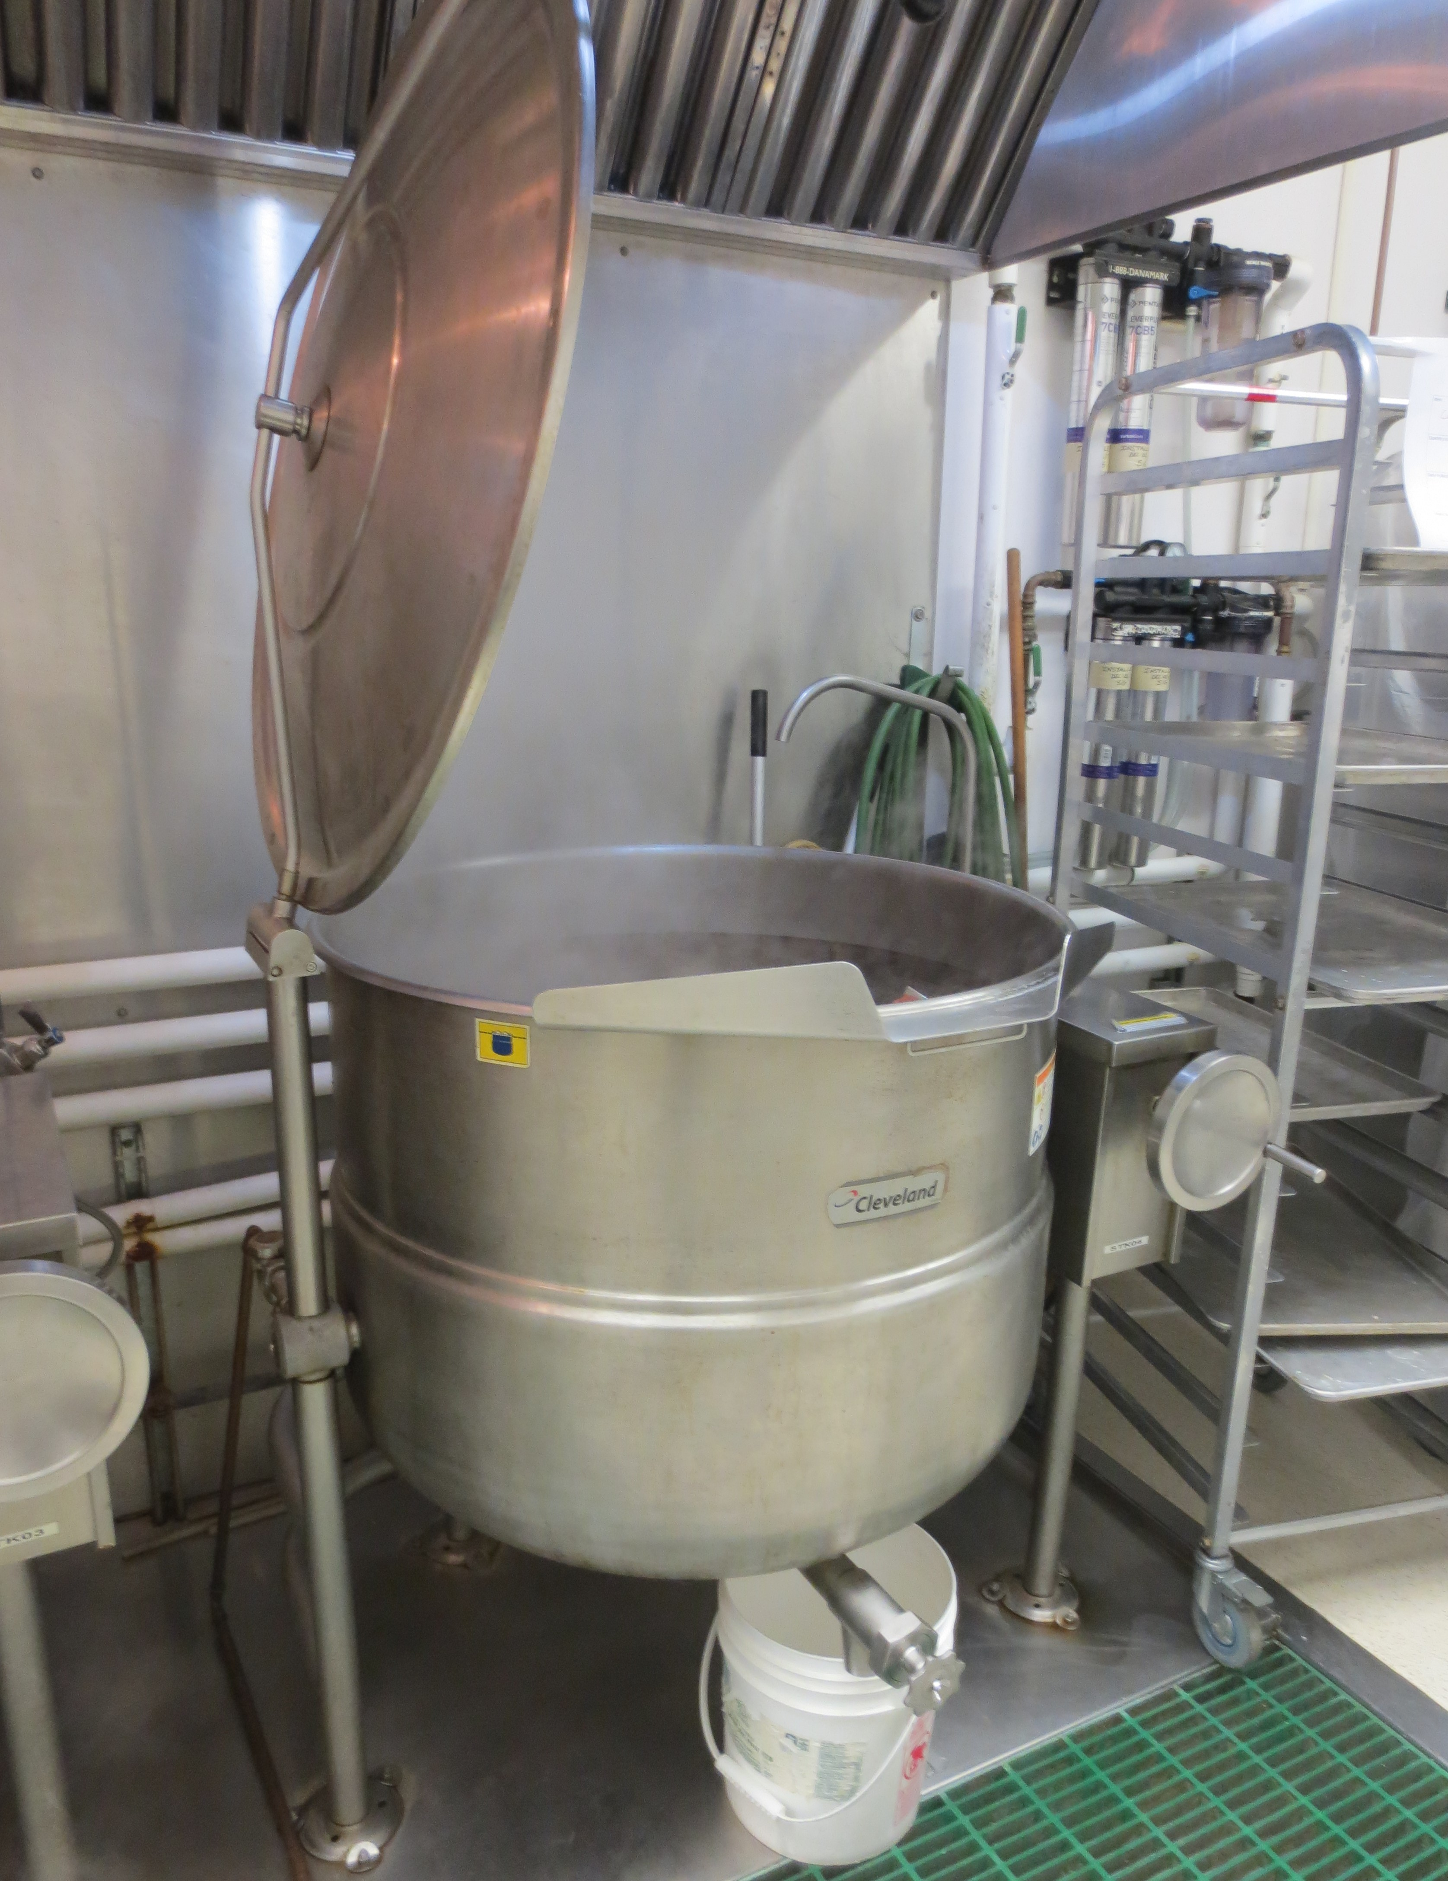
Figure 3: Buffet trays are stored on low-level shelves. They can weigh up to 20 lbs when full.  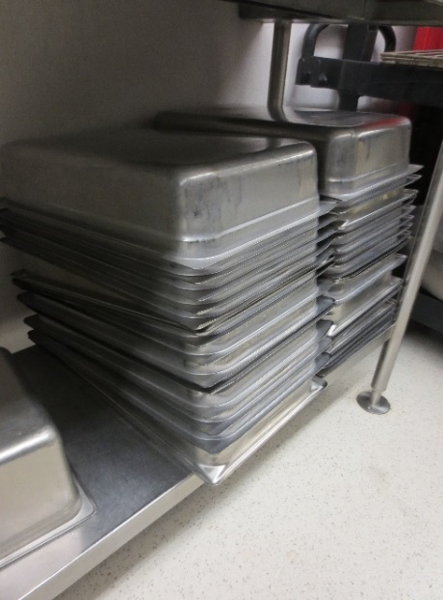 | Figure 4: A digital thermometer is used to check food temperatures. Temperatures are checked throughout the day and during dinner service.  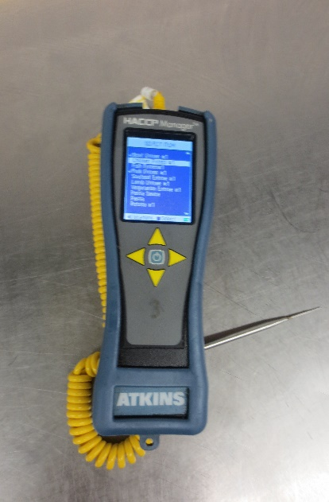

Figure 5: Ingredients, such as sauces and spices, are stored above the counter. Containers can weigh up to 8 lbs when full.  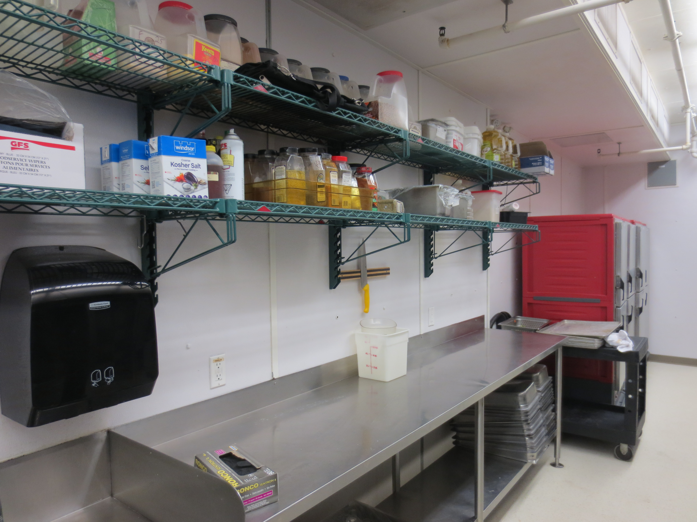 | Figure 6: The Chef will use a pushcart to collect supplies and ingredients.  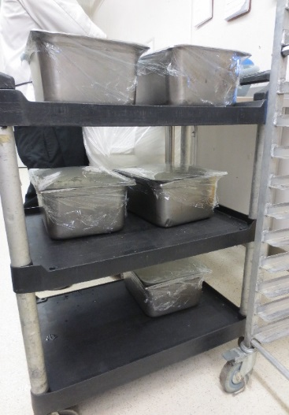

__________________________
Richard Huynh, BScKin
Kinesiologist

SITE SPECIFIC JOB DEMAND ADDITIONS:

Job Demand | Frequency |  |  |  |  | Details/Measurements
 | N/R | R | O | F | C
Site Specific Job Demand:

Validation Agreement

Job Title: | Chef
Data Collection Date: | February 27, 2018

We the undersigned have reviewed the Physical Demands Analysis for this position and agree that the physical demands documented in this report are representative of the true demands of the tasks associated with the job title as assessed on the date listed above.

Completed by: |  | Insert Lifemark Clinician Name and Credentials
Approved by: |  | Management Representative
Approved by: |  | Worker Representative
Approved by: |  | Labour Provider Representative

