Physical Demands Analysis

Carpenter

Prepared for:
Construction Owners Association of Alberta

Job Title: | Carpenter | Assessment Location: |  | Data Collection Date:

Completed By: |  | Submitted on:

Disclaimer: | The Physical Demands noted in this report may vary depending on company and location. Please contact the company directly to confirm this physical demands analysis is an accurate representation of the specific job title for the specific location.

Work Schedule: | Shift Duration: 12 hours/day; may vary  Break Schedule: Total of 1 hour break per day  Shift Rotation: 14 days on, 14 days off  On call is required: Yes; during the evening  Overtime required: No; but is often available

Education / Experience: | Education required: Journeyman Carpenter Certificate. To obtain this, they must complete a 4-year apprenticeship program. The in-class portion is 8 weeks for the first 3 years; and 12 weeks in the fourth year.  Hours required for position: ~1500 hours  Tickets that may be required (not limited to): Fall protection, H2S Alive, Wildlife awareness, Ground Disturbance, Elevated Work Platform (EWP) machinery use, Confined Space, First Aid, WHMIS, Construction Safety Training Systems (CSTS) and Basic Safety Orientation (BSO).

Labour Provider: | N/A

Job Overview: | The Carpenter is responsible for the construction and repairs of ceilings, walls, and floors of a building. This may include (but not limited to) repairing wall fixtures, replacing ceiling tiles, renovating old spaces, and constructing new spaces. Tasks are generated and logged through Electronically Generated Services (EGS). The Carpenter is trained in Field Level Hazard Assessments (FLHA), and may work alongside laborers or other maintenance staff. Their days may be unpredictable because certain repairs may take priority over other tasks.
 | % of shift | Job Task | Task Description
 | 10% | Safety/meetings | - Toolbox talk – Safety topics are discussed during the toolbox talk. The Carpenter will receive additional information such as:  - Tasks for the day  - Important events from previous shifts  - A FLHA is completed and signed before starting any work where hazards are present.  - The FLHA is updated when there are changes to the tasks.
 | 90% | On site work | - Selecting Electronic Generated Services (EGS) – EGS are accessed on the computer.  - EGS are selected and printed.  - Some EGS may take priority over others.  - Some EGS may require several days to complete due to the ordering of parts.  - Completing EGS  - EGS may need to be completed indoors and/or outdoors.  - Indoors – staff, guest, and common areas.  - Outdoors – building exterior such as on the roof or the side of the building.  - The Carpenter will need to collect necessary tools and materials to complete the EGS.  - Large pieces of material are cut to specific dimensions.  - Smaller pieces are lighter and easier to maneuver.  - The Carpenter may need to climb stairs, ladders, or drive to access the work area.  - The EGS may require the Carpenter to troubleshoot and repair or replace the following (but not limited to):  - Ceiling or wall fixtures  - Flooring, drywall, or ceiling tiles  - The EGS may require the Carpenter to construct new walls or renovate old areas.  - Other maintenance staff members may need to assist.  - High voltage areas (>24V) will require the assistance of an Electrician.  - Completing paperwork – paperwork for daily checks, EGS, PMs, orders, and hours.

Equipment/  Tools: | - Small hand tools, such as hammers and screwdrivers (~1-2 lbs)  - Measurement tools, such as tape measures and spirit levels (~1 lbs)  - Handheld power tools, such as a power drill (~4-5 lbs) or circular saw (12 lbs)  - Large power tools, such as a table saw or mitre saw  - Fasteners, such as screws and nails (<1 lbs)  - Step ladder (~7 lbs)  - 10 foot ladder (~30 lbs)  - Sheet of drywall (~50 lbs)

Exposures / Environment: | - High voltage equipment  - Sharp edges  - Hot temperatures  - Cold temperatures  - Working from heights  - Pinch points  - Rain  - Snow  - Ice  - Wind  - Dust  - Overhead hazards

Personal Protective  Equipment Required: | - Steel toed boots  - Foam safety eyewear (fectoggle)  - Long sleeves and pants
Personal Protective  Equipment as Required: | - Hard hat  - Gloves  - Safety vest and high visibility stripes

NOC STRENGTH LEVEL KEY
Strength Level | Definition
Limited (Lim) | Up to 5 kg (11 pounds)
Light (L) | 5 kg to 10 kg (11 – 22 pounds)
Medium (M) | 10 kg to 20 kg (22 – 44 pounds)
Heavy (H) | Greater than 20 kg (44 pounds plus)
*Strength Level Key based on the National Occupational Classification

FREQUENCY KEY
Frequency | % of Workday | Hours – Based on 8 hour Workday
Not Required (N/R) | 0% | 0
Rarely (R) | 1 – 5% | <25 min/day
Occasionally (O) | 6 – 33% | 25 min to 2 hours 40 min/day
Frequently (F) | 34 – 66% | 2 hours 41 min to 5 hours 17 min/day
Constantly (C) | 67 – 100% | 5 hours 18 min to 8 hours/day

*Frequency Key based on WCB Alberta Recommendations

Job Demand | Frequency / NOC Strength Level |  |  |  |  | Details/ Measurements
 | N/R | R | O | F | C

Material Handling:
Floor to Waist Level Lifting |  | H | M | Lim |  | - Heavy lifting may occur with materials such as large sheets of drywall (>44 lbs)  - A laborer or another maintenance staff member can assist with heavy lifting.  - Light to medium level lifting may occur with (but not limited to):  - 10 foot ladder (30 lbs)  - Power tools (~12 lbs)  - Smaller dry wall sheets or vinyl flooring.  - Limited level lifting may occur with (but not limited to):  - Small hand tools (~1 lbs)  - Power drill (4-5 lbs)
Knee to Waist Level Lifting |  | H | M | Lim |  | - As above
Waist to Waist Level Lifting |  | H | M | Lim |  | - As above
Waist to Chest Level Lifting |  |  | L | Lim |  | - Light level lifting may occur with smaller dry wall sheets or vinyl flooring.  - Limited level lifting may occur with (but not limited to):  - Small hand tools (~1 lbs)  - Power drill (4-5 lbs)
Waist to Shoulder Level Lifting |  |  | L |  |  | - As above
Waist to Overhead Level Lifting |  |  | Lim |  |  | - Limited level lifting may occur with (but not limited to):  - Small hand tools (~1 lbs)  - Power drill (4-5 lbs)  - Ceiling tiles (3-5 lbs)
Front Carry |  | H | M |  |  | - Heavy level carrying may occur with materials such as large sheets of drywall (>44 lbs)  - A laborer or another maintenance staff member can assist with heavy carrying.  - Limited to medium level carrying may occur with (but not limited to):  - Small hand tools (~1 lbs)  - Handheld power tools (4-12 lbs)  - 10 foot ladder (30 lbs)  - Small dry wall sheets or vinyl flooring.
Right / Left-handed Carry (Dominant Hand) |  |  | L | Lim |  | - Light level carrying may occur with power tools (~12 lbs).  - Limited level carrying may occur with (but not limited to):  - Small hand tools (~1 lbs)  - Power drill (4-5 lbs)
Shoulder Carry |  | L |  |  |  | - Light level carrying may occur when carrying material such as lumber.
Static  Pushing/Pulling (Force) |  |  |  | L |  | - Holding materials and fixtures in place during installation or repairs.
Dynamic  Pushing/Pulling (Force) |  |  | H |  |  | - Using tools such as a pry bar to remove flooring or wall panels.  - Pushing and pulling furniture or appliances to access installations or repairs.

Job Demand | Frequency |  |  |  |  | Details/Measurements
 | N/R | R | O | F | C

Upper Extremity Work:
Hand Gripping |  |  |  | X |  | - When lifting and carrying.  - When using hand tools and power tools.  - When driving.
Pinch Gripping |  |  |  | X |  | - Gripping screws, nails, and other small fasteners.  - When using a pen to complete paperwork.
Upper Extremity Coordination |  |  |  | X |  | - When lifting and carrying.  - When using hand tools and power tools.  - When driving.
Reaching Forward |  |  |  | X |  | - As above
Overhead Shoulder Level Reaching |  |  | X |  |  | - When using hand tools and handheld power tools.
Below Shoulder Level Reaching |  |  |  | X |  | - When lifting and carrying.  - When using hand tools and power tools.
Throwing |  | X |  |  |  | - When throwing waste material into bins.

Job Demand | Frequency |  |  |  |  |  | Details/Measurements
 | N/R |  | R | O | F | C
Positional Work:
Trunk Flexion (Bending) |  |  |  |  | X |  | - When lifting.  - When using tools at low levels.  - When installing or repairing flooring.  - Depending on the EGS, the Carpenter may need to spend time in many different positions.
Trunk Rotation (Twisting) |  |  |  | X |  |  | - When working behind equipment and in tight spaces.
Kneeling |  |  |  | X |  |  | - When using tools at low levels.
Crawling |  |  | X |  |  |  | - When completing EGS underneath the building or at low levels.
Crouching |  |  |  | X |  |  | - When using tools at low levels.
Squatting |  |  |  |  | X |  | - When lifting.
Neck Flexion |  |  |  |  | X |  | - When using tools at low levels.  - When using power tools such as a table saw or mitre saw.
Neck Extension |  |  |  | X |  |  | - When working on wall or ceiling fixtures.  - When using tools at overhead levels.
Neck Rotation |  |  |  | X |  |  | - When working behind equipment and in tight spaces.

Job Demand | Frequency |  |  |  |  | Details/Measurements
 | N/R | R | O | F | C
Static Work:
Sitting |  |  | X |  |  | - When completing paperwork and/or driving.
Static Standing |  |  |  | X |  | - When completing various EGS.
Balancing |  |  | X |  |  | - When using a ladder.

Job Demand | Frequency |  |  |  |  | Details/Measurements
 | N/R | R | O | F | C
Ambulation:
Walking: Level Surfaces |  |  |  |  | X | - Walking indoors.
Walking: Uneven Surfaces |  |  | X |  |  | - Walking outside.  - There may be snow, ice, mud, and gravel present.
Walking: Slopes |  |  | X |  |  | - As above
Jumping | X
Running | X

Job Demand | Frequency |  |  |  |  | Details/Measurements
 | N/R | R | O | F | C
Climbing:
Stairs |  |  |  | X |  | - Stairs indoors and outdoors.
Ladder |  |  | X |  |  | - Ladders indoors and outdoors.
Other | X

PHOTOS OF TASKS AND WORK ENVIRONMENT

Figure 1: A Carpenter may use handheld power tools such as a circular saw.  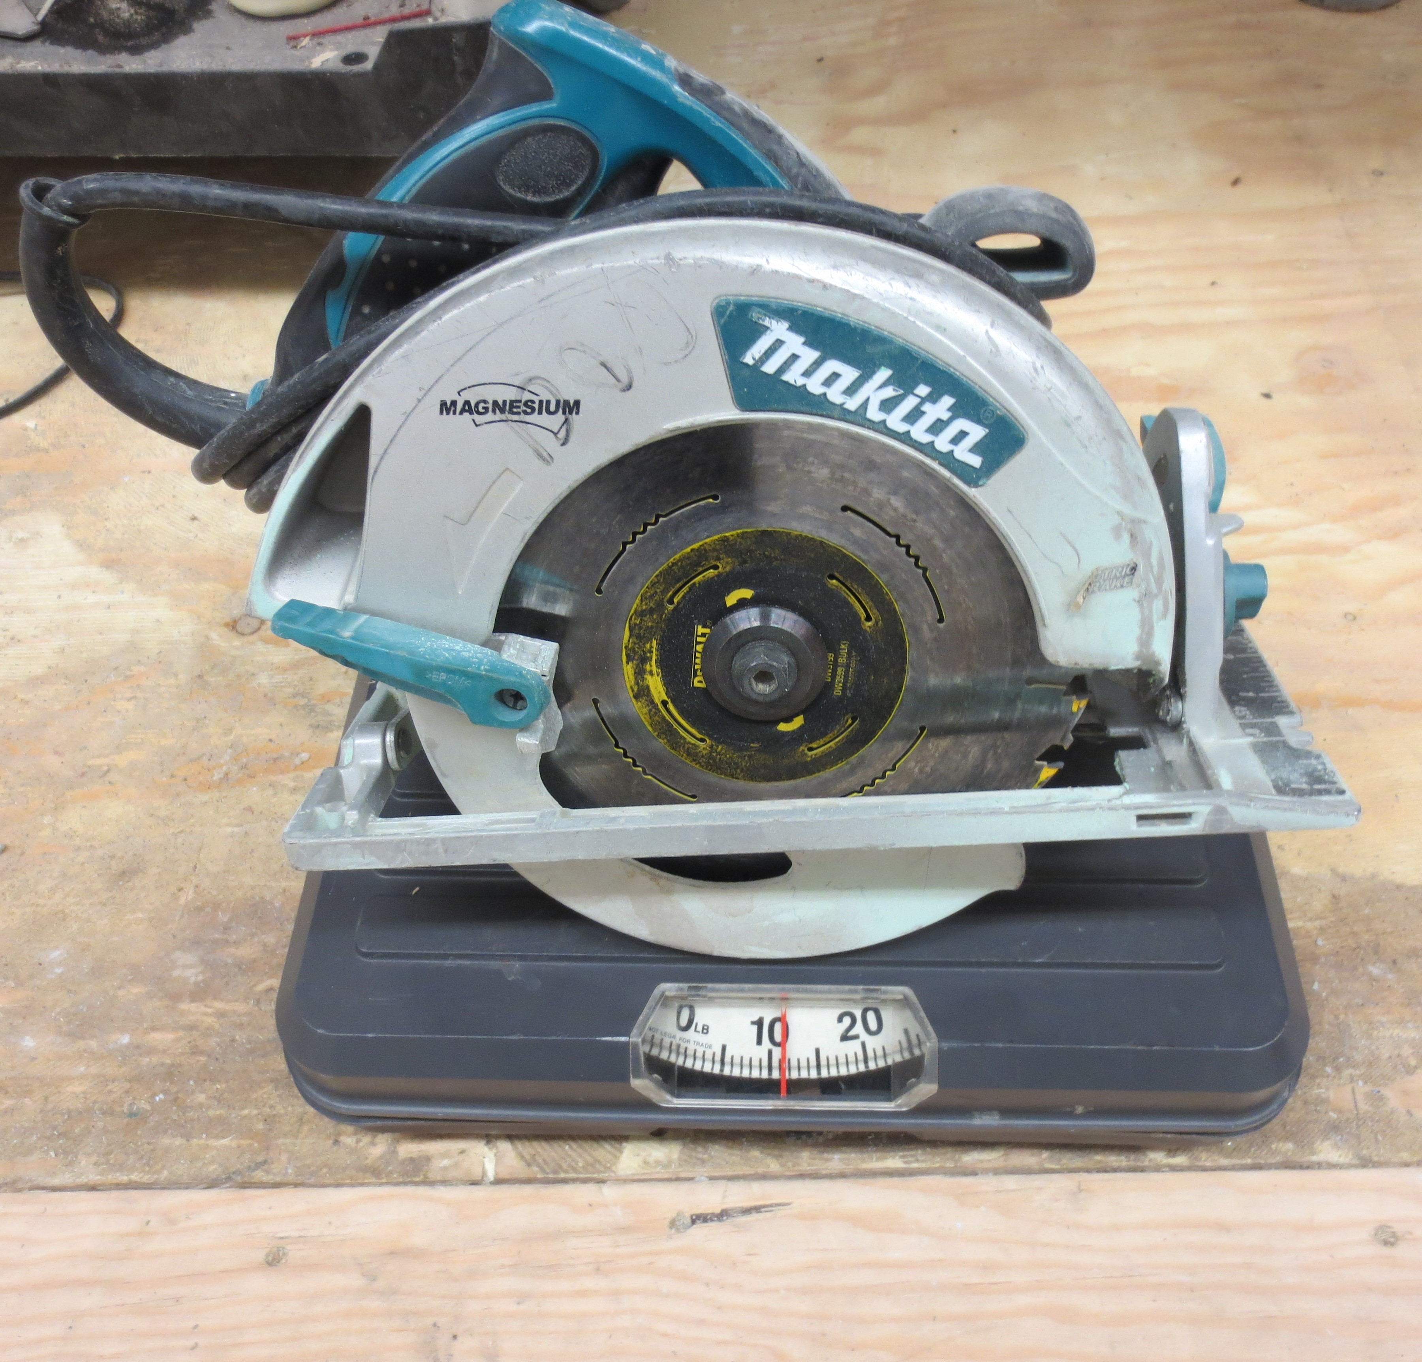 | Figure 2: A Carpenter may use large power tools such as a table saw. Large material is cut into smaller pieces in the workshop. Smaller cuts of material is easier to handle.  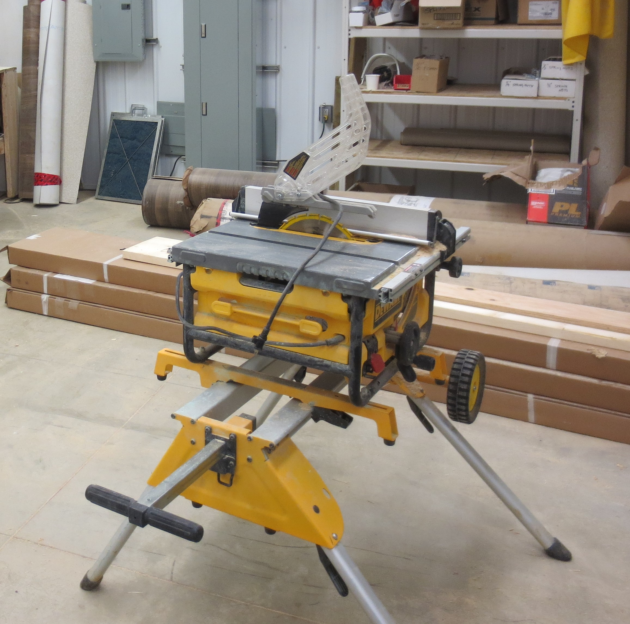
Figure 3: A Carpenter may repair wall fixtures such as clothing hooks. The Carpenter may need to replace an entire clothing hook.  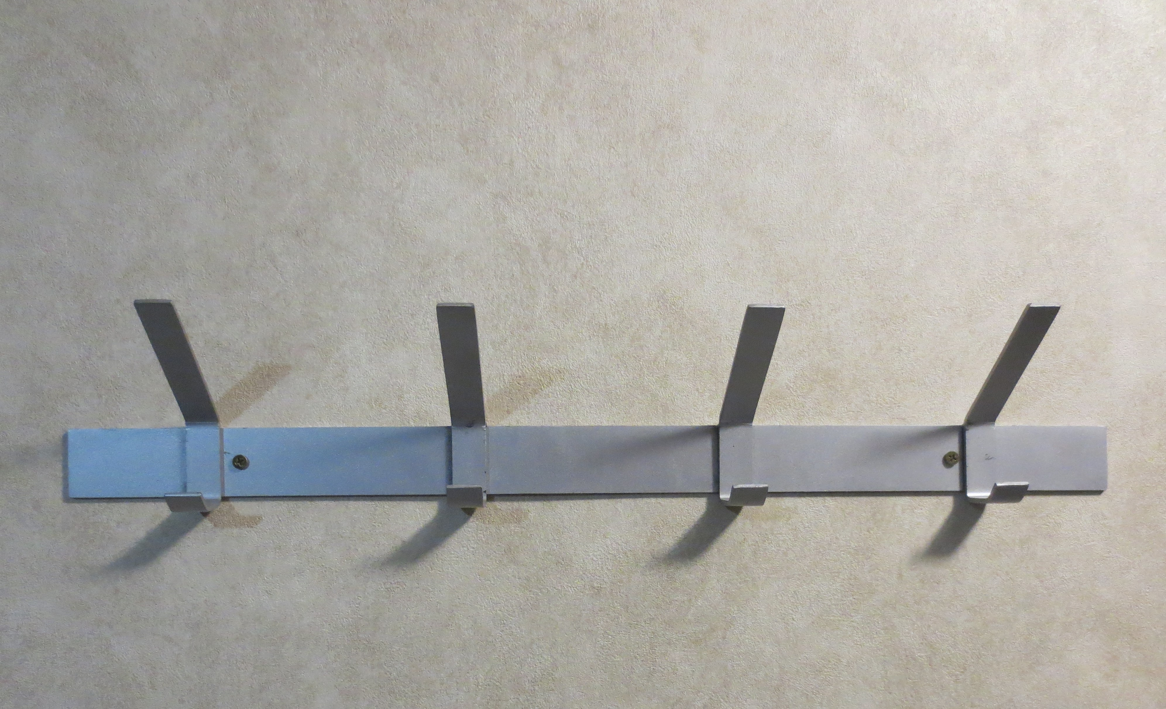 | Figure 4: A Carpenter may repair wall fixtures such as towel bars. The Carpenter may need to replace an entire towel bar.  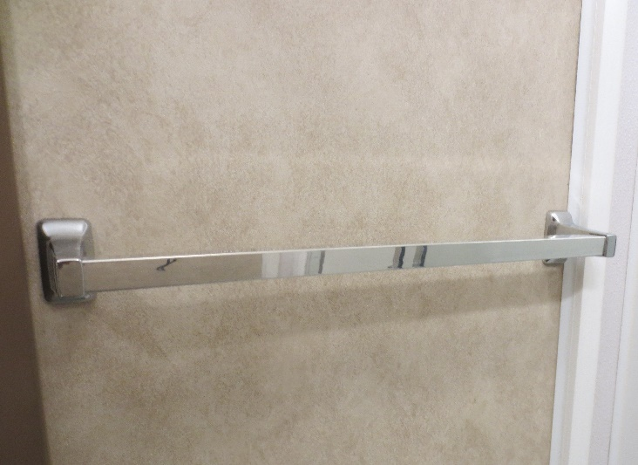

_________________________
Richard Huynh, BScKin
Kinesiologist

SITE SPECIFIC JOB DEMAND ADDITIONS:

Job Demand | Frequency |  |  |  |  | Details/Measurements
 | N/R | R | O | F | C
Site Specific Job Demand:

Validation Agreement

Job Title: | Carpenter
Data Collection Date: | February 26, 2018

We the undersigned have reviewed the Physical Demands Analysis for this position and agree that the physical demands documented in this report are representative of the true demands of the tasks associated with the job title as assessed on the date listed above.

Completed by: |  | Richard Huynh, Kinesiologist
Approved by: |  | Management Representative
Approved by: |  | Worker Representative
Approved by: |  | Labour Provider Representative

