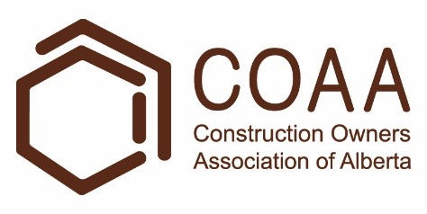 | Physical Demands Analysis  Camp Attendant  Prepared for:  Construction Owners Association of Alberta

Job Title: | Camp Attendant | Assessment Location: |  | Data Collection Date:

Completed By: |  | Submitted on:

Disclaimer: | The Physical Demands noted in this report may vary depending on company and location. Please contact the company directly to confirm this physical demands analysis is an accurate representation of the specific job title for the specific location.

Work Schedule: | Shift Duration: 10 hours/day; may vary  Break Schedule: Total of 1 hour break per day  Shift Rotation: 14 days on, 7 days off  On call is required: Yes; but very rare  Overtime required: No; but may be available

Education / Experience: | Education required: No post-secondary education is required  Hours required for position: N/A  Tickets that may be required (not limited to): First Aid, WHMIS, Construction Safety Training Systems (CSTS) and Basic Safety Orientation (BSO).

Labour Provider: | N/A

Job Overview: | The Camp Attendant is responsible for cleaning guest rooms while guests are staying over or after guests have checked out. Each day the Attendant is assigned a wing and rooms to clean.
 | % of shift | Job Task | Task Description
 | 10% | Safety/meetings | - Toolbox talk – Safety topics are discussed during the toolbox talk. The Camp attendant will receive additional information such as:  - Tasks for the day  - Important events from previous shifts  - Daily stretches are done before their shift starts.
 | 90% | On site work | - Collecting cleaning supplies and equipment  - A cleaning cart is loaded with cleaning supplies, equipment, and linen.  - Spray bottles and buckets are filled with cleaning solutions.  - The cleaning cart is pushed to the designated guest rooms within the wing.  - Cleaning guest rooms (following a checklist)  - Within the guest washroom,  - The attendant will clean the shower, toilet, and vanity.  - Replacing towels and amenities.  - Within the guest bedroom,  - The attendant will clean the lights, windows, walls, doors, floors, TVs, phones, chairs, and air conditioning unit.  - Replacing garbage bags and linen.  - Collecting garbage and used linen.  - Bags are carried to the entrance of the wing for later collection by the janitorial staff.  - Bags may be carried across the length of the wing and down a set of stairs.

Equipment/  Tools: | - Mop (3 dry, ~7 lbs wet)  - Bucket (~25 lbs when full)  - Chemical dispenser (5-12 lbs when full)  - Spray bottle (~1 lbs)  - Microfiber towels (<1 lbs)  - Broom and dust pan (3 lbs)

Exposures / Environment: | - Chemicals  - Pinch points

Personal Protective  Equipment Required: | - Gloves
Personal Protective  Equipment as Required: | - Safety eyewear

NOC STRENGTH LEVEL KEY
Strength Level | Definition
Limited (Lim) | Up to 5 kg (11 pounds)
Light (L) | 5 kg to 10 kg (11 – 22 pounds)
Medium (M) | 10 kg to 20 kg (22 – 44 pounds)
Heavy (H) | Greater than 20 kg (44 pounds plus)
*Strength Level Key based on the National Occupational Classification

FREQUENCY KEY
Frequency | % of Workday | Hours – Based on 8 hour Workday
Not Required (N/R) | 0% | 0
Rarely (R) | 1 – 5% | <25 min/day
Occasionally (O) | 6 – 33% | 25 min to 2 hours 40 min/day
Frequently (F) | 34 – 66% | 2 hours 41 min to 5 hours 17 min/day
Constantly (C) | 67 – 100% | 5 hours 18 min to 8 hours/day
*Frequency Key based on WCB Alberta Recommendations

Job Demand | Frequency / NOC Strength Level |  |  |  |  | Details/ Measurements
 | N/R | R | O | F | C

Material Handling:
Floor to Waist Level Lifting |  |  | L |  |  | - Limited to light level lifting may occur with (but not limited to):  - Microfiber cloth (<1 lbs)  - Spray bottle (~1 lbs)  - Linen (1-3 lbs)  - Small garbage bags (5-10 lbs)  - Bags of linen (10 – 15 lbs)
Knee to Waist Level Lifting |  | M | L |  |  | - Limited to light level lifting may occur with (but not limited to):  - Linen (1-3 lbs)  - Small garbage bags (5-10 lbs)  - Bags of linen (10 – 15 lbs)  - Chemical dispenser (5-12 lbs)  - Medium level lifting may occur with (but not limited to) a mopping bucket (~25 lbs).  - Occurs when emptying the bucket.
Waist to Waist Level Lifting |  |  | L |  |  | - Limited to light level lifting may occur with (but not limited to):  - Microfiber cloth (<1 lbs)  - Spray bottle (~1 lbs)  - Linen (1-3 lbs)  - Small garbage bags (5-10 lbs)  - Bags of linen (10 – 15 lbs)  - Chemical dispenser (5-12 lbs)
Waist to Chest Level Lifting |  |  | L |  |  | - As above
Waist to Shoulder Level Lifting |  |  | Lim |  |  | - Limited level lifting may occur with (but not limited to):  - Microfiber cloth (<1 lbs)  - Spray bottle (~1 lbs)
Waist to Overhead Level Lifting |  |  | Lim |  |  | - As above
Front Carry |  |  | L |  |  | - Limited to light level carrying may occur with (but not limited to):  - Microfiber cloth (<1 lbs)  - Spray bottle (~1 lbs)  - Linen (1-3 lbs)  - Small garbage bags (5-10 lbs)  - Bags of linen (10 – 15 lbs)
Right / Left-handed Carry (Dominant Hand) |  |  | L |  |  | - As above
Shoulder Carry | X
Static  Pushing/Pulling (Force) | X
Dynamic  Pushing/Pulling (Force) |  |  |  | L |  | - Cleaning cart (15 lbs of force)  - Pulling bags of linen or garbage  - Using a microfiber cloth, broom, or mop.

Job Demand | Frequency |  |  |  |  | Details/Measurements
 | N/R | R | O | F | C

Upper Extremity Work:
Hand Gripping |  |  |  | X |  | - Gripping cleaning equipment, cleaning cart, linen, and supplies.
Pinch Gripping |  | X |  |  |  | - When using a pen to complete paperwork.
Upper Extremity Coordination |  |  |  | X |  | - When using cleaning equipment.  - When maneuvering the cleaning cart, linen, and supplies.
Reaching Forward |  |  |  | X |  | - As above
Overhead Shoulder Level Reaching |  |  | X |  |  | - Reaching overhead to clean high-level surfaces.
Below Shoulder Level Reaching |  |  |  | X |  | - When lifting equipment such as spray bottles and towels.  - Reaching to clean low-level surfaces.  - Reaching to change linen.
Throwing | X

Job Demand | Frequency |  |  |  |  |  | Details/Measurements
 | N/R |  | R | O | F | C
Positional Work:
Trunk Flexion (Bending) |  |  |  |  | X |  | - When lifting equipment such as spray bottles and towels.  - When cleaning at low levels.  - When changing linen.
Trunk Rotation (Twisting) |  |  |  | X |  |  | - When using a mop or broom.
Kneeling |  |  |  | X |  |  | - When cleaning at low levels.
Crawling |  | X
Crouching |  |  |  |  | X |  | - As above
Squatting |  |  |  |  | X |  | - When lifting equipment such as spray bottles and towels.
Neck Flexion |  |  |  |  | X |  | - When lifting equipment such as spray bottles and towels.  - When cleaning at low-levels.
Neck Extension |  |  |  |  | X |  | - When cleaning at high-levels.
Neck Rotation |  |  |  | X |  |  | - When using a mop or broom.

Job Demand | Frequency |  |  |  |  | Details/Measurements
 | N/R | R | O | F | C
Static Work:
Sitting |  | X |  |  |  | - When attending meetings.
Static Standing |  |  | X |  |  | - When using a spray bottle and microfiber cloth to clean.  - When folding linen.
Balancing | X

Job Demand | Frequency |  |  |  |  | Details/Measurements
 | N/R | R | O | F | C
Ambulation:
Walking: Level Surfaces |  |  |  |  | X | - Walking indoors.
Walking: Uneven Surfaces | X
Walking: Slopes | X
Jumping | X
Running | X

Job Demand | Frequency |  |  |  |  | Details/Measurements
 | N/R | R | O | F | C
Climbing:
Stairs |  |  |  | X |  | - Stairs indoors.
Ladder | X
Other | X

PHOTOS OF TASK AND WORK ENVIRONMENT
Figure 1: The Camp Attendant will load a cleaning cart with linen and supplies. The cart is pushed from room to room.  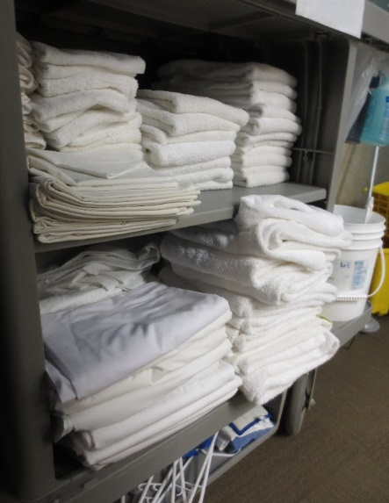 | Figure 2: A dispensing system is used to fill spray bottles and mop buckets with cleaning chemicals.  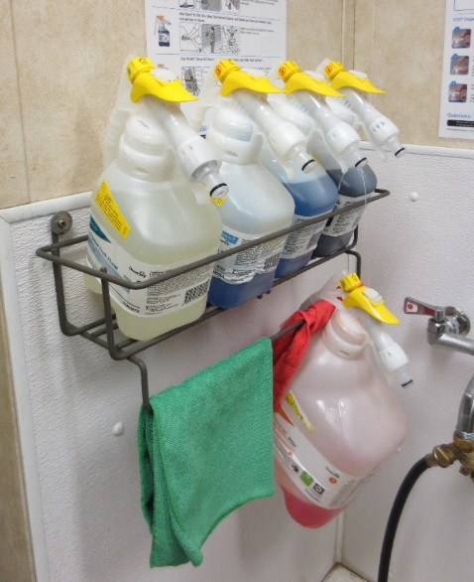

Figure 3: The Camp Attendant will use the dispensing system to fill up the mop bucket.  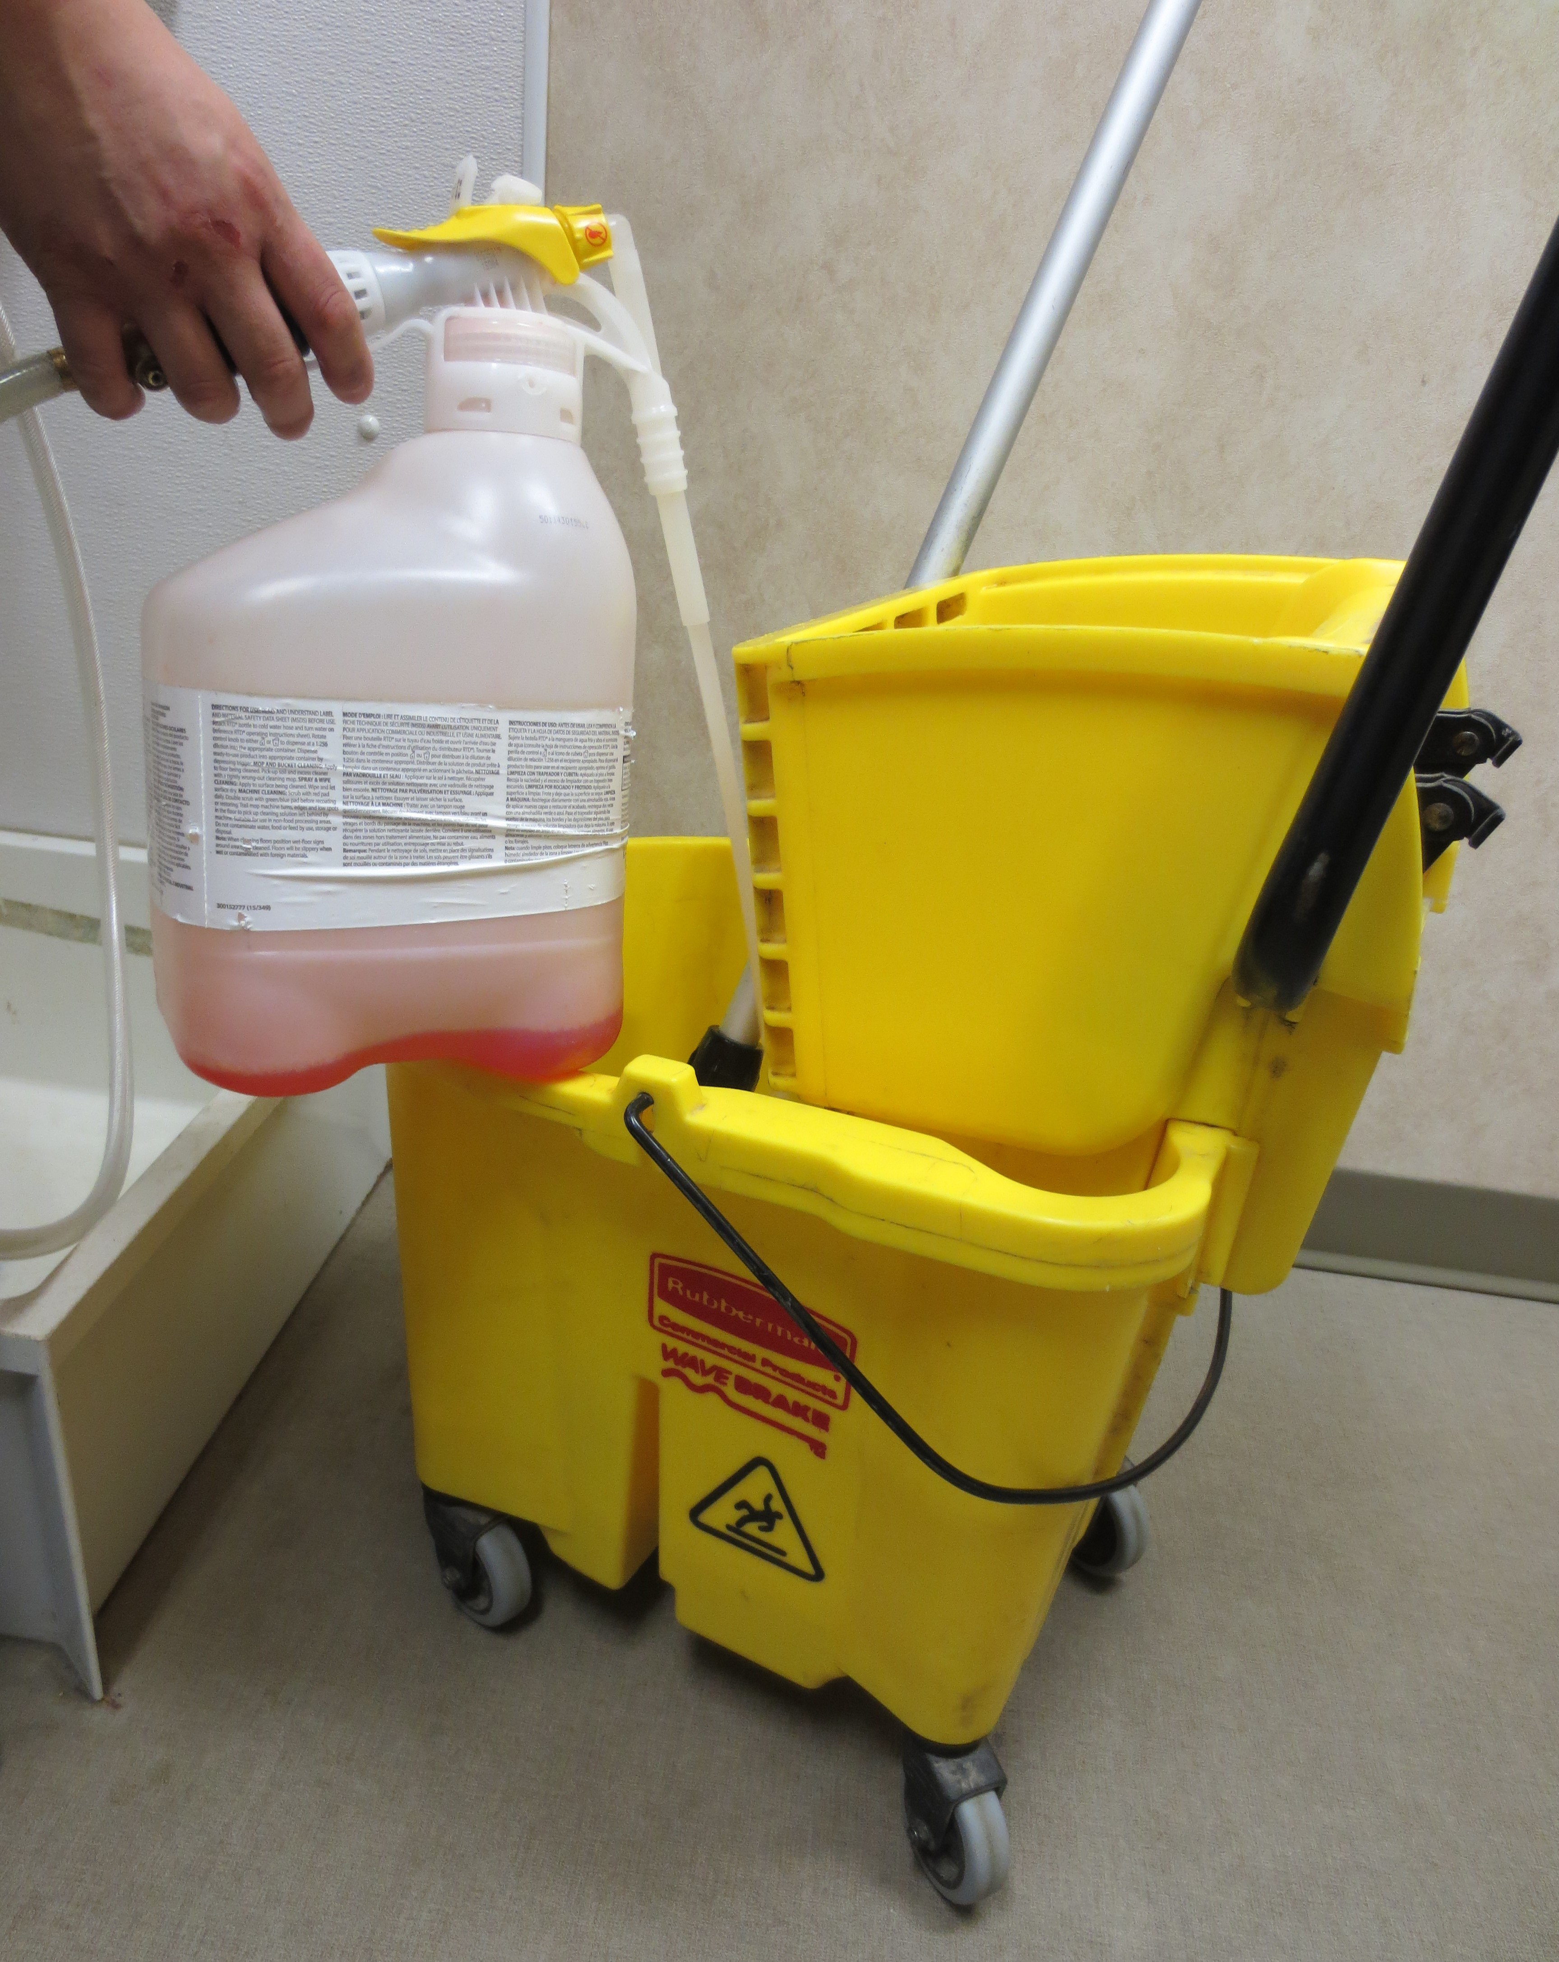 | Figure 3: When cleaning guest rooms, the Camp Attendant will replace.  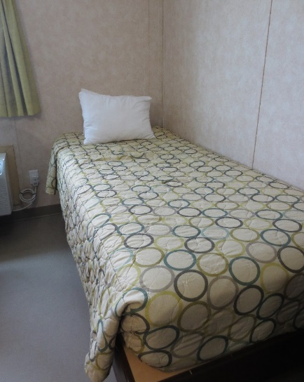
__________________________
Richard Huynh, BScKin
Kinesiologist

SITE SPECIFIC JOB DEMAND ADDITIONS:

Job Demand | Frequency |  |  |  |  | Details/Measurements
 | N/R | R | O | F | C
Site Specific Job Demand:

Validation Agreement

Job Title: | Camp Attendant
Data Collection Date: | February 27, 2018

We the undersigned have reviewed the Physical Demands Analysis for this position and agree that the physical demands documented in this report are representative of the true demands of the tasks associated with the job title as assessed on the date listed above.

Completed by: |  | Insert Lifemark Clinician Name and Credentials
Approved by: |  | Management Representative
Approved by: |  | Worker Representative
Approved by: |  | Labour Provider Representative

