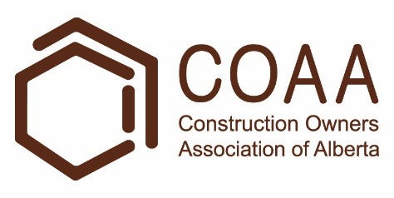 | Physical Demands Analysis  Bricklayer  Prepared for:  Construction Owners Association of Alberta

Job Title: | Bricklayer | Assessment Location: |  | Data Collection Date:

Completed By: |  | Submitted on:

Disclaimer: | The Physical Demands noted in this report may vary depending on company and location. Please contact the company directly to confirm this physical demands analysis is an accurate representation of the specific job title for the specific location.

Work Schedule: | Shift Duration: 5 days/week, 8 hours/day; may vary  Break Schedule: Total of 1 hour break per day  Shift Rotation: Not applicable  On call is required: No  Overtime required: No; but may be available

Education / Experience: | Education required: Journeyman Bricklayer Certificate or equivalent. To obtain this, they must complete a 4 year apprenticeship program. The in-class portion is 8 weeks for the first 3 years, and 12 weeks in the fourth year.  Hours required for position: ~1500 hours  Tickets that may be required (not limited to): Fall protection, First Aid, WHIMIS, Construction Safety Training Systems (CSTS) and Basic Safety Orientation (BSO).

Labour Provider: | N/A

Job Overview: | The Bricklayer is responsible for working on various masonry projects such as new commercial buildings and restoration projects. Their tasks include (but not limited to) reading blueprints, installing concrete masonry units (CMUs), inspecting walls, and installing vapor barriers.
 | % of shift | Job Task | Task Description
 | 60-80% | Installing concrete masonry units | - Reading blueprints and instructions.  - Installing CMUs, which involves spreading mortar, lifting blocks into place, and tooling joints.  - The motions are very repetitive.  - The Bricklayer may install up to 150 blocks a day, or 400-500 bricks a day.  - Working at heights on scaffolding or swing stages.
 | 10-30% | Prepping, inspecting, and finishing walls | - Rubbing, patching, and inspecting walls.  - Installing insulation, anchors, and vapor barriers.
 | 0-10% | Miscellaneous tasks | - Completing Field Level Hazard Assessments (FLHAs).  - Assisting other workers by performing the following tasks:  - General site clean up  - Mixing mortar  - Pouring concrete

Equipment/  Tools: | - Hand tools such as a trowel, hammer, or jointer (1-3 lbs)  - Mortar board (~5 lbs)  - Grinder (~5 lbs)  - Hammer drill (~10 lbs)  - Masonry saw  - Quickie saw

Exposures / Environment: | - Hot Temperatures  - Cold Temperatures  - Dust and fumes  - Working from heights  - Pinch points  - Overhead hazards

Personal Protective  Equipment Required: | - Hard hat  - Steel toed boots  - Foam safety eyewear (fectoggle)  - Safety vest or high visibility stripes  - Long sleeves and pants
Personal Protective  Equipment as Required: | - Dust mask or respirator  - Hearing protection  - Face shield  - Gloves  - Fall protection

NOC STRENGTH LEVEL KEY
Strength Level | Definition
Limited (Lim) | Up to 5 kg (11 pounds)
Light (L) | 5 kg to 10 kg (11 – 22 pounds)
Medium (M) | 10 kg to 20 kg (22 – 44 pounds)
Heavy (H) | Greater than 20 kg (44 pounds plus)
*Strength Level Key based on the National Occupational Classification

FREQUENCY KEY
Frequency | % of Workday | Hours – Based on 8 hour Workday
Not Required (N/R) | 0% | 0
Rarely (R) | 1 – 5% | <25 min/day
Occasionally (O) | 6 – 33% | 25 min to 2 hours 40 min/day
Frequently (F) | 34 – 66% | 2 hours 41 min to 5 hours 17 min/day
Constantly (C) | 67 – 100% | 5 hours 18 min to 8 hours/day

*Frequency Key based on WCB Alberta Recommendations

Job Demand | Frequency / NOC Strength Level |  |  |  |  | Details/ Measurements
 | N/R | R | O | F | C

Material Handling:
Floor to Waist Level Lifting |  |  | H | M |  | - Occurs when lifting material to build a wall.  - Heavy lifting may include (but not limited to) pails of concrete (~50 lbs).  - Medium level lifting may include (but not limited to):  - 4” Terrazzo blocks (25 lbs)  - 8” split face block (41 lbs)  - Limited level lifting may include (but not limited to) hand tools and small power tools.
Knee to Waist Level Lifting |  |  | H | M |  | - As above.
Waist to Waist Level Lifting |  |  | H |  |  | - As above.
Waist to Chest Level Lifting |  |  | M |  |  | - Occurs when lifting material to build a wall.  - Medium level lifting may include (but not limited to):  - 4” Terrazzo blocks (25 lbs)  - 8” split face block (41 lbs)  - Limited level lifting may include (but not limited to) hand tools and small power tools.
Waist to Shoulder Level Lifting |  |  | M |  |  | - Occurs when lifting material to build a wall.  - The Bricklayer will try to avoid shoulder level and overhead level lifting by using scaffolding.  - Medium level lifting may include (but not limited to):  - 4” Terrazzo blocks (25 lbs)  - 8” split face block (41 lbs)  - Limited level lifting may include (but not limited to) hand tools and small power tools.
Waist to Overhead Level Lifting |  |  | M |  |  | - As above.
Front Carry |  |  | M |  |  | - Occurs when carrying material to build a wall.  - Medium level carrying may include (but not limited to):  - 4” Terrazzo blocks (25 lbs)  - 8” split face block (41 lbs)  - Limited level carrying may include (but not limited to) hand tools and small power tools.
Right / Left-handed Carry (Dominant Hand) |  |  | H |  |  | - Occurs when carrying material to build a wall.  - Heavy level carrying may include (but not limited to) pails of concrete (~50 lbs)  - Medium level carrying may include (but not limited to):  - 4” Terrazzo blocks (25 lbs)  - 8” split face block (41 lbs)  - Limited level carrying may include (but not limited to) hand tools and small power tools.
Shoulder Carry |  | M |  |  |  | - Medium level carrying may include (but not limited to) rebar or planks.
Static  Pushing/Pulling (Force) |  | M |  |  |  | - Occurs when holding material and equipment in place.
Dynamic  Pushing/Pulling (Force) |  |  |  |  | L | - Occurs when manipulating materials and using equipment.

Job Demand | Frequency |  |  |  |  | Details/Measurements
 | N/R | R | O | F | C

Upper Extremity Work:
Hand Gripping |  |  |  |  | X | - Occurs during the installation of CMUs, which involves gripping tools and materials, such as blocks.
Pinch Gripping |  | X |  |  |  | - Occurs when operating a hoist and writing FLHAs
Upper Extremity Coordination |  |  |  |  | X | - Occurs during the installation of CMUs, which involves gripping tools and materials, such as blocks.
Reaching Forward |  |  |  |  | X | - Occurs when using hand tools, power tools, lifting, and carrying.
Overhead Shoulder Level Reaching |  |  | X |  |  | - As above.
Below Shoulder Level Reaching |  |  |  |  | X | - As above.
Throwing |  | X |  |  |  | - Occurs when throwing waste into bins.

Job Demand | Frequency |  |  |  |  |  | Details/Measurements
 | N/R |  | R | O | F | C
Positional Work:
Trunk Flexion (Bending) |  |  |  |  | X |  | - Occurs when lifting, and leveling and tooling the wall.
Trunk Rotation (Twisting) |  |  |  |  | X |  | - Occurs when retrieving a block or mortar.
Kneeling |  |  |  | X |  |  | - Occurs when starting the construction of a wall.
Crawling |  | X
Crouching |  |  |  | X |  |  | - Occurs when starting the construction of a wall and lifting.
Squatting |  |  |  |  | X |  | - As above.
Neck Flexion |  |  |  |  | X |  | - Monitoring surroundings, inspecting the work
Neck Extension |  |  |  |  | X |  | - As above.
Neck Rotation |  |  |  |  | X |  | - As above.

Job Demand | Frequency |  |  |  |  | Details/Measurements
 | N/R | R | O | F | C
Static Work:
Sitting | X
Static Standing |  |  |  |  | X | - Installing CMUs, washing and finishing a wall.
Balancing |  |  | X |  |  | - Climbing scaffolds or ladders.

Job Demand | Frequency |  |  |  |  | Details/Measurements
 | N/R | R | O | F | C
Ambulation:
Walking: Level Surfaces |  |  |  | X |  | - Walking on scaffolds and concrete floors.  - Walking on level surfaces is site dependant.
Walking: Uneven Surfaces |  |  |  | X |  | - Walking on gravel, ice, snow, water, and mud.
Walking: Slopes |  |  | X |  |  | - Walking on slopes is site dependant.
Jumping | X
Running | X

Job Demand | Frequency |  |  |  |  | Details/Measurements
 | N/R | R | O | F | C
Climbing:
Stairs |  | X |  |  |  | - Walking up to various building levels.  - The amount of stairs is site dependant.
Ladder |  |  | X |  |  | - Climbing up scaffolds and ladders.
Other | X

PHOTOS OF TASKS AND WORK ENVIRONMENT

Figure 1: The Bricklayer will spend the most of their workday installing CMUs according to blueprints and specifications.  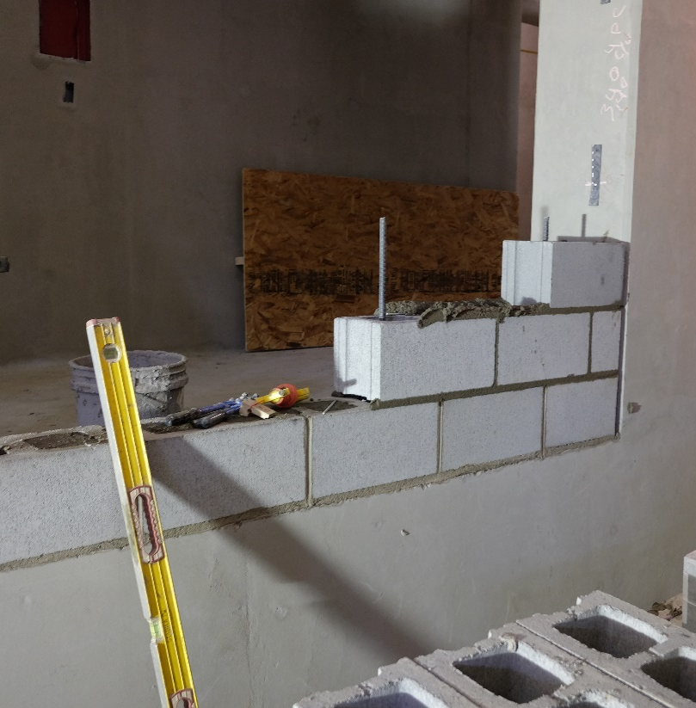 | Figure 2: The Bricklayer is using a spirit level to ensure blocks are flush with one another. The Bricklayer will use a variety of hand tools to install CMUs.  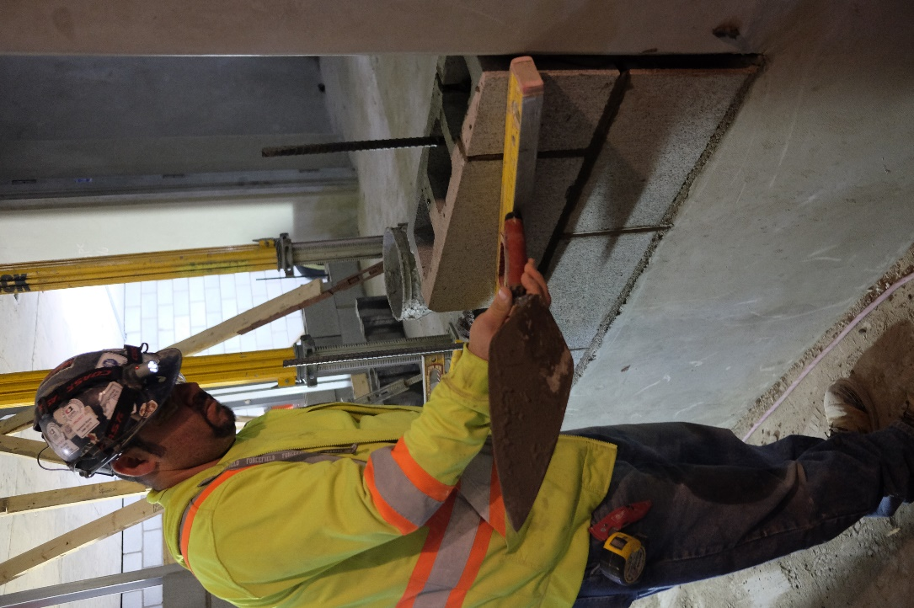

Figure 3: The Bricklayer is crouching to install CMUs at a low level. The Bricklayer will spend time in various postures when installing CMUs.  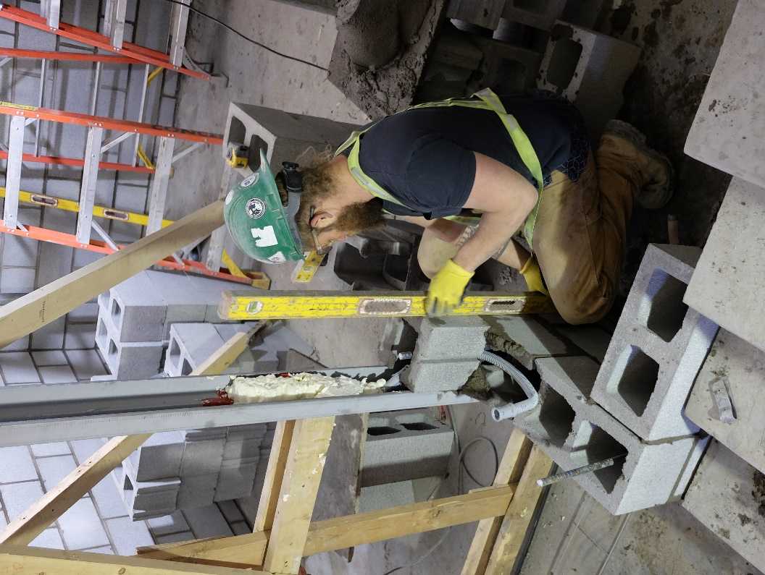 | Figure 4: The Bricklayer is using a masonry saw to cut a block to size. The Bricklayer may assist other workers.  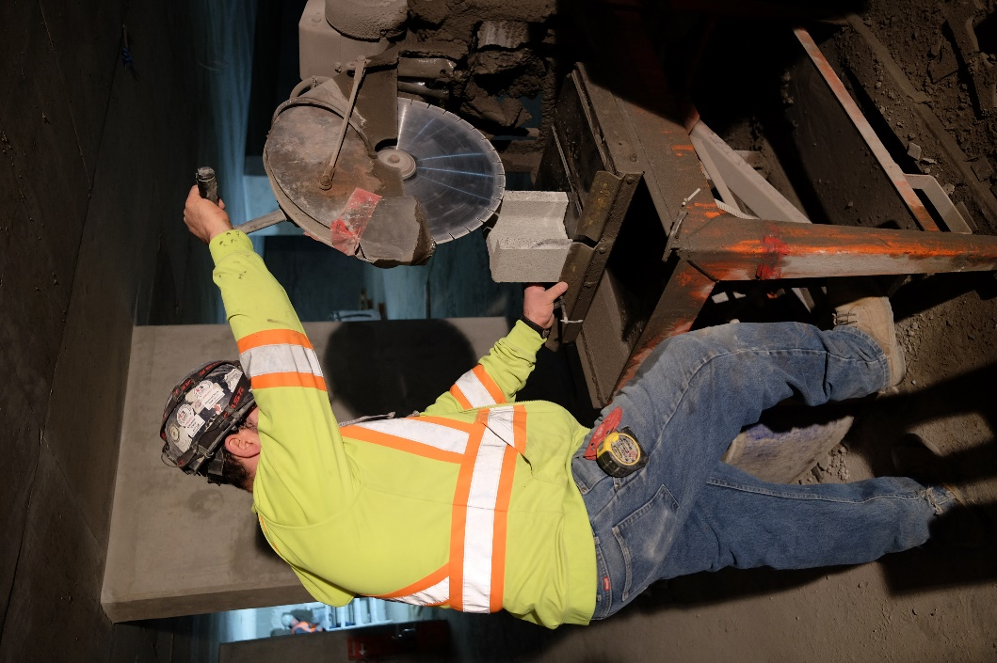

__________________________
Richard Huynh, BScKin
Kinesiologist

SITE SPECIFIC JOB DEMAND ADDITIONS:

Job Demand | Frequency |  |  |  |  | Details/Measurements
 | N/R | R | O | F | C
Site Specific Job Demand:

Validation Agreement

Job Title: | Bricklayer
Data Collection Date: | May 11, 2018

We the undersigned have reviewed the Physical Demands Analysis for this position and agree that the physical demands documented in this report are representative of the true demands of the tasks associated with the job title as assessed on the date listed above.

Completed by: |  | Insert Lifemark Clinician Name and Credentials
Approved by: |  | Management Representative
Approved by: |  | Worker Representative
Approved by: |  | Labour Provider Representative

