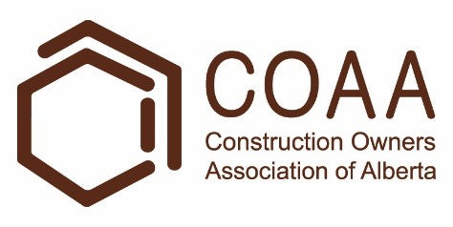 | Physical Demands Analysis  Baker  Prepared for:  Construction Owners Association of Alberta

Job Title: | Baker | Assessment Location: |  | Data Collection Date:

Completed By: |  | Submitted on:

Disclaimer: | The Physical Demands noted in this report may vary depending on company and location. Please contact the company directly to confirm this physical demands analysis is an accurate representation of the specific job title for the specific location.

Work Schedule: | Shift Duration: 10 hours/day; may vary  Break Schedule: Total of 1 hour break per day  Shift Rotation: 14 days on, 7 days off  On call is required: Yes; but very rare  Overtime required: No; but may be available

Education / Experience: | Education required: Journeyman Baking Certificate. To obtain this, they must complete a 4-year apprenticeship program. The in-class portion is 8 weeks for the first 3 years; and 12 weeks in the fourth year.  Hours required for position: ~1500 hours  Tickets that may be required (not limited to): First Aid, WHMIS, Construction Safety Training Systems (CSTS) and Basic Safety Orientation (BSO).

Labour Provider: | N/A

Job Overview: | The Baker is responsible for the preparation of baked goods. They may bake pastries using a recipe, or prepare premade desserts.
 | % of shift | Job Task | Task Description
 | 10% | Safety/meetings | - Toolbox talk – Safety topics are discussed during the toolbox talk. The Baker will receive additional information such as:  - Tasks for the day  - Important events from previous shifts
 | 90% | On site work | - When baking pastries from a recipe, the Baker will perform the following tasks:  - Sanitizing workstation using a food safe cleaner.  - Collecting supplies  - Equipment such as mixing bowls, baking sheets, and whisks.  - Ingredients such as sugar, flour, and eggs.  - Preparing ingredients according to the recipe.  - Measuring and mixing ingredients.  - Baking pastries in the convection oven.  - Allowing pastries to cool.  - Portioning pastries into individual servings.  - Storing pastries on rolling racks for later service.  - When preparing premade pastries, the Baker will perform the following tasks:  - Sanitizing workstation using a food safe cleaner.  - Collecting supplies  - Equipment such as baking sheets and cooling racks.  - Boxes of pastries such as tarts or donuts.  - Preparing premade pastries.  - The baker may need to mix packets of ingredients, bake pastries, or portion pastries into individual servings.  - Storing pastries on rolling racks for later service.  - The baker will sanitize their workstation and take equipment to the dishwasher between tasks.

Equipment/  Tools: | - Baking and cooking utensils, such as whisks and spatulas (~1 lbs)  - Oven mitts (<1 lbs)  - Baking sheets (~1 lbs)  - Mixing bowls, various sizes  - Push cart  - Rolling racks  - Step ladder

Exposures / Environment: | - Wet floors  - Cold temperatures  - Hot temperatures  - Pinch points

Personal Protective Equipment Required: | - Hair net  - Beard net  - Gloves  - Non-slip footwear
Personal Protective Equipment as Required: | - Oven mitts

NOC STRENGTH LEVEL KEY
Strength Level | Definition
Limited (Lim) | Up to 5 kg (11 pounds)
Light (L) | 5 kg to 10 kg (11 – 22 pounds)
Medium (M) | 10 kg to 20 kg (22 – 44 pounds)
Heavy (H) | Greater than 20 kg (44 pounds plus)
*Strength Level Key based on the National Occupational Classification

FREQUENCY KEY
Frequency | % of Workday | Hours – Based on 8 hour Workday
Not Required (N/R) | 0% | 0
Rarely (R) | 1 – 5% | <25 min/day
Occasionally (O) | 6 – 33% | 25 min to 2 hours 40 min/day
Frequently (F) | 34 – 66% | 2 hours 41 min to 5 hours 17 min/day
Constantly (C) | 67 – 100% | 5 hours 18 min to 8 hours/day
*Frequency Key based on WCB Alberta Recommendations

Job Demand | Frequency / NOC Strength Level |  |  |  |  | Details/ Measurements
 | N/R | R | O | F | C

Material Handling:
Floor to Waist Level Lifting |  | H |  | L |  | - Heavy level lifting may occur with baking ingredients, such as bags of sugar (44 lbs).  - Limited to light level lifting may occur with (but not limited to):  - Empty baking sheets (~1.5 lbs each)  - Baking ingredients  - Boxes of pastries (~10 lbs)
Knee to Waist Level Lifting |  | H | M | L |  | - Heavy level lifting may occur with baking ingredients, such as bags of sugar (44 lbs).  - Medium level lifting may occur with large mixing bowls.  - Limited to medium level lifting may occur with (but not limited to):  - Empty baking sheets (~1.5 lbs each)  - Utensils (1-2 lbs)  - Baking sheets with pastries (~12 lbs)  - Baking ingredients  - Boxes of pastries (~10 lbs)
Waist to Waist Level Lifting |  | H | M | L |  | - As above
Waist to Chest Level Lifting |  |  |  | L |  | - Limited to light level lifting may occur with (but not limited to):  - Utensils (1-2 lbs)  - Baking sheets with pastries (~12 lbs)  - Medium size mixing bowls (~1 lbs each)  - Boxes of pastries (~10 lbs)
Waist to Shoulder Level Lifting |  |  |  | L |  | - As above
Waist to Overhead Level Lifting |  |  | L |  |  | - As above
Front Carry |  | H | M |  |  | - Heavy level carrying may occur with baking ingredients, such as bags of sugar (44 lbs).  - Limited to medium level carrying may occur with (but not limited to):  - Empty baking sheets (~1.5 lbs each)  - Utensils (1-2 lbs)  - Baking sheets with pastries (~12 lbs)  - Large mixing bowls (40 lbs)  - Baking ingredients  - Boxes of pastries (~10 lbs)
Right / Left-handed Carry (Dominant Hand) |  |  | M |  |  | - Limited to medium level carrying may occur with (but not limited to):  - Empty baking sheets (~1.5 lbs each)  - Utensils (1-2 lbs)  - Pails of ingredients (up to 35 lbs)
Shoulder Carry | X
Static  Pushing/Pulling (Force) | X
Dynamic  Pushing/Pulling (Force) |  |  |  | L |  | - Pushing rolling racks (up to 15 lbs)  - Pushing cart of supplies (up to 15 lbs)  - Opening and closing walk in freezer and refrigerator door

Job Demand | Frequency |  |  |  |  | Details/Measurements
 | N/R | R | O | F | C

Upper Extremity Work:
Hand Gripping |  |  |  | X |  | - Gripping utensils, baking sheets, door handles, cart handles.
Pinch Gripping |  |  |  | X |  | - When using a pen to complete paperwork.  - Sorting individual pastries.
Upper Extremity Coordination |  |  |  | X |  | - When lifting equipment and supplies  - When using baking utensils.
Reaching Forward |  |  |  | X |  | - As above
Overhead Shoulder Level Reaching |  |  | X |  |  | - Reaching for supplies stored on overhead shelves such as mixing bowls.
Below Shoulder Level Reaching |  |  |  | X |  | - When lifting equipment and supplies such as baking sheets.  - Reaching into large mixing bowls.
Throwing | X

Job Demand | Frequency |  |  |  |  |  | Details/Measurements
 | N/R |  | R | O | F | C
Positional Work:
Trunk Flexion (Bending) |  |  |  |  | X |  | - When lifting equipment and supplies such as baking sheets.  - Reaching into large mixing bowls.
Trunk Rotation (Twisting) |  |  |  | X |  |  | - When moving baking sheets from the oven to rolling rack.  - When walking through tight spaces in the walk-in fridge and freezer.
Kneeling |  | X |  |  |  |  | .
Crawling |  | X
Crouching |  |  | X |  |  |  | - When checking on baked goods at the bottom of the oven or rolling rack.
Squatting |  |  |  | X |  |  | - When lifting equipment and supplies such as baking sheets.
Neck Flexion |  |  |  |  | X |  | - When lifting equipment and supplies such as baking sheets.  - When mixing ingredients at counter height.  - When portioning servings on the counter.
Neck Extension |  |  |  | X |  |  | - When reaching for supplies and baking sheets at higher levels.
Neck Rotation |  |  |  | X |  |  | - When collecting baking supplies, such as ingredients and equipment.

Job Demand | Frequency |  |  |  |  | Details/Measurements
 | N/R | R | O | F | C
Static Work:
Sitting |  | X |  |  |  | - When attending meetings.
Static Standing |  |  |  | X |  | - When preparing pastries or mixing ingredients.
Balancing |  | X |  |  |  | - On a step ladder.

Job Demand | Frequency |  |  |  |  | Details/Measurements
 | N/R | R | O | F | C
Ambulation:
Walking: Level Surfaces |  |  |  |  | X | - Walking indoors.
Walking: Uneven Surfaces | X
Walking: Slopes | X
Jumping | X
Running | X

Job Demand | Frequency |  |  |  |  | Details/Measurements
 | N/R | R | O | F | C
Climbing:
Stairs | X
Ladder |  | X |  |  |  | - Within the walk-in freezer or refrigerator.
Other | X

PHOTOS OF TASK AND WORK ENVIRONMENT

Figure 1: The Baker will use a large industrial mixer when preparing some pastries. The mixing bowl (40 lbs) is lifted into place before ingredients are added.  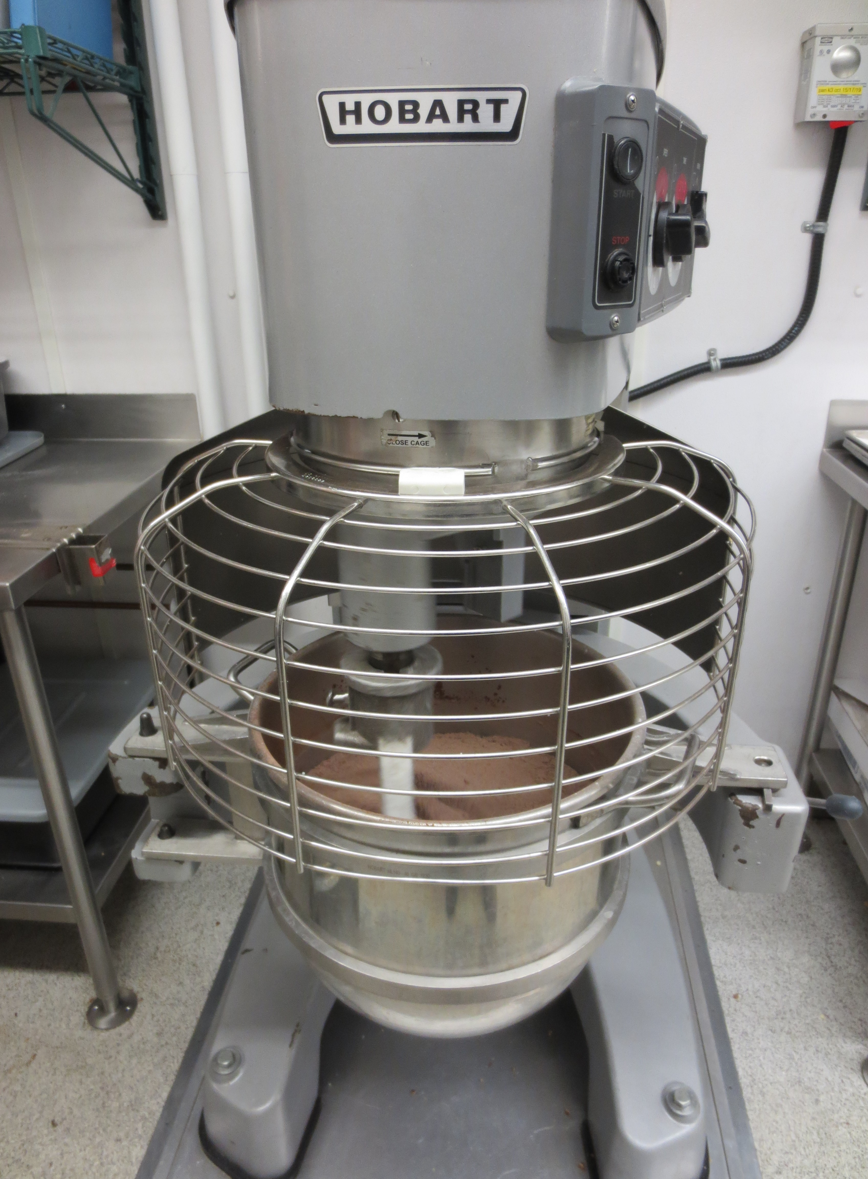 | Figure 2: The mixing bowl can swing out to the side so the baker may transfer ingredients onto a baking sheet or another container.  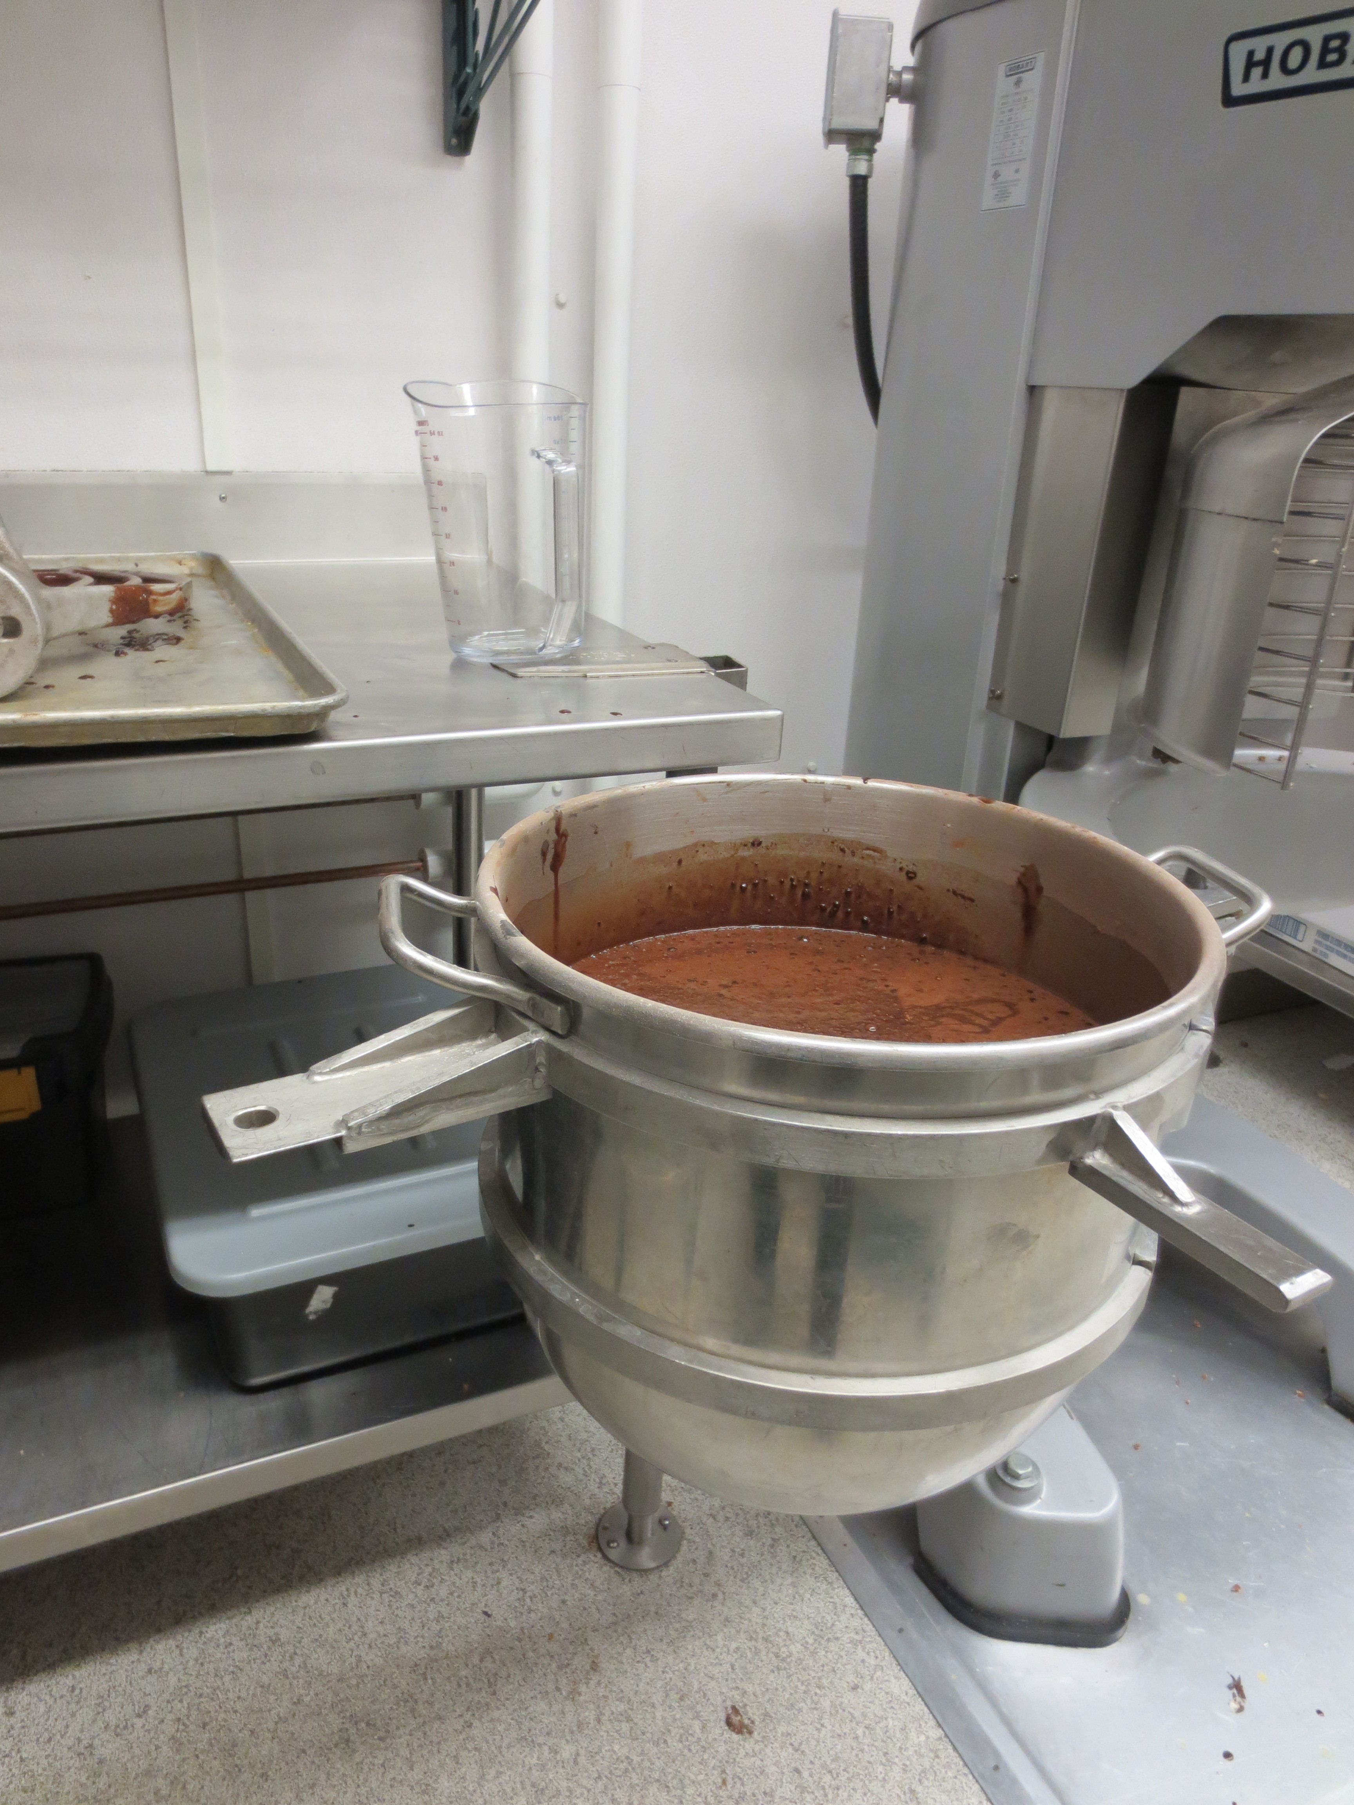

Figure 3: Mixing bowls and other equipment is stored on shelves above the workstation.  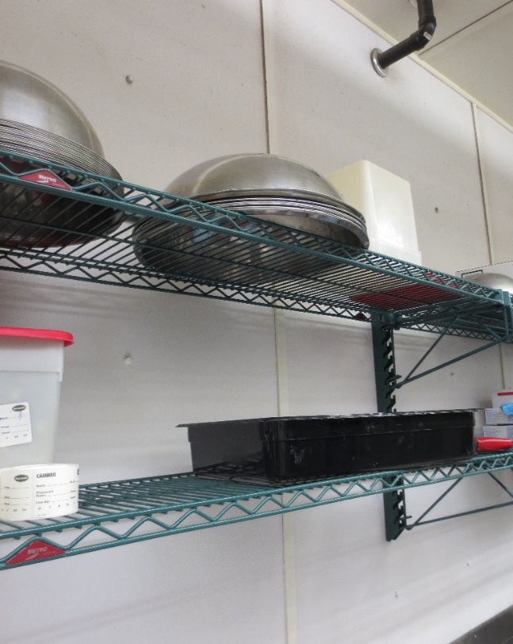 | Figure 3: Once finished baking, trays of baked goods are moved from the convection oven onto rolling racks. Trays are stored on the rolling racks before being sent out for service.  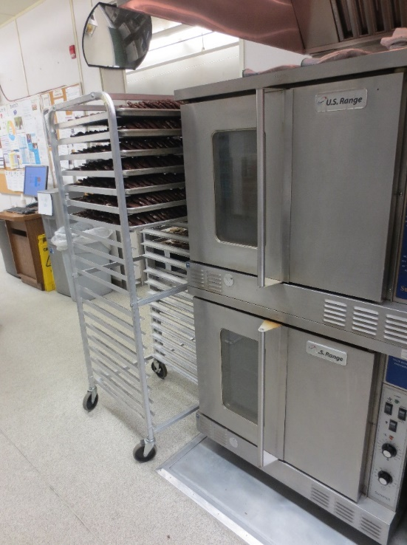

__________________________
Richard Huynh, BScKin
Kinesiologist

SITE SPECIFIC JOB DEMAND ADDITIONS:

Job Demand | Frequency |  |  |  |  | Details/Measurements
 | N/R | R | O | F | C
Site Specific Job Demand:

Validation Agreement

Job Title: | Baker
Data Collection Date: | February 27, 2018

We the undersigned have reviewed the Physical Demands Analysis for this position and agree that the physical demands documented in this report are representative of the true demands of the tasks associated with the job title as assessed on the date listed above.

Completed by: |  | Insert Lifemark Clinician Name and Credentials
Approved by: |  | Management Representative
Approved by: |  | Worker Representative
Approved by: |  | Labour Provider Representative

