 | Physical Demands Analysis  Modular Industrial 1st Year Apprentice Pipefitter  Prepared for:  Construction Owners Association of Alberta

Job Title: | Modular Industrial 1st Year Apprentice Pipefitter | Assessment Location: |  | Data Collection Date:

Completed By: |  | Submitted on:

Disclaimer: | The Physical Demands noted in this report may vary depending on company and location. Please contact the company directly to confirm this physical demands analysis is an accurate representation of the specific job title for the specific location.  Depending on the company and location, safety standards for lifting require any lifting greater than 50 lbs. to be done with two people; and any lifting greater than 80 lbs. to be done with the use of machinery.

Work Schedule: | Shift Duration: 4 days/week, 10 hours/day; may vary  Break Schedule: Total of 1 hour break per day  Shift Rotation: Not applicable  On call is required: No  Overtime required: No; but may be available

Education / Experience: | Education required: The 1st Year Apprentice is not required to have completed schooling. Upon completion of the number of hours required, they are eligible to participate in school. The full Alberta Trained Journeyman apprenticeship is 3 years. In class portion is 2 months per year of apprenticeship. To become a part of the union in Alberta, there is a 4 year apprenticeship program. Once certified as a Pipefitter, there is an opportunity to become a Red Seal Pipefitter to allow employment in all provinces in Canada.  Hours required for position: 1500 hours per year of apprenticeship.  Tickets that may be required (not limited to): Fall protection, H2S Alive, wildlife awareness, ground disturbance and Elevated Work Platform (EWP) machinery use, Confined Space, First Aid, WHIMIS, Construction Safety Training Systems (CSTS) and Basic Safety Orientation (BSO).

Labour Provider:

Job Overview: | An Industrial 1st Year Apprentice Pipefitter is responsible for assisting with creating, placing and securing a piping system within a structure. The Journeyman will double check the 1st Year Apprentice Pipefitter’s work.
 | % of shift | Job Task | Task Description
 | 10 | Safety / Job Prep and Planning Phase | - Attend safety meetings as required and perform daily stretching routine. Complete appropriate paperwork for task, including pre-task safety card.  - Direction provided by foreman / journeyman; although may be required to assist with reading blue prints, drawings and be knowledgeable of specs.  - Communication with other tradesmen; specifically working in close proximity to Pipefitter Welders and Crane Operators.  - Gather materials and tools required for the job; may need to fabricate own materials, depending on the job site.  - Inspect any equipment prior to using it. Flag off area as required.
 | 5 | Spotting for moving equipment | - A spotter is required for moving the EWP, crane, or any additional equipment that is moving throughout the site.
 | 85 | Assembling, Placing and Securing a piping system | - Preparing the spools to be assembled requires bevelling or tapering the edges of the spool using a grinder. May be required to move dunnage to prop spool up; or use pipe stand. The pipefitter performs capping and wrapping bevelled edges to protect them from the elements.  - A system is made up of many spools. To build a system, spools may be joined (welding, bolting) to a different spool or to a valve, typically with a casket between each depending on the configuration.  - Once the system is assembled, it is ready to be placed into the structure. Again, depending on the size of the system, a crane would typically be used. The pipefitter would be responsible for securing the nylon sling or support to attach to the crane and assisting / directing the crane operator for placement into the structure. This is called Rigging.  - The system remains held in the structure while the pipefitter secures the system into the structure. The pipefitter uses wrenches to secure the spool into the structure. They will then use a torque wrench to ensure the structure is as tight as it is required to be, according to the specs.  - Typically in a module, it is to be transported to a different location. Therefore, the pipefitter builds temporary supports to secure the spool to the structure. The temporary supports can be made of angle iron, threaded rod, wire rope and clamps.  - On occasion, the Pipefitter is required to complete hydro testing to ensure leaks in the piping system are not present. This is completed using a water pump truck/hydro wagon and increasing the pressure.

Equipment/  Tools/ Materials: | Equipment, tools and materials used may include, but are not limited to:  - Hammer  - Measuring tape  - Combination wrench  - Torque wrench  - Clamps (beam)  - EWP (Elevated Work Platform)  - Zoom boom & Cranes (driven by Heavy Equipment Operators)  - Squares  - Levels  - Nylon slings  - Shackles  - Wire rope  - Chain falls  - Come along  - Crosby clips  - Ratchet / socket  - Wire rope sling  - Pipe stand (large and small)  - Canvas bag to hold tools  - Hydraulic tools  - Grinders

Exposures / Environment: | Exposures and environment may include, but are not limited to:  - Inclement weather (rain, wind, varying temperatures, snow, ice, etc.)  - Uneven, slippery, rough walking surface  - Loud noises  - Sparks (if around welder)  - Moving vehicles / heavy equipment around site  - Heights greater than 6 feet  - Toxins (fire proofing materials, paint, gases, fumes)  - Vibration  - Tools falling  - Trip hazards  - Head and/or knee bangers

Personal Protective  Equipment Required: | - Hard hat  - Steel toed boots  - Gloves  - Foam safety eyewear (fectoggle)  - Safety vest or high visibility stripes  - Long sleeves and pants
Personal Protective  Equipment as Required: | - Harness / fall arrest  - Hearing protection  - Face shield  - Respirator

NOC STRENGTH LEVEL KEY
Strength Level | Definition
Limited (Lim) | Up to 5 kg (11 pounds)
Light (L) | 5 kg to 10 kg (11 – 22 pounds)
Medium (M) | 10 kg to 20 kg (22 – 44 pounds)
Heavy (H) | Greater than 20 kg (44 pounds plus)

FREQUENCY KEY
Frequency | % of Workday | Hours – Based on 8 hour Workday
Not Required (N/R) | 0% | 0
Rarely (R) | 1 – 5% | <25 min/day
Occasionally (O) | 6 – 33% | 25 min to 2 hours 40 min/day
Frequently (F) | 34 – 66% | 2 hours 41 min to 5 hours 17 min/day
Constantly (C) | 67 – 100% | 5 hours 18 min to 8 hours/day

*Frequency Key based on WCB Alberta Recommendations
*Strength Level Key based on the National Occupational Classification

Job Demand | Frequency / NOC Strength Level |  |  |  |  | Details/ Measurements
 | N/R | R | O | F | C

Material Handling:
Floor to Waist Level Lifting |  | H | M |  |  | Gate valve – 78 lbs.  Pipe stand – 62 lbs. (can be separated top – 17 lbs. and bottom – 45 lbs.)  Mini pipe stand – 22 lbs.  Hand tools (hammer – 1 lb.)  Supports – 25 lbs.  20ft. chain, 1 ½ ton capacity chain fall – 45 lbs. (length of chain and capacity can vary, making it weigh less or more)  3 ton beam clamp – 22 lbs.  Shackle – can vary between 17 lbs. (used more often) to 47 lbs (a 35 ton shackle, used rarely)  Hydraulic tools – (hydro container – 17 lbs. and Ram – 37 lbs.)  Come Along – 32 lbs.
Knee to Waist Level Lifting |  | H | M |  |  | As above
Waist to Waist Level Lifting |  | H | M | L |  | As above
Waist to Chest Level Lifting |  | M |  | L |  | Mini pipe stand – 22 lbs.  Hand tools (hammer – 1 lb.)  Supports – 25 lbs.  20ft. chain, 1 ½ ton capacity chain fall – 45 lbs. (length of chain and capacity can vary, making it weigh less or more)  3 ton beam clamp – 22 lbs.  Shackle – 17 lbs.  Come Along – 32 lbs.
Waist to Shoulder Level Lifting |  | M |  | L |  | Hand tools (hammer – 1 lb.)  3 ton beam clamp – 22 lbs.  Shackle – 17 lbs.  Supports – 25 lbs.  Come Along – 32 lbs.
Waist to Overhead Level Lifting |  |  | L |  |  | Hand tools (hammer – 1 lb.)  ¾ ton capacity come along – 20 lbs.  3 ton beam clamp – 22 lbs.  Shackle – 17 lbs
Front Carry |  | H | M | L | Lim | Pipe stand – 62 lbs. (can be separated top – 17 lbs. and bottom – 45 lbs.)  Mini pipe stand – 22 lbs.  Hand tools (hammer – 1 lb.)  Supports – 25 lbs.  20ft. chain, 1 ½ ton capacity chain fall – 45 lbs. (length of chain and capacity can vary, making it weigh less or more)  ¾ ton capacity come along – 20 lbs.  3 ton beam clamp – 22 lbs.  Shackle – can vary between 17 lbs. (used more often) to 47 lbs (a 35 ton shackle, used rarely)  Hydraulic tools – (hydro container – 17 lbs. and Ram – 37 lbs.)
Right / Left-handed Carry (Dominant Hand) |  |  | M | Lim | Lim | Mini pipe stand – 22 lbs.  Hand tools (hammer – 1 lb.)  3 ton beam clamp – 22 lbs.  Smaller shackles – 17 lbs.  Come Along – 32 lbs.
Shoulder Carry |  | M |  |  |  | Supports – 25 lbs.  Electrical Cable – 20 lbs.
Static  Pushing/Pulling (Force) |  |  | L |  |  | While using hand tools
Dynamic  Pushing/Pulling (Force) |  | H |  |  |  | Flapper valve – floor level – 200 lbs. +  Outrigger pads – floor level and circular – 70 lbs.  Tool Cart – 20 lbs.

Job Demand | Frequency |  |  |  |  | Details/Measurements
 | N/R | R | O | F | C

Upper Extremity Work:
Hand Gripping |  |  |  |  | X | Using hand tools, slings, securing shackles, moving smaller pipe stands
Pinch Gripping |  | X |  |  |  | Pen/pencil if required during measurement and calculation
Upper Extremity Coordination |  |  |  |  | X | Fabricating pipe, welding, threading and bolting spools, securing spools to assemble system, rigging, bolting up, ship prep  Retrieving all materials
Reaching Forward |  |  | X |  |  | Fabricating pipe, welding, threading and bolting spools, securing spools to assemble system, rigging, bolting up, ship prep  Retrieving all materials  Spotting (hand signals)
Overhead Shoulder Level Reaching |  |  | X |  |  | As above
Below Shoulder Level Reaching |  |  | X |  |  | As above
Throwing | X |  |  |  |  | Not Required

Job Demand | Frequency |  |  |  |  |  | Details/Measurements
 | N/R |  | R | O | F | C
Positional Work:
Trunk Flexion (Bending) |  |  |  | X | X |  | Lifting materials and tools  Fabricating pipe, welding, threading and bolting spools, securing spools to assemble system, rigging, bolting up, ship prep
Trunk Rotation (Twisting) |  |  |  | X |  |  | Fabricating pipe, welding, threading and bolting spools, securing spools to assemble system, rigging, bolting up, ship prep  Retrieving materials
Kneeling |  |  |  | X |  |  | Bolting up,  Retrieving materials
Crawling |  |  | X |  |  |  | Bolting up,
Crouching |  |  |  | X |  |  | Bolting up,  Retrieving materials
Squatting |  |  |  | X |  |  | Fabricating pipe, welding, threading and bolting spools, securing spools to assemble system, rigging, bolting up, ship prep  Retrieving materials from floor
Neck Flexion |  |  |  | X |  |  | Operating EWP  Fabricating pipe, bolting up  Retrieving materials from low levels
Neck Extension |  |  |  | X |  |  | Spotting  Operating EWP  Fabricating pipe, bolting up  Retrieving materials from high levels
Neck Rotation |  |  |  | X | X |  | As needed for functional movement patterns

Job Demand | Frequency |  |  |  |  | Details/Measurements
 | N/R | R | O | F | C
Static Work:
Sitting | X |  |  |  |  | Not Required
Standing |  |  | X | X |  | Operating EWP  Safety meetings  Planning phase, working on system while spools are on pipe stand or on ground
Balancing |  | X |  |  |  | On ladders of scaffolding to access system in structure

Job Demand | Frequency |  |  |  |  | Details/Measurements
 | N/R | R | O | F | C
Ambulation:
Walking: Level Surfaces |  | X |  |  |  | Inside an office or on-site trailer
Walking: Uneven Surfaces |  |  |  | X |  | Gravel, construction site with hazards, scaffolding plywood surface
Walking: Slopes | X |  |  |  |  | Not Required
Jumping | X |  |  |  |  | Not Required
Running | X |  |  |  |  | Not Required

Job Demand | Frequency |  |  |  |  | Details/Measurements
 | N/R | R | O | F | C
Climbing:
Stairs |  |  | X |  |  | Scaffolding stairs to access system in structure, in office or to access on-site trailer
Ladder |  | X |  |  |  | Scaffolding ladders to access scaffolding deck
Other | X

PHOTOS OF TASKS AND WORK ENVIRONMENT
Figure 1: A large pipe system that has been assembled, placed, secured and temporary secured in some places for transportation in a module.  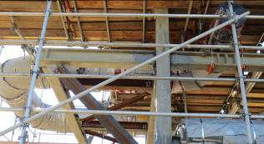 | Figure 2: A smaller pipe system that is being assembled while sitting on two pipe stands (one on each end). Note the various valves being used in this system.  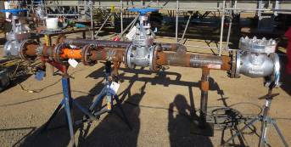
Figure 3: A valve with casket that will be secured once the next spool in the system is connected.  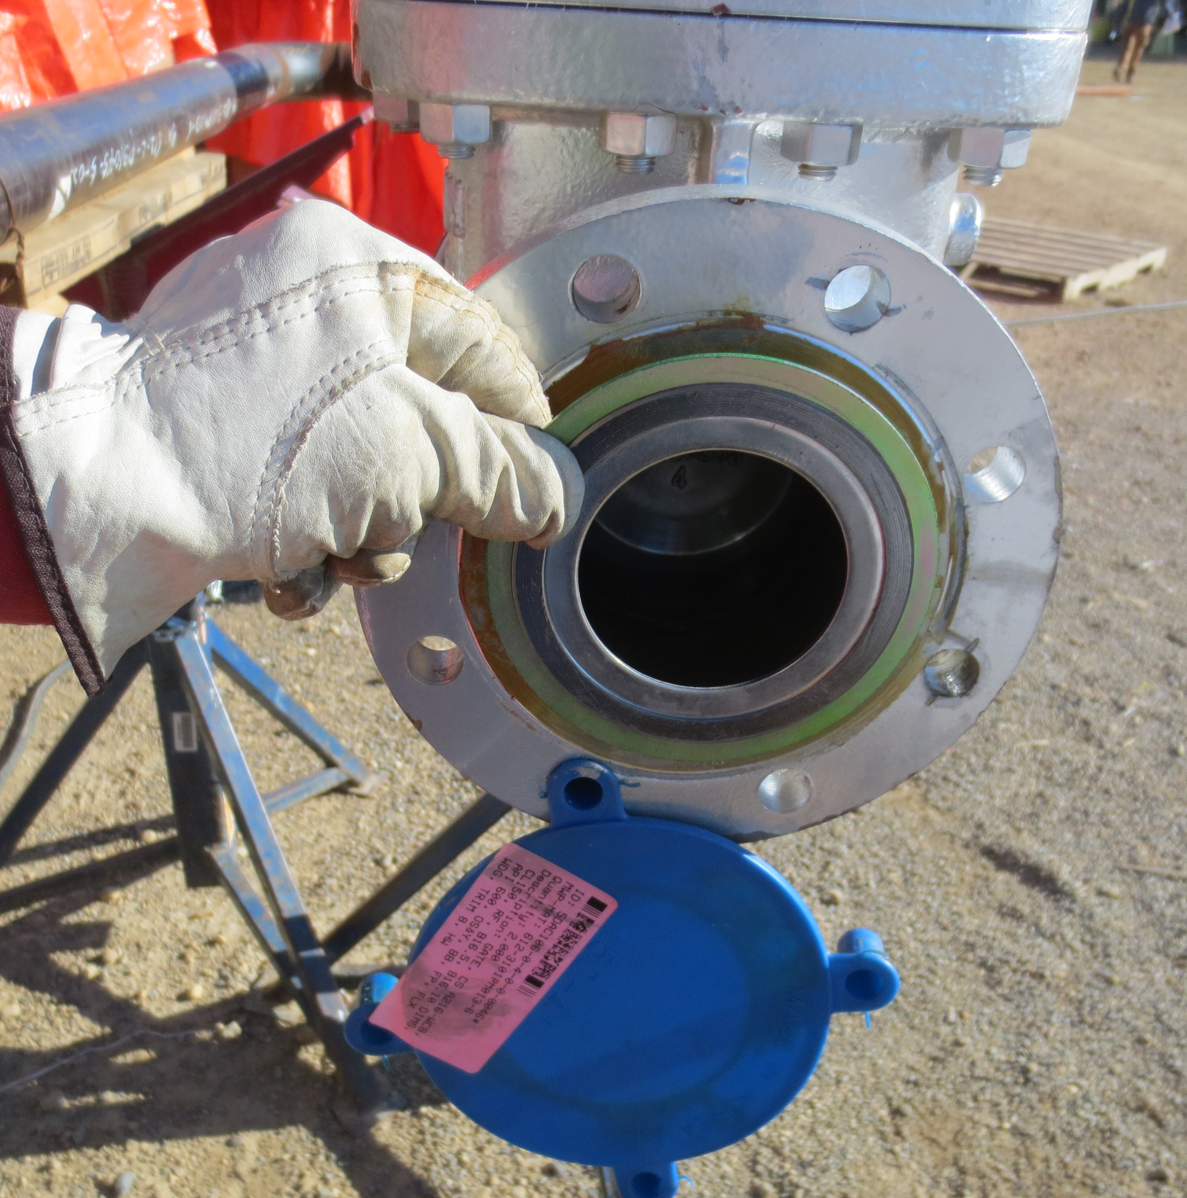 | Figure 4: Two pipes that have been temporarily secured with wire ropes and clamps (lashing).  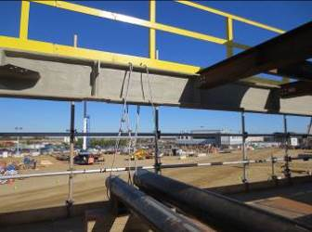
Figure 5: A larger valve that would be used in a piping system.  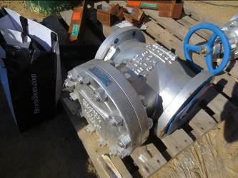 | Figure 6: A pipe stand used to hold piping spools at waist or chest height while working on them.  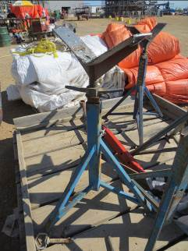
Figure 7: A pipe edge that has been bevelled / tapered by the Pipefitter using a grinder.  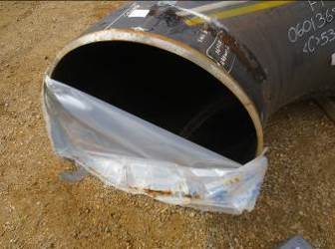 | Figure 8: Two spools that have been bolted together and torqued. Note the writing directly on the spool stating ‘TORQUED’.  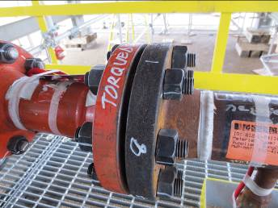
Figure 9: An example of rigging; the crane is used to manipulate the large system within the structure. The Pipefitter is required to use hand signals to relay directions to the crane operator.  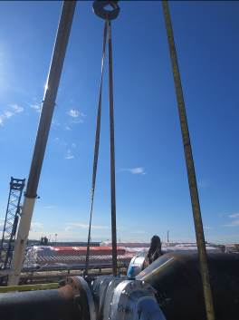 | Figure 10: The same system as Figure 9, but from a different angle. Note the slings used; the Pipefitter is responsible for securing these to the crane and spool.  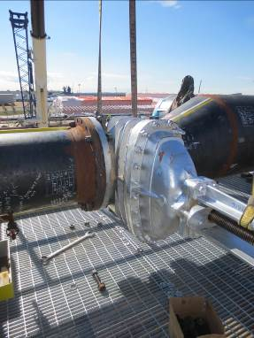
Figure 11: The water pump truck / hydro wagon used to complete hydro testing.  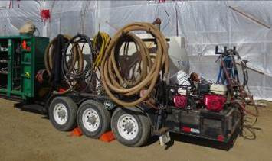 | Figure 12: Bent ready rod used to secure pipe.  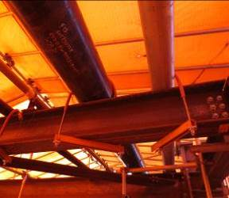
Figure 13: Bending ready rod around appropriate sized pipe guide which will be used to secure pipe.

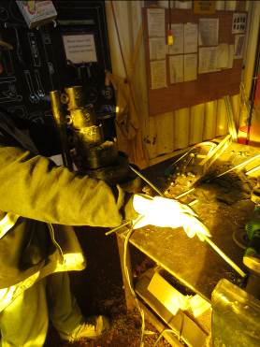

__________________________
Ryan Pauls MSc, CEP, CES, EIMC Level2
Exercise Physiologist

SITE SPECIFIC JOB DEMAND ADDITIONS:
Job Demand | Frequency |  |  |  |  | Details/Measurements
 | N/R | R | O | F | C
Site Specific Job Demand:

Validation Agreement

Job Title: | Modular Industrial 1st Year Apprentice Pipefitter
Data Collection Date: | September 14, 2015

We the undersigned have reviewed the Physical Demands Analysis for this position and agree that the physical demands documented in this report are representative of the true demands of the tasks associated with the job title as assessed on the date listed above.

Completed by: |  | Ryan Pauls MSc, CEP, CES, EIMC Level2
Approved by: |  | Management Representative
Approved by: |  | Worker Representative

