PROJECT CONTRACTOR CARGO MANAGEMENT PLAN “Our Path to Zero”

SCOPE AND PURPOSE

This plan contains:

• Project Logistics
• Designated Representatives
• Site Map outlining driving routes and pre-designated parking / unloading locations
• Training plan for all personnel that will be involved in the Loading/Unloading of Type 3 Deliveries/Shipments

The purpose of the Contractor Cargo Management Plan is to carry out the day-to-day work activities in compliance with the Enbridge Cargo Management Guideline. This document is not to supersede requirements set forth in the guideline. The guideline, along with this management plan, shall accomplish Enbridge’s expectation for zero incidents in regards to loading/unloading operations.

A Cargo Management Hazard Assessment will be completed before all type 3 Delivery/Shipment loading/unloading operations. The intent of the hazard assessment is to ensure that all parties involved understand their roles and responsibilities and have a coordinated approach to identifying and controlling the hazards associated with each step in the loading/unloading process.

Designated Representatives

Below is a list of the Designated Representatives that have been trained to identify hazards and controls associated with the loading/unloading of cargo and has the knowledge to complete a hazards assessment form and communicate identified hazards with workers involved with the loading/unloading operation

Name | Title | Phone Number

Delivery Plan

- All Deliveries will come through the designated access point labeled on the map.
- Drivers will check in with security at front and sign-in.
- Security will instruct the driver to wait for the designated representative before doing anything with the shipment including unstrapping his load.
- Security will contact the designated representative to meet driver
- The Designated Representative, for type 3 Delivery, will complete and communicate a Cargo Management Hazard Assessment with the unloading crew.
- All other deliveries will be delivered to appropriate receiver

Shipment Plan
- If required, a lift plan will be created and communicated
- Prior to any loading of type 3 shipments, a Cargo Management Hazard Assessment will be completed by the designated Representative
- The vehicle will be loaded safely and according to plan
- After the cargo has been loaded, the representative and crew will do a final walk around check to insure all hazards have been controlled.
- The representative will then give the driver the ok to finalize the securing of the load.
- The driver will follow the haul route to exit the facility

Site Map

Access Point- identified below
Haul Route- Displayed in yellow

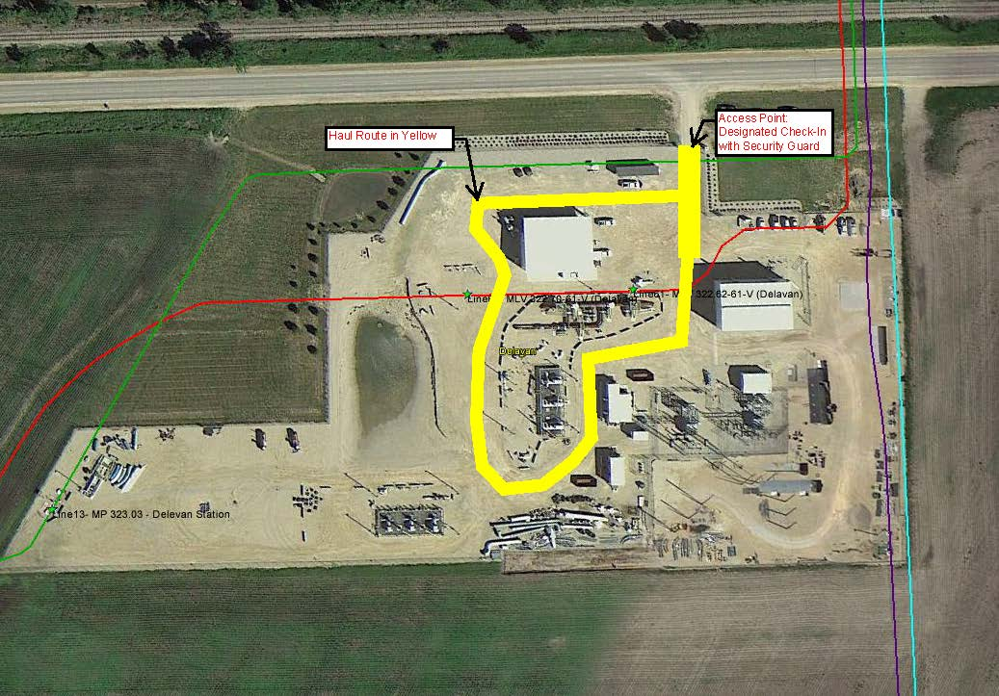

Signage

Signage will be used to remind drivers not to begin the Unloading process until directed to do so

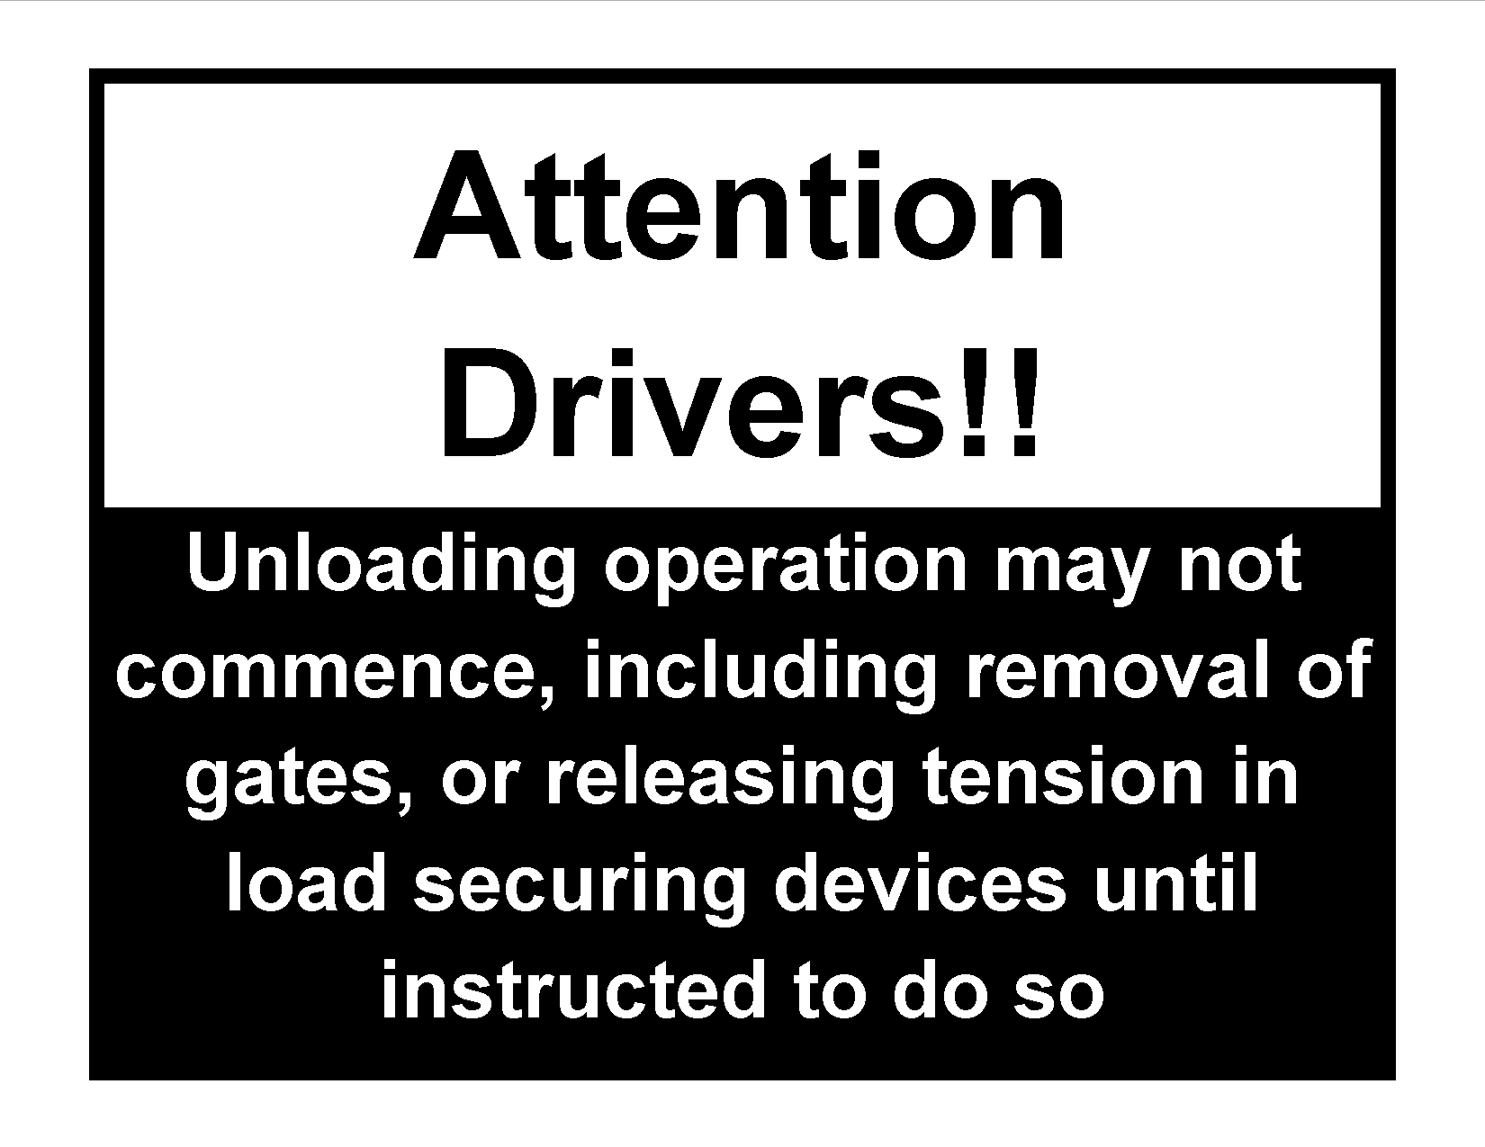

TRAINING PLAN

Level One Training- Awareness
Upon arriving onsite for the first time, all contractors and sub-contractor employees must go through a Cargo Management Awareness with their site specific training.

Level Two Training- Designated Representative / Operators
Designated representatives and operators will be required to go through loading/unloading training in order to be able to identify hazards and controls associated with loading/unloading operations and an understand any legislative Cargo Securement Rules.

Once the “Level Two Training- Designated Representative / Operators Cargo Management Training” is completed, the Representatives and operators will be required to wear a sticker representing Cargo Management and the year it was completed on their hardhat. This allows Inspectors and upper management to know they are qualified to be a representative or operator to perform the loading/unloading process.

Designated Representative and Operator – Cargo Management Training Sticker

Focused Competency Assessment’s
Used by Foreman/ Safety / Superintends / Management

Page left intentionally blank
Please see document on following page

FOCUSED COMPETENCY ASSESSMENT - LOAD Securement (Loading, Off-Loading & Transportation)
Project Name |  |  |  |  |  | Date |  |  | Day | Month |  | Year
Contractor |  |  |  |  |  | Crew Inspected
Conducted by |  |  |  |  |  | Date & Sign.
Conducted by |  |  |  |  |  | Date & Sign.
Distribution |  | Contractor Representative |  |  |  | Project Safety Coordinator
 |  | - Safety Retention Binder
 | - Interview worker(s) to ask the following Open Questions & rank responses.  - Desired answers on second page. |  |  |  |  |  |  | 0 = N/A |  |  |  |  | Response Ranking
 |  |  |  |  |  |  |  | 1 = Below Expectations
 |  |  |  |  |  |  |  | 2 = Meets Expectations
 |  |  |  |  |  |  |  | 3 = Above Expectations
 | - Explain the task steps on the hazard assessment concerning for the loading/off-loading of materials or equipment?
 | CORRECTIVE ACTION:
 | - Describe and show the dominant pinch/crush/contact points of the load?
 | CORRECTIVE ACTION:
 | - Describe the most likely and or severe injury to occur during loading/off-loading?
 | CORRECTIVE ACTION:
 | - Explain the conditions the truck/trailer needs to be in before beginning loading/off-loading?
 | CORRECTIVE ACTION:
 | - Explain how to prevent loads becoming unstable during loading/off-loading?
 | CORRECTIVE ACTION:
 | - Describe and show the safe method to access the trailer deck or tops of loads?
 | CORRECTIVE ACTION:
 | - Describe load securement requirements for safe transportation on private or public roads?
 | CORRECTIVE ACTION:
 | - What actions will you take to prevent serious injuries from happening to yourself or anyone else on this job?
 | CORRECTIVE ACTION:
 | Assessment Summary Ranking = |  | Response Ranking Total ( )  Number of Applicable Questions ( ) x 3 |  | X 100 |  | > 67% = Above Expectations  67% = Meets Expectations  < 67% = Below Expectations |  |  |  |  |  | %
 | Supervisor Improvement Action Plan to Prevent Injuries During Loading/Off-Loading or Transporting (Address All Below Expectations Items)
 | Supervisor informed of any improvement opportunities and agreement established to address improvements.
 | Supervisor name: |  |  | Signature: |  |  |  |  |  |  | Date:
 | Assessment follow-up date:
 | Additional Comments, Commendations or Items of Concern

Desired Responses to Interview Questions
- Explain the task steps on the hazard assessment concerning for the loading/off-loading of materials or equipment?
Listen for: Clear and full understanding of the task being performed; level of risk tolerance the worker(s) have with the task and level of controls being used; actions to ensure the delivery driver’s safety, protection and control while on site; vehicle area placement to ensure no vehicle/trailer movement; identification and assessment of the load for stored energy due to shifting or becoming insecure; planned access and work at heights; area control; rigging, hoisting or lifting plans; other?
- Describe and show the dominant pinch/crush/contact points of the load?
Listen and look for: Stored energy due to unstable load components shifting or falling, springs/chains/banding/slings under tension, pipe bunk condition/size/placement, other?
- Describe the most likely and or severe injury to occur during loading/off-loading?
Listen for: Head injury, fractured limbs/back/neck, separation/dislocation of joints, due to falls; suffocation due to entrapment due to being crushed, caught between or under a load; head injury, fractured limbs/back/neck, separation/dislocation of joints, internal organ damage due to crushing from uncontrolled load movement; strains, sprains, pinched or cut limbs; other?
- Explain the conditions the truck/trailer needs to be in before beginning loading/off-loading?
Listen for: Firm level ground; pads to support trailer landing gear when disconnected from truck on softer ground; brakes applied and or wheel chalks; other?
- Explain how to prevent loads becoming unstable during loading/off-loading?
Listen and look for: Pipe bunk support placement; sufficient sized dunnage for layered loads; layered strapping for loads that could become loose or unstable; deck stakes, other?
- Describe and show the safe method to access the trailer deck or tops of loads?
Listen and look for: Ladders held or secured to the deck to gain access onto deck; use of sand/melting agents for icy/slippery surfaces, covering open holes in deck with plywood or other? satisfactory material; fall protection plan if working over 2 m (6 ft) in height to load/unload, use of aerial work platform, ladders, step-ups, when every reasonable practicable to do so; other?
- Describe load securement requirements for safe transportation on private or public roads?
Listen for: Number and placement of straps/chains for the size, weight and or position of the load; strap protection from sharp edges; anchoring locations to trailer and loads; use of tensioning devices; cargo restraining devices (Shoring bars, dunnage bags, tie-downs; how often to re-check securement; oversize/wide load indicators; other?
- What actions will you take to prevent serious injuries from happening to yourself or anyone else on this job?
Listen for verbal commitment to the following: Stopping work and intervening when unsafe behaviours/conditions are identified; asking questions when unclear; following the plan established from the hazard assessment; other?
Comments to improve this focused inspection

Focused Competency Assessment – Load Securement - Rigging, Hoisting and Lifting Loads

Page left intentionally blank

Please see document on following page

FOCUSED COMPETENCY ASSESSMENT - LOAD SECUREMENT (Rigging, Hoisting and Lifting Loads)
Project Name |  |  |  |  |  | Date |  | Day |  | Month |  | Year
Contractor |  |  |  |  |  | Crew Inspected
Conducted by |  |  |  |  |  | Date & Sign.
Conducted by |  |  |  |  |  | Date & Sign.
Distribution |  | Contractor Representative |  |  |  | Project Safety Coordinator
 |  | - Safety Retention Binder
 | - Interview worker(s) to ask the following Open Questions & rank responses.  - Desired answers on second page. |  |  |  |  |  |  |  | 0 = N/A |  |  |  | Response Ranking
 |  |  |  |  |  |  |  |  | 1 = Below Expectations
 |  |  |  |  |  |  |  |  | 2 = Meets Expectations
 |  |  |  |  |  |  |  |  | 3 = Above Expectations
 | - Explain the class of lift and the hazard assessment performed for the hoisting or lifting of the load?
 | Corrective Action:
 | - Describe and show the dominant pinch/crush/contact points when rigging and while hoisting or lifting of the load?
 | CORRECTIVE ACTION:
 | - Describe the most likely and or severe injury to occur while using hoisting or lifting equipment?
 | CORRECTIVE ACTION:
 | - Explain the process used to inspect the rigging devices, hoisting and lifting equipment?
 | CORRECTIVE ACTION:
 | - Explain how to control loads and the area around the load, while it’s being hoisted or lifted?
 | CORRECTIVE ACTION:
 | - Explain the qualifications needed for the hoisting or lifting equipment operator and the rigger?
 | CORRECTIVE ACTION:
 | - Describe the load weights, ratings for the selected rigging, along with the configuration/orientation details of the rigging?
 | CORRECTIVE ACTION:
 | - What are you going to do to prevent the types of injuries you described from happening to you or anyone else on this job?
 | CORRECTIVE ACTION:
 | Assessment Summary Ranking = |  | Response Ranking Total ( )  Number of Applicable Questions ( ) x 3 |  | X 100 |  | > 67% = Above Expectations  67% = Meets Expectations  < 67% = Below Expectations |  |  |  |  |  | %
 | Supervisor Improvement Action Plan to Prevent Loading/Off-Loading Injuries (Address All Below Expectations Items)
 | Supervisor informed of any improvement opportunities and agreement established to address improvements.
 | Supervisor name: |  |  | Signature: |  |  |  |  |  |  | Date:
 | Assessment follow-up date:
 | Additional Comments, Commendations or Items of Concern

Definitions:
- Hoisting equipment: Movement by means of rope/chain and pulleys; i.e. crane, side-boom, chain hoist (Chainfall), tirfor, come-a-long etc.
- Lifting equipment: Movement by mechanical devices other than rope/chain and pulleys; i.e. excavator, forklift, loader, jacks, etc.
Desired Responses to Interview Questions
- Explain the task steps on the hazard assessment concerning for the loading/off-loading of materials or equipment?
Listen for: Clear and full understanding of the task being performed; level of risk tolerance the worker(s) have with the task and level of controls being used; class of lift; know weight of the load; who performed the lift plan, other
- Critical: single or multi lift > 75% of the manufacturer’s rating chart, over or between overhead High Voltage power lines
- Serious: workers being hoisted in a man-basket, lift can endanger existing facilities of one-of-a-kind equipment or processes, special lifting or rigging equipment configurations, may come within the safe limits of approach to high voltage equipment, over existing permanent structures or blind lift
- Standard: any lift that is not classified as serious or critical.
- Describe and show the dominant pinch/crush/contact points of the load?
Listen for: Area under and around the load or boom; swing radius or extension of the counter weight; area between the load and any stationary objects; areas in-front or behind tracks or wheels; other
- Describe the most likely and or severe injury to occur during loading/off-loading?
Listen for: Head injury, fractured limbs/back/neck, separation/dislocation of joints, internal organ damage due to crushing from load movement and stationary objects, boom or hook; swing radius or extension of the counter weight; strains, sprains, pinched or cut limbs; other
- Explain the conditions the truck/trailer needs to be in before beginning loading/off-loading?
Listen for: Pre-use inspection by competent/qualified worker; rejection criteria of any rigging component, requirements for certified components or equipment; other
- Explain how to prevent loads becoming unstable during loading/off-loading?
Listen for: Effective communication between rigger and operator; use of tag lines and not placing hands on loads higher than shoulder height; area flagging/tagging to control area and warn about hazards; other
- Describe and show the safe method to access the trailer deck or tops of loads?
Listen for: Crane or equipment certification/qualification, trade qualified, other
- Describe load securement requirements for safe transportation on private or public roads?
Listen for: Known load weights; minimum rated component; angle of slings; weight distribution on each attachment point; other
- What actions will you take to prevent serious injuries from happening to yourself or anyone else on this job?
Listen for verbal commitment to the following: Stopping work and intervening when unsafe behaviours/conditions are identified; asking questions when unclear; following the plan established from the hazard assessment; other
Comments to improve this focused inspection

FOCUSED COMPETENCY INSPECTION - Load Securement (Cribbing, Skids or Pipe stands)

Page left intentionally blank
Please see document on following page

FOCUSED COMPETENCY ASSESSMENT - LOAD PLACEMENT (Cribbing or Pipe stands)
Project Name |  |  |  |  |  | Date |  |  | Day | Month |  | Year
Contractor |  |  |  |  |  | Crew Inspected
Conducted by |  |  |  |  |  | Date & Sign.
Conducted by |  |  |  |  |  | Date & Sign.
Distribution |  | Contractor Representative |  |  |  | Project Safety Coordinator
 |  | - Safety Retention Binder
 | - Interview worker(s) to ask the following Open Questions & rank responses.  - Desired answers on second page. |  |  |  |  |  |  | 0 = N/A |  |  |  |  | Response Ranking
 |  |  |  |  |  |  |  | 1 = Below Expectations
 |  |  |  |  |  |  |  | 2 = Meets Expectations
 |  |  |  |  |  |  |  | 3 = Above Expectations
 | - Explain the task steps on the hazard assessment concerning the placing of loads on cribbing or pipe stands?
 | CORRECTIVE ACTION:
 | - Describe and show the dominant pinch/crush/contact points when using cribbing or pipe stands?
 | CORRECTIVE ACTION:
 | - What are the most severe injuries to occur with improper loading or techniques when using cribbing, blocking or pipe stands?
 | CORRECTIVE ACTION:
 | - Describe how ground conditions affect and determine requirements for the base of a box crib or the use of a pipe stand?
 | CORRECTIVE ACTION:
 | - Explain the process used to inspect skids used for cribbing or stands to support pipe?
 | CORRECTIVE ACTION:
 | - Explain how to build proper box cribbing for heavy loads, and the techniques to prevent movement of the load?
 | CORRECTIVE ACTION:
 | - Describe how to determine the weight of a section of pipe to be placed onto pipe stands?
 | CORRECTIVE ACTION:
 | - What actions will you take to prevent serious injuries from happening to yourself or anyone else on this job?
 | CORRECTIVE ACTION:
 | Assessment Summary Ranking = |  | Response Ranking Total ( )  Number of Applicable Questions ( ) x 3 |  | X 100 |  | > 67% = Above Expectations  67% = Meets Expectations  < 67% = Below Expectations |  |  |  |  |  | %
 | Supervisor Improvement Action Plan to Prevent Injuries While Placing Loads (Address All Below Expectations Items)
 | Supervisor informed of any improvement opportunities and agreement established to address improvements.
 | Supervisor name: |  |  | Signature: |  |  |  |  |  |  | Date:
 | Assessment follow-up date:
 | Additional Comments, Commendations or Items of Concern

Desired Responses to Interview Questions
- Explain the task steps on the hazard assessment concerning for the loading/off-loading of materials or equipment?
Listen for: Clear and full understanding of the task being performed; level of risk tolerance the worker(s) have with the task and level of controls being used; recognizing hazards of placing loads due to: pinch/crush points, falling/rolling loads, stability/centre of gravity of loads, stock piling heights; other?
- Describe and show the dominant pinch/crush/contact points of the load?
Listen for: Hand or body position under or between load and stationary objects; caught under or between a load due from dropping/falling or rolling; other?
- Describe the most likely and or severe injury to occur during loading/off-loading?
Listen for: Head injury, fractured limbs/back/neck, separation/dislocation of joints, due to falls; suffocation due to entrapment due to being crushed, caught between or under a load; head injury, fractured limbs/back/neck, separation/dislocation of joints, internal organ damage due to crushing from uncontrolled load movement; strains, sprains, pinched or cut limbs; other
- Explain the conditions the truck/trailer needs to be in before beginning loading/off-loading?
Listen for: Pre-use inspection to identified flaws, defects or damage against set rejection criteria, for skids, blocking, stands; other
- Explain how to prevent loads becoming unstable during loading/off-loading?
Listen for: Firm level ground conditions; solid foundation base row in softer material such as sand; alternating layers of skids for normal loads; alternating layers of solid layers of skids for heavy loads; not going higher than the height of a skid; cradling to prevent movement; other.
- Describe and show the safe method to access the trailer deck or tops of loads?
Listen for: Slopped or soft ground can cause lateral side movement or destabilization; matting placed as a means to provide firm base; other.
- Describe load securement requirements for safe transportation on private or public roads?
Listen for: Knowing the length, diameter and schedule of the pipe, along with a reference chart; other.
- What actions will you take to prevent serious injuries from happening to yourself or anyone else on this job?
Listen for verbal commitment to the following: Stopping work and intervening when unsafe behaviours/conditions are identified; asking questions when unclear; following the plan established from the hazard assessment; other
Comments to improve this focused inspection?

